

Základní škola a mateřská škola, Svoboda nad Úpou, okres Trutnov
Bc. Lucie Ševčíková
VY_22_INOVACE_2.2.1 AJ6,7g_17
Téma: přítomné časy - hra
Datum: 11. 1. 2013
Číslo projektu : CZ.1.07/1.4.00/21.3068
Anotace:

Tato hra je určena k praktickému použití obou přítomných časů. Žáci na základě daných slov tvoří věty. Hra se může hrát ve dvojici i ve skupinách. Hra je určena pro žáky 6. a 7. ročníku a může být prezentována i na interaktivní tabuli.

Monica/ not cry now

Monica/ not cry now

What/you/ do ? now

My cat/ drink/ cold milk never

Sam/ not paint/ a picture right now

You/have/ any sisters ?

Sally/cut grass in the garden sometimes

you/speak English ? now

Damian/ not | You/get up
sing | early?
at the | every day
moment
Sarah/ not | Jerry/work in
wash her | his garden
hands | every day
now
Mark/ go to

the cinema
sometimes
Kate/ not skate
at the moment
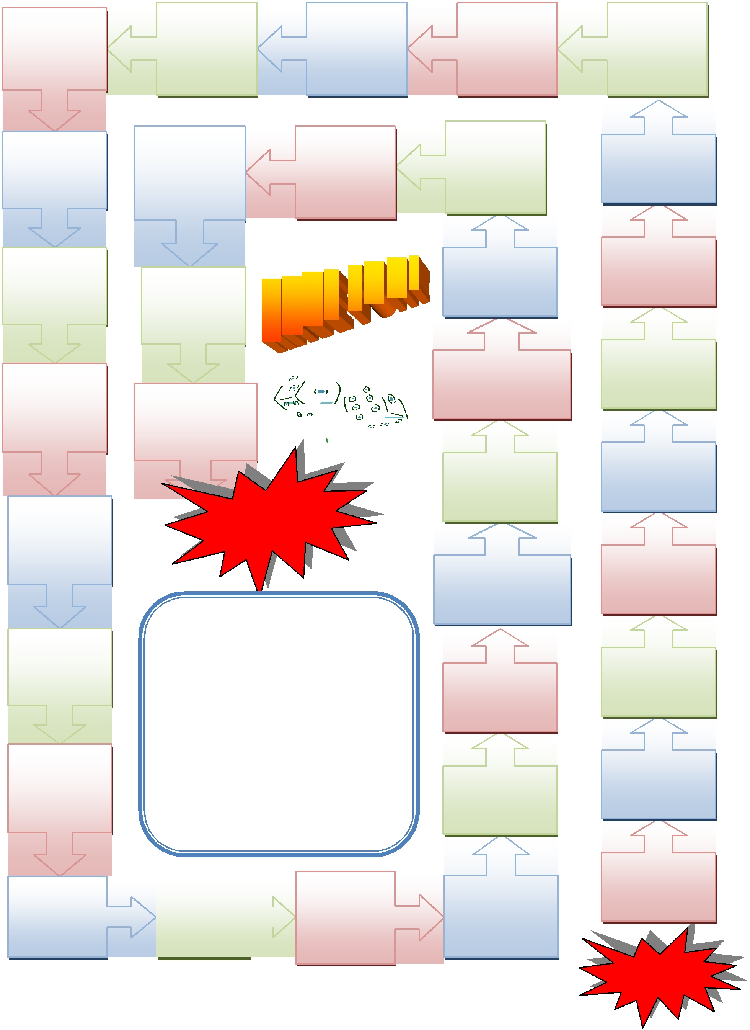

FINISH

Present simple or continuous

SAY IT RIGHT! Throw a dice. Use the words to say a sentence.

You can´t move if you are wrong

We/not |  | students/
 |  | work
stand |  | work
 |  | at the
now |  | at the
 |  | moment
Your

mum/read

books ?

often

I/go shopping with my parents

at weekends

you/play/ cards ? often

Our teacher/ walk around us now

You/have/ any brothers

My best friend/do homework

now

You/ how old/be?

we/cook dinner now

Boris/ not watch TV usually

Damian/ not sing

at the moment

Eva and Pam/not swim now

you/go/to school

?

you/ sit

?

now

My mum/work in the garden now

Adam/not like cats

They/listen to music now

She /not eat pizza

On Mondays

I/play/ PC games often

START

