Střední škola technická a dopravní, Ostrava – Vítkovice, p. o.

Název projektu:
INOVACE S ÚSMĚVEM
Registrační číslo projektu: CZ.1.07/1.5.00/34.0859

Šablona klíčové aktivity:
III/2 Inovace a zkvalitnění výuky prostřednictvím ICT

Tematická oblast:
General Topics for the New Maturita Exam

Název:
Travelling and Tourism Worksheet
VY_32_INOVACE_43-12_PL_Travelling_and_Tourism_Worksheet

Autor: Mgr. Veronika Richterová

Anotace
Název materiálu | Travelling and Tourism Worksheet
Kód přílohy | VY_32_INOVACE_43-12_PL_Travelling_and_Tourism_Worksheet
Anotace | Tento pracovní list je určen studentům a slouží nejen k procvičení probraného učiva – slovní zásoby Cestování a Turismus, nýbrž i k nácviku jazykových dovedností potřebných k nové maturitní zkoušce. Pracovní list může být použit i jako test.
Jméno autora | Mgr. Veronika Richterová
Škola | Střední škola technická a dopravní, Ostrava – Vítkovice, p. o.
Datum vytvoření | Březen 2013
Šablona klíčové aktivity | III/2 Inovace a zkvalitnění výuky prostřednictvím ICT
Jazyk | Angličtina
Očekávaný výstup | Studenti si procvičí a zafixují slovní zásobu k maturitnímu tématu Travelling and Tourism. Studenti si také prohloubí jazykové dovednosti potřebné k maturitní zkoušce.
Klíčová slova | Air, Sea, Road, Rail Travel, Means of Transport, Accommodation, Holidays, Useful Phrases.
Druh učebního materiálu | Pracovní list
Druh interaktivity | Aktivita
Cílová skupina | Žák
Stupeň středního vzdělání | Střední vzdělání s maturitní zkouškou
Typická věková skupina | 14 - 19
Použitá literatura a zdroje | - Klipart Microsoft Word 2007, 2010  - HASTINGS, Bob. Maturita activator: intenzivní příprava k maturitě : anglický jazyk - základní úroveň obtížnosti. Warszawa: Pearson Education Polska, 2009, 215 s. ISBN 978-83-7600-055-8.  - www.bridge-online.cz

Metodický list
Název materiálu | Travelling and Tourism Worksheet
Kód přílohy | VY_32_INOVACE_43-12_PL_Travelling_and_Tourism_Worksheet
Jméno autora | Mgr. Veronika Richterová
Škola | Střední škola technická a dopravní, Ostrava – Vítkovice, p. o.
Datum vytvoření | Březen 2012
Šablona klíčové aktivity | III/2 Inovace a zkvalitnění výuky prostřednictvím ICT
Zaměření výukového materiálu | Pracovní list je určen studentům k procvičení a fixaci slovní zásoby maturitního téma Travelling and Tourism a k nácviku a prohloubení jazykových dovedností potřebných k nové maturitní zkoušce.
Cíl výukového materiálu | Cílem pracovního listu je procvičit slovní zásobu a prohloubit jazykové dovednosti týkající se maturitního téma Travelling and Tourism. Cílem je také zjistit zpětnou vazbu studentů.
Stručný popis práce s výukovým materiálem | Cvičení 1 – pojmenovat obrázky  Cvičení 2 – doplnit slovíčka opačného významu  Cvičení 3 – doplnit komparativ (srovnání obrázků)  Cvičení 4 – v odpovědích najít pět chyb ve slovní zásobě a pět chyb v gramatice  Cvičení 5 – v textu dopisu označit správnou odpověď A, B, C  Cvičení 6 – pomocí frází v tabulce doplnit konverzační situaci

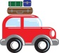 TRAVELLING - WORKSHEET 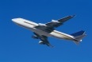
- Name the vocabulary
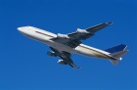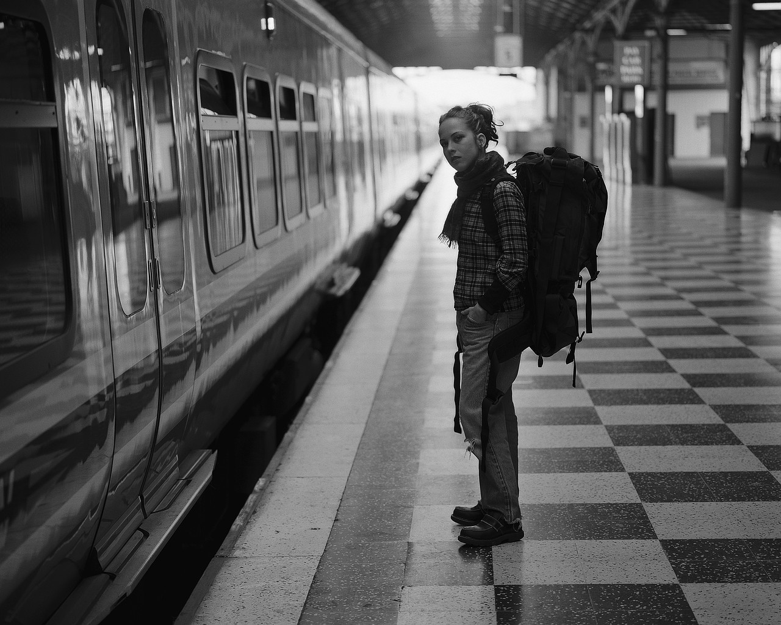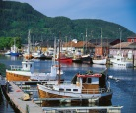

- Complete with opposites
to arrive X arrival X to take off X
one-way ticket X minor road X to check in X

- Compare these two means of transport/Complete the comparison
The first picture represents ______ (type) travel, while the second picture represents the _____ travel. The plane is ______ (size) than the car and it can transport ______ (quantity) people. Travelling by car is __________ (price) than travelling by the plane. If we compare the safety, the plane is much ________ (safety) than the car. I ______ (preference) travelling by plane, because it is _______ (good) than travelling by the car in many ways.
Picture A Picture B
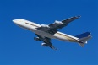
- Read the answers to the questions and in each answer find five mistakes in vocabulary and five mistakes in grammar. Then aswer the questions on your own
What are your favourite means of transport? Why?
My favorite means of traffic is car and a train. I like travel by car because it is speed and comfortable, evenhough the petrol is expensive. I travel with train because it is quite cheap, is fast and safety and I feel never scared.
If you had enough money, where would you travel?
If I have enough money, I travel round the world, because I love traveling. I would start in the west Europe, and I would continue to the east. I would like visit Asia and countrysides like Tchai-wan, Laos, e.g. I would to complete in United States of America.
Where are you going to travel during the summer?
I going to travell a lot of. I am go to go to croatia with my boyfriend for two month and than I am going go to Egypt with my parents for one month. I looking backward!
- Use of English – Complete the letter with the most suitable answer A, B, C
Hi mum!
I’m sorry I haven’t written until now, but I’ve been really busy. So you wanna know about my holiday? Right, let’s see then. But I’m going to disappoint you cause it’s been a total disaster!
It all began at the airport. Our flight was 1)______three hours. Next, I had a problem with my 2) ______ luggage as it was too big. Moreover, there was also problem with the 3)_______. There were big turbulences and one of the air 4) _______ even collapsed! Another problem occurred at the baggage 5) ______. One of my 6) ______ got lost!
Still, it hasn’t been all. After the arrival to our 7) _______ we found out that our hotel was fully 8) __________. As a result, they arranged a different hotel for us but this one is really poor! Regarding the weather, it’s been cloudy and windy most of the time, and you can rarely see the sun here! The food is disgusting, just seafood and pommes frites a thousand ways!
I hope that at least the flight back home will be without problems. Believe me or not, I’m really looking forward to coming home!!!
With love,
Lucy
- a) delay b) delayed c) missed
- a) hand b) handbook c) guide
- a) fly b) flew c) flight
- a) hostesses b) persons c) attendants
- a) place b) reclaim c) claim
- a) baggages b) luggages c) baggage
- a) destination b) destiny c) target
- a) full b) reserved c) booked

- Imagine the following situation. You and your friend plan a holiday together. You should agree on where, when, for how long and where to stay. Complete the conversation with suitable words from the chart
A: ˮWhat _______ going to Egypt? I’ve never been there.“ B: ˮI _________ it’s a good idea. Haven’t you heard about the protests?“ A: ˮYou’re absolutely______. So what do you ________?“ B: ˮI’d like to visit Ibiza. You know, I love big parties.“ A: ˮNo way. I totally _______. I hate noise and parties. I’d prefer something quieter.“ B:“Ok, then. _______ to Mallorca!“ A: ˮThat ______ great. I’ve seen an ad offering 7-day all inclusive ****Mallorca Beach Hotel in June and July. ___________ ok?“ B: ˮI _____ going in July. Is that a problem for you?“ A: ˮNo, it’s ok. So, we_________ going to Mallorca for seven days in July and stay in a **** hotel.“
*disagree *would that be *let’s go *would prefer *right
*suggest *about *sounds *have we agreed on *don’t think

SOLUTION TRAVELLING - WORKSHEET
- Name the vocabulary
plane air hostess boarding pass railway train platform harbour boat
- Complete with opposites
to arrive X to depart/leave arrival X departure to take off X to land
one-way ticket X return ticket minor road X main road check in X to check out

- Compare these two means of transport/Complete the comparison
The first picture represents air (type) travel, while the second picture represents the road travel. The plane is bigger (size) than the car and it can transport more (quantity) people. Travelling by car is cheaper (price) than travelling by the plane. If we compare the safety, the plane is much safer (safety) than the car. I prefer (preference) travelling by plane, because it is better (good) than travelling by the car in many ways.
- Read the answers to the questions and in each answer find five mistakes in vocabulary and five mistakes in grammar. Then aswer the questions on your own
What are your favourite means of transport? Why?
My favorite (favourite) means of traffic (transport) is a car and a train. I like travelling by car because it is speed (fast) and comfortable, evenhough (eventhough) the petrol is expensive. I travel by with train because it is quite cheap, it is fast and safety (safe) and I never feel never scared.
If you had enough money, where would you travel?
If I have had enough money, I would travel round (around) the world, because I love traveling (travelling). I would start in the west Europe, and I would continue to the east. I would like to visit Asia and countrysides (countries) like Tchai-wan, Laos, e.g (etc.). I would to complete (finish/end) in the United States of America.
Where are you going to travel during the summer? I am going to travell (travel) a lot of (a lot). I am going to go to croatia (Croatia) with my boyfriend for two months and than (then) I am going to go to Eypt with my parents for one month. I am looking backward (forward)!
- Use of English – Complete the letter with the most suitable answer
Hi mum!
I’m sorry I haven’t written until now, but I’ve been really busy. So you wanna know about my holiday? Right, let’s see then. But I’m going to disappoint you cause it’s been a total disaster!
It all began at the airport. Our flight was 1)______three hours. Next, I had a problem with my 2) ______ luggage as it was too big. Moreover, there was also problem with the 3)_______. There were big turbulences and one of the air 4) _______ even collapsed! Another problem occurred at the baggage 5) ______. One of my 6) ______ got lost!
Still, it hasn’t been all. After the arrival to our 7) _______ we found out that our hotel was fully 8) __________. As a result, they arranged a different hotel but this one was really poor! Regarding the weather, it’s been cloudy and windy most of the time, and you can rarely see the sun here! The food is disgusting, just seafood and pommes frites a thousand ways!
I hope that at least the flight back home will be without problems. Believe me or not, I’m really looking forward to coming home!!!
With love,
Lucy
- a) delay b) delayed c) missed
- a) hand b) handbook c) guide
- a) fly b) flew c) flight
- a) hostesses b) persons c) attendants
- a) place b) reclaim c) claim
- a) baggages b) luggages c) baggage
- a) destination b) destiny c) target
- a) full b) reserved c) equipped

- Imagine the following situation. You and your friend plan a holiday together. You should agree on where, when, for how long and where to stay. Complete the conversation with suitable words from the chart
A: ˮWhat about going to Egypt? I’ve never been there.“ B: ˮI don’t think it’s a good idea. Haven’t you heard about the protests?“ A: ˮYou’re absolutely right. So what do you suggest?“ B: ˮI’d like to visit Ibiza. You know, I love big parties.“ A: ˮNo way. I totally disagree. I hate noise and parties. I’d prefer something quieter.“ B:“Ok, then. Let’s go to Mallorca!“ A: ˮThat sounds great. I’ve seen an ad offering 7-day all inclusive ****Mallorca Beach Hotel in June and July. Would that be ok?“ B: ˮI would prefer going in July. Is that a problem for you?“ A: ˮNo, it’s ok. So, we have agreed on going to Mallorca for seven days in July and stay in a **** hotel.“
*disagree *would that be *let’s go *would prefer *right
*suggest *about *sounds *have we agreed on *don’t think
Použitá literatura a zdroje

Klipart Microsoft Word PowerPoint Presentation 2007, 2010

HASTINGS, Bob. Maturita activator: intenzivní příprava k maturitě : anglický jazyk - základní úroveň obtížnosti. Warszawa: Pearson Education Polska, 2009, 215 s. ISBN 978-83-7600-055-8.

www.bridge-online.cz

