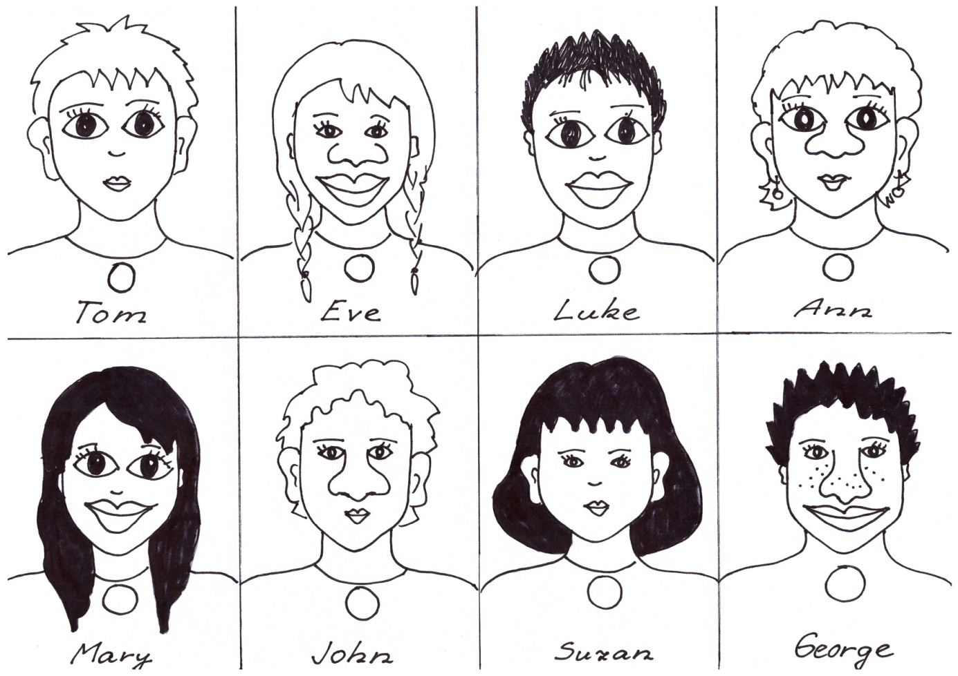
Podle textu se pokuste určit, o kterou osobu jde. Číslo u povídání o dané osobě napište do prázdného kolečka v příslušném obrázku.

Number 1 has got long dark hair, big eyes, a big mouth, small ears and a small nose.
Number 2 has got small ears, long light hair, a big nose, a big mouth and small eyes.
Number 3 has got short dark hair, small ears, a big nose, small eyes and a big mouth.
Number 4 has got long dark hair, big ears, small eyes, a small mouth and a small nose.
Number 5 has got a small nose, big eyes, big ears, a small mouth and short light hair.
Number 6 has got got a big nose, big ears, a small mouth, small eyes and short light hair.
Number 7 has got big ears, short light hair, a big nose, a small mouth and big eyes.
Number 8 has got a big mouth, a small nose, big eyes, small ears and short dark hair.

Řešení: 1 – Mary, 2 – Eve, 3 – George, 4 – Suzan, 5 – Tom, 6 – John, 7 – Ann,
8 - Luke

Zdroj: vlastní kresba autorky

