Digitální učební materiál

Číslo projektu | CZ.1.07/1.5.00/34.0029
Číslo materiálu | VY_32_INOVACE_10-12
Název školy | Střední průmyslová škola stavební, Resslova 2,  České Budějovice
Autor | Mgr. Daniel Hegr
Tematický celek | Anglický jazyk – Holidays´ review
Ročník | 3. ročník
Datum tvorby | 4.9.2013
Anotace | Tento D.U.M. je pracovní list, který se konverzační formou zaměřuje na letní prázdniny. Studenti odpovídají na otázky a popisují v minulém čase, jak a kde prázdniny strávili, hodnotí, jak prázdniny splnily jejich očekávání, popisují prázdninovou cestu, zda o prázdninách pracovali, používali angličtinu atd. Studenti mají k dispozici tematické fráze a slovní zásobu. Dále se v pracovním listu procvičuje popis a porovnávání obrázků z prázdnin.
Metodický pokyn | Tento pracovní list doporučuji promítnout přes dataprojektor či interaktivní tabuli. Studenti mohou mít k dispozici slovník.  DUM je určen pro studenty středních škol a slouží k procvičení tematické slovní zásoby a schopnosti studentů reagovat na otázky.
Zdroje: Vše z vlastních zdrojů autora

Summer holidays
- Work in pairs and answer each other the following questions.
- How did you spend the holidays?
- What activities did you do in July and August?
- Did you travel anywhere or did you stay at home?
- How did you travel there?
- What was this summer´s best experience?
- If you could change anything about the holidays, what would it be?
- Name some positive and negative points about your holidays.
- Did you try something new during the holidays?
- Did you travel with your family or with friends?
- Did you work?
- What was the weather like?
Tell the class about your neighbour´s experiences.
You can use the following phrases and vocabulary:
He/she spent a week in … They went/travelled to … He stayed in … She liked … best.
He enjoyed/ didn´t like (-ing) … She would change … He would like to …
Good/bad about the holidays was that …. She tried (-ing) … He wanted to … but …
He had a job/worked in … The weather was … It rained/was … etc.
Abroad/in this country at sea in the mountains in the countryside at home travel by car/bike/plane friends party cottage weekend fun enjoy play prefer jump read watch meet experience something new summer job earn some money rain sunny hot/cold etc.

- Types of holidays
Describe the pictures and compare different ways how you can spend summer holidays.
You can use the following vocabulary:
It is a picture of I can see in the picture there is/are also at the bottom/top in the middle in the centre in the foreground/background on the right/left next to between behind in front of enjoy sea atmosphere sand sun beach festival stage people weather band umbrella mountains climb up/down ride fly watch listen sunbathe campsite tent ship in the open raft sail roller-coaster have fun experience adrenalin ride catch historical/interesting places fishing culture travelling cottage sport relaxing active/passive fun party camping etc.

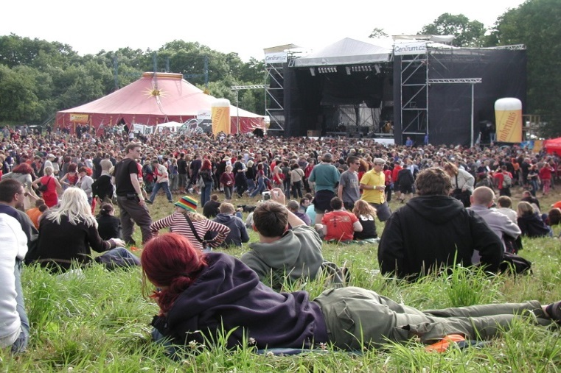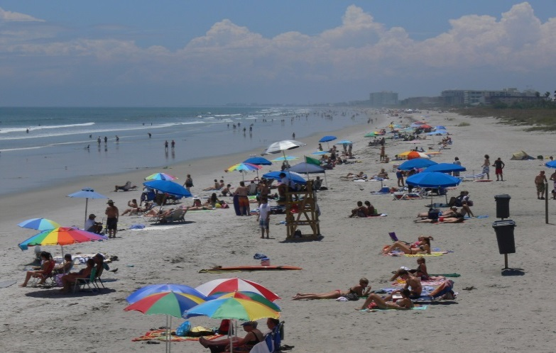
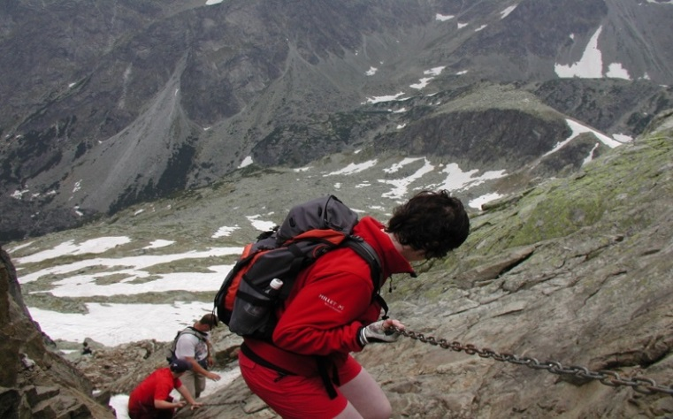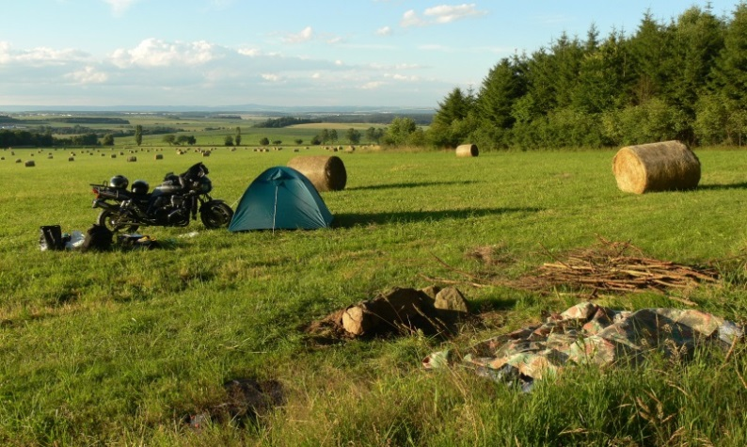
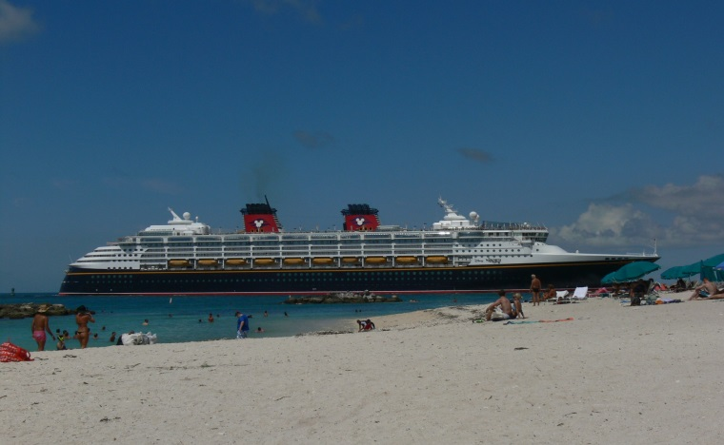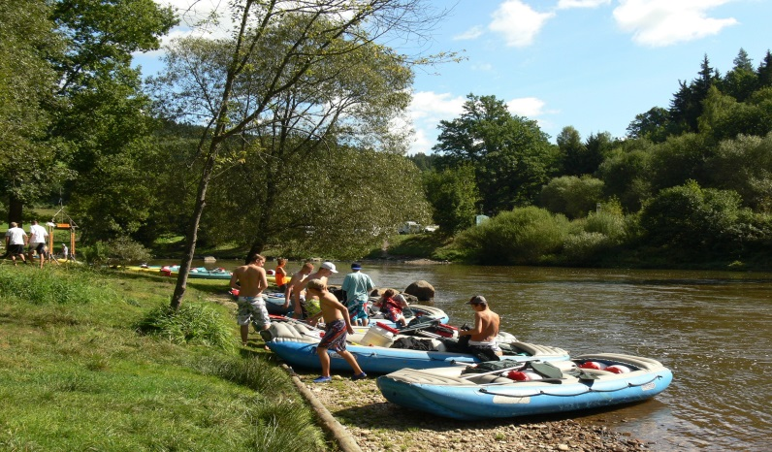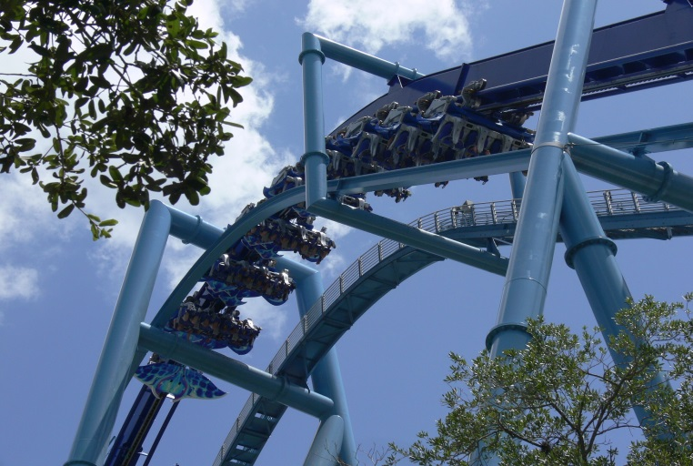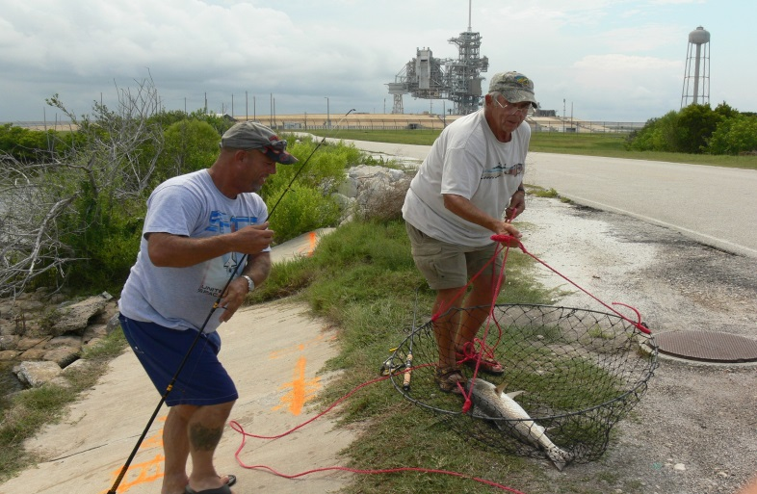
- Which type of holidays is your favourite and why?
- What are your favourite summer activities?
- Speak about your experiences during this year´s summer holidays
- What would you like to try and what is boring for you?

- Describe a trip or a journey
- Where did you travel? What was your destination?
- How did you get there? What means of transport did you use?
- How long did the journey take?
- Where did you stay during the trip (hotel, motel, camp, in the open etc.)?
- What did you like/dislike about the trip?
- Where would you like to go next holidays?

- Using English during summer
- Did you speak English to anybody?
- Who did you speak to?
- What was the situation/what did you speak about?
- Were you satisfied with your communicative abilities?
- What did you do to improve your English during the summer?

- Summer job
- Did you work during the holidays?
- Did you like the job?
- What did you do there? Say something about the work activities, tools, materials, customers, colleagues etc.
- How long did you work there?
- Were you satisfied with the money you have earned?
- Would you like to work there in future?

- Dream holidays
Imagine that you have plenty of money and the holidays are just beginning…
- How would you spend your dream holidays?
- Would you travel abroad? Which continent?
- How would you travel there?
- Which of the following destinations is most attractive to you and why?
New York, Los Angeles, London, Berlin, Rio de Janeiro, Beijing, Melbourne, Moscow
- Do you know any interesting facts about these cities?
- Do you have a special place that you would like to visit? Why?

