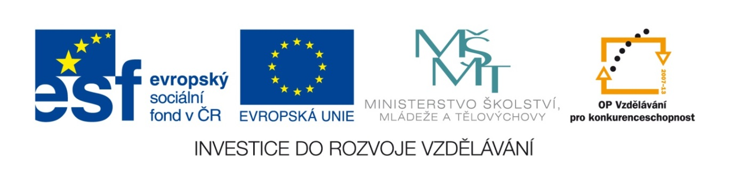
Základní škola a mateřská škola, Šaratice, okres Vyškov

III/2 Inovace a zkvalitnění výuky prostřednictvím ICT
VY_32_INOVACE_184

Jméno autora: Mgr. Zdena Černá
Datum vytvoření: září 2011
Ročník: 8. – 9.
Vzdělávací oblast: Jazyk a jazyková komunikace
Vzdělávací obor: Anglický jazyk
Tematický okruh: Anglický jazyk VI. – IX. třída
Číslo projektu: CZ.1.07./1.4.00/21.1996

Pracovní list
EXPERIMENTS WITH A GLASS OF WATER
A) What will happen if you put a paper clip in a glass of water? Will it sink or float ?
- Slowly on the fork : It will .............................................
- Quickly dropped : It will .............................................
B) What will happen if you put a needle in a glass of water? Will it sink or float ?
- Slowly and carefully on the fork : ..................................
- Quickly dropped : ..................................
C) What will happen if you put a coin in a glass of water ? Will the coin look larger or smaller ?
..........................................................................................
D) What will happen if you put a pencil in a glass of water ? Will the pencil look larger, smaller,
or broken ?
.........................................................................................
E) What will happen if you put a piece of aluminium foil in a glass of water? Will it sink or float ?
- Rolled into a ball and dropped : .....................................
- Shaped into a boat : .....................................
Match your utensils (pomůcky)with their English names:
paper clip needle coin fork aluminium foil

ŘEŠENÍ:
A) What will happen if you put a paper clip in a glass of water? Will it sink or float ?
- Slowly on the fork : It will FLOAT.
- Quickly dropped : It will SINK .
B) What will happen if you put a needle in a glass of water? Will it sink or float ?
- Slowly and carefully on the fork : It will FLOAT.
- Quickly dropped : It will SINK.
C) What will happen if you put a coin in a glass of water ? Will the coin look larger or smaller ?
It will look LARGER.
D) What will happen if you put a pencil in a glass of water ? Will the pencil look larger, smaller,
or broken ?
It will look LARGER and BROKEN.
E) What will happen if you put a piece of aluminium foil in a glass of water? Will it sink or float ?
- Rolled into a ball and dropped : It will SINK.
- Shaped into a boat : It will FLOAT.
Match your utensils (pomůcky)with their English names:
paper clip = kancelářská sponka needle = jehla coin = mince fork = vidlička aluminium foil = hliníková fólie, alobal

Zdroj:
GILL, Simon a Michaela ČAŇKOVÁ. Intercultural activities. 1st ed. Oxford: Oxford University Press, 2002, 65 s. Oxford basics. ISBN 01-944-2178-3.

