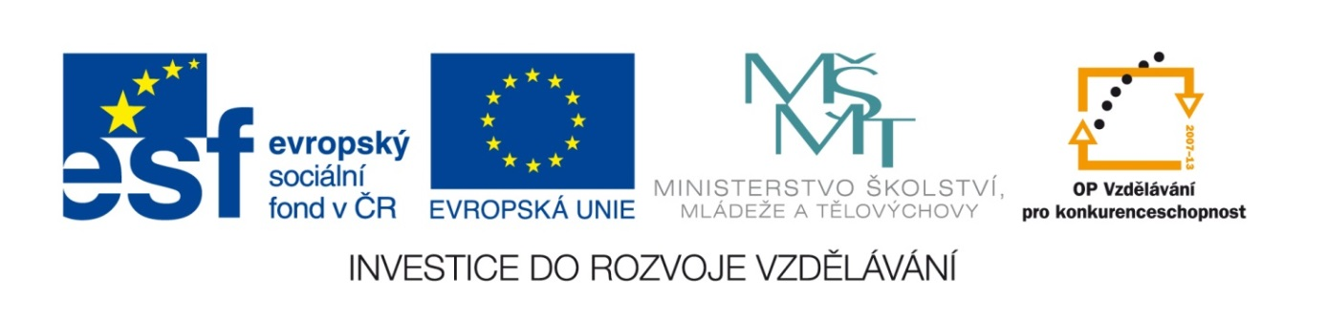
Základní škola a mateřská škola, Šaratice, okres Vyškov

III/2 Inovace a zkvalitnění výuky prostřednictvím ICT
VY_32_INOVACE_195

Jméno autora: Mgr. Zdena Černá
Datum vytvoření: duben 2012
Ročník: 6. – 9.
Vzdělávací oblast: Jazyk a jazyková komunikace
Vzdělávací obor: Anglický jazyk
Tematický okruh: Anglický jazyk VI. – IX. třída
Číslo projektu: CZ.1.07./1.4.00/21.1996

THE LITTLE RED RIDING HOOD
Text nastříhejte na jednotlivé části, vystřihněte obrázky.
1. PŘIŘAĎTE NÁZVY POSTAV K OBRÁZKŮM: Who’s this?
Mummy
Little Red Riding Hood
the Big Bad Wolf
Grandma
(ŘEŠENÍ: Mummy=obr.1, LRRh=2, wolf=7, grandma=9)

2. PŘIŘAĎTE SLŮVKA K OBRÁZKŮM.
Nechte děti poskládat obrázky tak, jak si myslí, že po sobě následují.
Společně s dětmi obrázky nahlas pojmenujte, zatím bez textu. Zopakujte.
Rozdejte slůvka, děti je přiřazují k obrázkům.
THE LIST OF WORDS:
Mummy Little Red Riding Hood
a coat, a hat a basket
flowers
a wardrobe Grandma cupcakes
Wolf a house a bed
eyes ears mouth, teeth a vase
Little Red Riding Hood with Grandma
tea bruised Wolf

(ŘEŠENÍ)
1 Mummy 2 Little Red Riding Hood 3 a coat, a hat 4 a basket 5 flowers
6 a wardrobe 7 Grandma 8 cupcakes 9 Wolf 10 a house 11 a bed 12 eyes
13 ears 14 mouth, teeth 15 a vase 16 Little Red Riding Hood with Grandma
17 tea 18 bruised Wolf

3. PŘIŘAĎTE TEXT K OBRÁZKŮM
Text nejdřív vyprávějte, děti poslouchají a ukazují na příslušné obrázky, případně ještě poupraví
jejich pořadí.
Znovu zopakujte, tentokrát s částmi textu.
Přečtěte, pak zkuste odebrat text, děti mohou zkusit vyprávět vlastními slovy.
(ŘEŠENÍ)
Once upon a time there was a little girl.
Her name was Little Red Riding Hood (dale LRRH).
(obr.2)
One day Mummy tells her: “Little Red Riding Hood, put on your red jacket and your red hat.
Here you are. Take this bunch of flowers, take this basket with cakes for Grandma.
“OK, Mummy.”
(obr.1,3,4,5,6,9)
Grandma lives in a her old little house in the forest.
(obr.8,9)
LRRH skips and sings: ”Cakes and flowers for Grandma.....”
(obr.2,5,6)
But behind the tree there is a wolf. The Big Bad Wolf! He can hear everything.
“Grandma likes cakes, eh? And I like LRRH .... and cakes, too. Yum, yum”.
(obr.7)
The Wolf runs and runs until he comes to Grandma’s house.
There he stops and knocks the door.
((obr.5)
“Come in,” Grandma says. The Wolf rushes in.
Grandma screams and hides in the wardrobe.
(obr.7,9.10)
The Wolf puts on Grandma’s pink hat and one of her pink nightgowns, jumps to bed
and waits for LRRH.
(obr.11)
Here she goes, knocks the door and calls:
“Hello, Grandma! Here I am with a basket of cakes for you!”
Hello, dear. Come in.
(obr.2,4,11)
LRRH comes to the bed and says:
“Oh, Grandma, what big eyes you have!”
“All the better to see you with!”
(obr.12)
“Oh, Grandma, what big ears you have!”
“All the better to hear you with!”
(obr.13)
“And what big ....... teeth you have!”
“All the better to eat you with!!”
(obr.14)
“Aagh!” LRRH screams. But she’s a brave girl.
She grabs a big blue vase and hits the Wolf over head with it.
The shocked Wolf runs away. He runs and runs until he stops in the next district.
(obr.15)
Grandma jumps from the wardrobe.
“My dear brave girl” “Grandma! Are you OK?”
“Oh, yes. I’m just a little bit dizzy. But I’m so hungry!”
“Time for cakes and a nice cup of tea!”
(obr.16,17)
The Wolf runs and runs far away over five districts.
So that was the end of the Big Bad Wolf.
(obr.18)

THE STORY
(Text k nastříhání)
Once upon a time there was a little girl.
Her name was Little Red Riding Hood (dale LRRH).
One day Mummy tells her: “Little Red Riding Hood, put on your red jacket and your red hat.
Here you are. Take this bunch of flowers, take this basket with cakes for Grandma.
“OK, Mummy.”
Grandma lives in a her old little house in the forest.
LRRH skips and sings: ”Cakes and flowers for Grandma.....”
But behind the tree the is a wolf. The Big Bad Wolf! He can hear everything.
“Grandma likes cakes, eh? And I like LRRH .... and cakes, too. Yum, yum”.
The Wolf runs and runs until he comes to Grandma’s house.
There he stops and knocks the door.
“Come in,” Grandma says. The Wolf rushes in.
Grandma screams and hides in the wardrobe.
The Wolf puts on Grandma’s pink hat and one of her pink nightgowns, jumps to bed
and waits for LRRH.
Here she goes, knocks the door and calls:
“Hello, Grandma! Here I am with a basket of cakes for you!”
Hello, dear. Come in.
LRRH comes to the bed and says:
“Oh, Grandma, what big eyes you have!”
“All the better to see you with!”
“Oh, Grandma, what big ears you have!”
“All the better to hear you with!”
“And what big ....... teeth you have!”
“All the better to eat you with!!”
“Aagh!” LRRH screams. But she’s a brave girl.
She grabs a big blue vase and hits the Wolf over head with it.The shocked Wolf runs away.

Grandma jumps from the wardrobe.
“My dear brave girl” “Grandma! Are you OK?”
“Oh, yes. I’m just a little bit dizzy. But I’m so hungry!”
“Time for cakes and a nice cup of tea!”

The Wolf runs and runs far away over five districts.
So that was the end of the Big Bad Wolf.

(Obrázky k nastříhání)
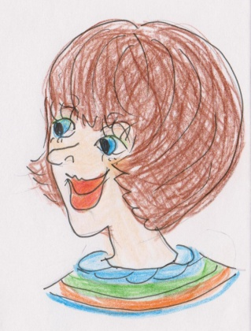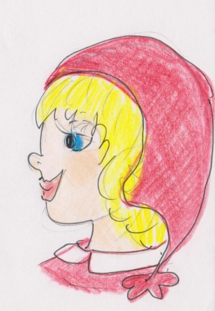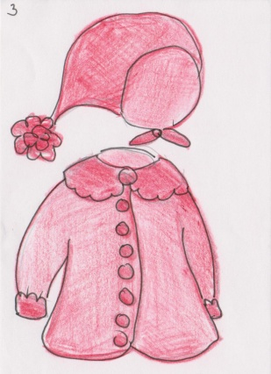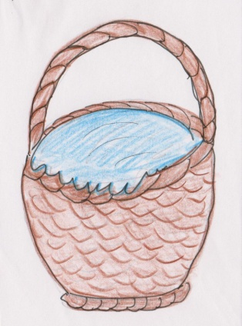
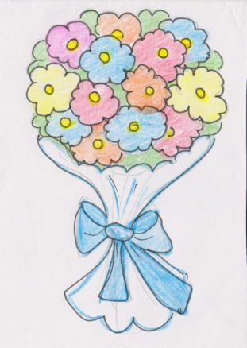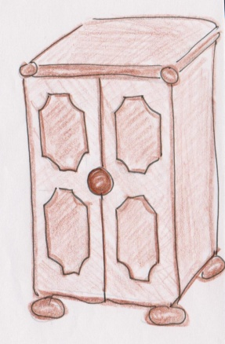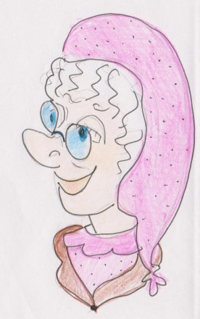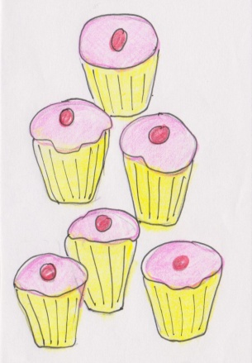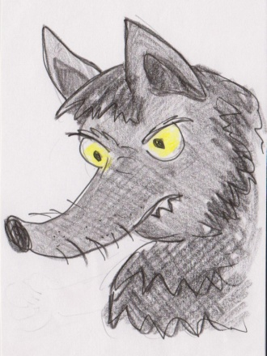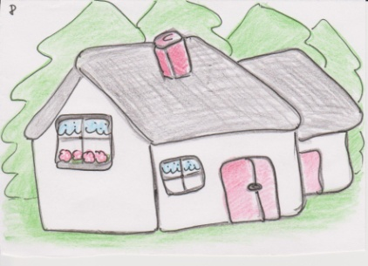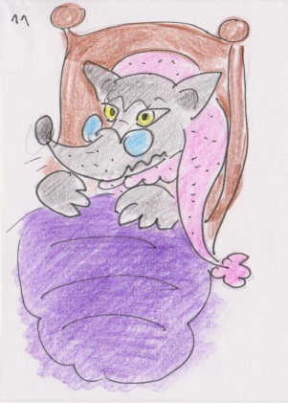
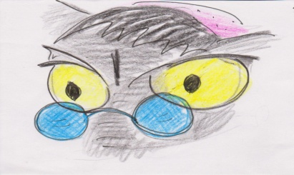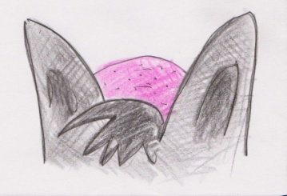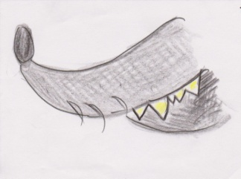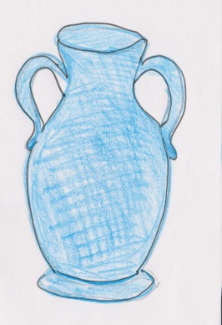
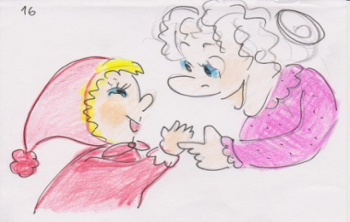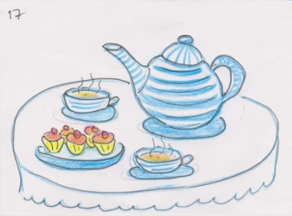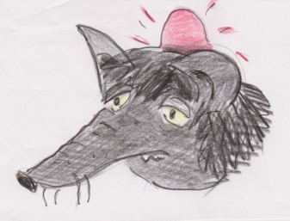
Řešení -
- uvedeno u každé části zvlášť.

Zdroj:
ELLIS, Gail a Penny HANCOCK. PEARSON EDUCATION. Pebbles 1: Teacher's Book 1. osmé. Edinbourgh Gate, Harlow, Essex CM20 2JE, England: Longman, 2004. ISBN 0 582 25908 8. Dostupné z: www.longman.com

