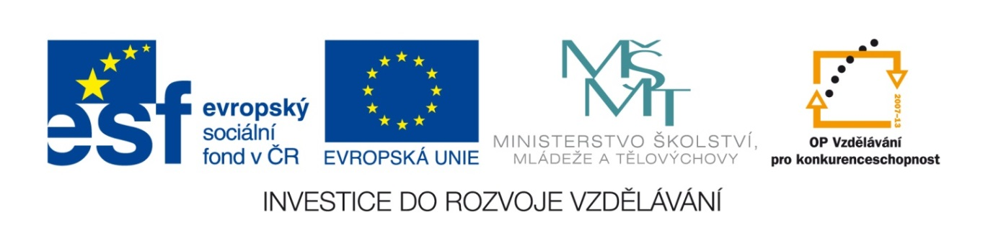
Základní škola a mateřská škola, Šaratice, okres Vyškov

III/2 Inovace a zkvalitnění výuky prostřednictvím ICT
VY_32_INOVACE_199

Jméno autora: Mgr. Zdena Černá
Datum vytvoření: květen 2012
Ročník: 7. – 9.
Vzdělávací oblast: Jazyk a jazyková komunikace
Vzdělávací obor: Anglický jazyk
Tematický okruh: Anglický jazyk VI. – IX. třída
Číslo projektu: CZ.1.07./1.4.00/21.1996

Pracovní list
Postup:
Podle potřeby si ujasněte slovní zásobu.
Cvičení A – spojte správně výrazy metaforické s jejich významy.
Cvičení B – doplňte správné výrazy do vět.
Cvičení C - doplňte chybějící slova.
Cvičení A a B/2 – doplňte chybějící slova.
Cvičení 1 a 2 – vypracujte jednoduchý cvičný test.
COLOUR IDIOMS 1: BLACK/ WHITE
A) Literal and non-literal meanings
- matching them up:
1. A black look is a. not serious and often saves embarrassment. (ztrapnění)
2. A white elephant is b. a dangerous road or corner.
3. A black sheep is c. different from the rest of the family.
4. The black economy is d. an angry one (=look).
5. A black picture is a e. in writing.
6. A black spot is f. something useless. (neužitečný)
7. A white lie is g. a depressing one.
8. In black and white means h. illegal.
B) Fill the gaps with these expressions:
a) white elephant b)white collars c)black and white d) white lie
e) black or white f)black and white 2 g)black spot h) black eye i) black look
1. I don’t really like Diane’s new robe, but I didn’t want to upset her (=naštvat ji),
so I told her a little ...............................................
2. Would you like ................................................ coffee?
3. I will believe that only when I see it in ................................................... .
4. Let’s sell that table. We never use and it just takes the space.
I know. It’ a bit of a ............................................. .
5. People who work in offices and administrative positions are called .................................................. .
6. I said “sorry” but he just gave me a ............................................... .
7. There are lots of accidents on this road all the year long. Be careful driving along there.
It’s a real ................................... .
8. How did you get that ....................................? Did you have a fight?
9. Warning in the Daily Telegraph: Thinking in ................................................ makes you see red.

C) Revision. Add the missing words.
1. This road is an accident black ............................. .
2. I told her a little white ............................. .
3. This table is a bit of a white ................................... .
4. She gave me a black ................................ .
5. People in offices and administrative are called white ................................ .
6. The black .............................. is illegal.
COLOUR IDIOMS 2: RED/ BLUE
A) Red or blue I:
1. Very important or famous people walk on a ........................ carpet.
2. In our mother tongue we say that bruises (modřiny) are .......................... or black.
3. When you are embarrassed (cítit se trapně) your face goes as ..................... as a beetroot.
4. .......................... colour makes bulls angry.
B) Red or blue II:
1. When something surprising or shocking happens it’s like a bolt (rána) out of the ........................... .
2. Our Italian partners were incredibly welcoming (vstřícní) – they gave us a ........................ carpet
treatment (zacházení).
3. Come on, Dan. It’s your birthday. Let’s go out and paint the town ............................. .
4. I love going to the cinema, but I don’t have much time. I go once in a .......................... moon.
5. A thief (zloděj) wanted to get into my handbag, but I caught him ......................... handed
and started to scream. (Just in time!)
6. When something makes you really angry it makes you see ............................. .
7. When I fell off my bike I was black and ............................ all over.

TEST:
(...Now do that once more again!)
1) MATCH BOTH PARTS OF THE SENTENCES
1. A black look is a. not serious and often saves embarrassment. (ztrapnění)
2. A white elephant is b. a dangerous road or corner.
3. A black sheep is c. different from the rest of the family.
4. The black economy is d. an angry one (=look).
5. A black picture is a e. in writing.
6. A black spot is f. something useless. (neužitečný)
7. A white lie is g. a depressing one.
8. In black and white means h. is a nickname for people in offices and administration
9. “White collars” (límečky) i. illegal.
2) COMPLETE THE MISSING WORDS
1. This road is an accident black ............................. .
2. I told her a little white ............................. .
3. This table is a bit of a white ................................... .
4. She gave me a black ................................ .
5. People in offices and administrative are called white ................................ .
6. The black .............................. is illegal.

1) MATCH BOTH PARTS OF THE SENTENCES
1. A black look is a. not serious and often saves embarrassment. (ztrapnění)
2. A white elephant is b. a dangerous road or corner.
3. A black sheep is c. different from the rest of the family.
4. The black economy is d. an angry one (=look).
5. A black picture is a e. in writing.
6. A black spot is f. something useless. (neužitečný)
7. A white lie is g. a depressing one.
8. In black and white means h. is a nickname for people in offices and administration
9. “White collars” (límečky) i. illegal.
2) COMPLETE THE MISSING WORDS
1. This road is an accident black ............................. .
2. I told her a little white ............................. .
3. This table is a bit of a white ................................... .
4. She gave me a black ................................ .
5. People in offices and administrative are called white ................................ .
6. The black .............................. is illegal.
Řešení:
1A) 1d, 2f, 3c, 4h, 5g, 6b, 7a, 8e
1B) 1d, 2e, 3f, 4a, 5b, 6i, 7g, 8h, 9c
1C) 1.spot, 2.lie, 3.elehhant, 4.look, 5.collars, 6.economy
2A) 1.red, 2.blue, 3.red, 4.red
2B) 1.blue, 2.red, 3.red, 4.blue, 5.red, 6.red, 7.blue

Zdroj:
WRIGHT, Jon. Idioms organiser: organised by metaphor, topic and key word. Editor Jimmie Hill, Morgan Lewis. Ilustrace Bil Stott. Hove: LTP - Language teaching publications, c1999, 296 s. ISBN 18-993-9606-3.

