

ZÁKLADNÍ ŠKOLA SLOVAN, KROMĚŘÍŽ, PŘÍSPĚVKOVÁ ORGANIZACE
ZEYEROVA 3354, 767 01 KROMĚŘÍŽ

projekt v rámci vzdělávacího programu
VZDĚLÁNÍ PRO KONKURENCESCHOPNOST

ŠABLONA ČÍSLO: III/2
NÁZEV: INOVACE A ZKVALITNĚNÍ VÝUKY PROSTŘEDNICTVÍM ICT

PŘEDMĚT: Anglický jazyk
ROČNÍK: 8. ročník
TÉMA: Making arrangements
AUTOR: Jana Veselá, DiS.
DATUM VYTVOŘENÍ: 14. 5. 2012

VY_32_INOVACE_33_JV

Anotace:
Výukovým materiálem je pracovní list, který slouží jako podpůrný materiál k 6. lekci ke knížce Project 2. Na tomto pracovním listě je na začátku vysvětleno, jakými způsoby můžeme někoho v angličtině někam pozvat nebo něco nabídnout pomocí výrazu shall. Ve druhé části žáci sami tvoří věty, kde použijí jeden z předepsaných způsobů pozvání.

Ilustrace: www.office.microsoft.com

Pilotáž:
Pilotáž byla provedena v hodinách anglického jazyka ve třídách 8. ročníku. Žáci si měli možnost natrénovat ustálené složení vět. Museli pochopit danou situaci a k ní adekvátně zareagovat.

Making arrangements 
- Let´s swim in the pool!
- Why don´t we swim in the pool?
- What about swimming in the pool!
- Shall we swim in the pool?
- Would you like to swim in the pool?
- Would you mind swimming in the pool?
- Shall I swim with you in the pool?

Let´s practise!

 | 1.You know that there is a good thriller on in the cinema. You don´t want to go alone. You ask your friend.  What ………………………………………………………………………………………..?
 | 2. There is open a new salsa club. You want your boyfriend to attend these lessons with you.  Why ………………………………………………………………………………………..?
 | 3.You like having fun. So you thinf that karaoke could be really funny. You ask your friends:  Shall ………………………………………………………………………………………..?
 | 4.You want to surprise your girlfriend. So you invite her to eat out. But you have booked the restaurant only for you and your girlfriend.  Would..............mind………………………………………………………………..?
 | 5.Your sister is cooking. You want to help her. So you ask:  Shall………………………………………………………………………………………………?
 | 6.You can see your neighbour carrying a lot of boxes and a bag. What do you say?  Shall……………………………………………………………………………………………….?
 | 7.You and your friend decided to go shopping. You need some help to choose the correct piece of clothes for you.  Would……………….mind…………………………………………………………………..?
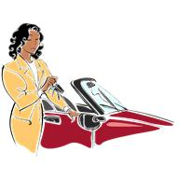 | 8.You have an appointment with your boyfriend but he is late. You aren´t sure if to wait for him.  Shall…………………………………………………………………………………………………?
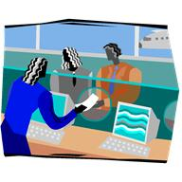 | 9.You are at the airport. Your wife is nervous to be late. So she asks:  Would ……………………….mind………………………………………., darling?
 | 10.You are at a party of your colleague. You are congratulating to him. And you want someone to take a photo of you. So you ask:  Why …………………………………………..………………………………..…….?
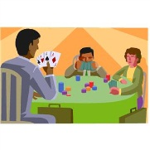 | 11.You want to play cards with your friends so you ask them:  Would………………………like…………………………………………..………?
 | 12.Your wife is in hospital. You are going to visit her and to stay at her for a while. You have also a bunch of flowers for her.  Would…………………………..mind…………………………………..……….?
 | 13.You are on your holidays at sea. You feel wonderful and you want to sunbathe there. So you say:  Let´s ………………………………………………………………………..…………?
 | 14.You are going for a business trip. Your husband is accompaigning you. The train has just arrived. You want to say good bye to each other.  Let´s……………………………………………………………………………..……..?
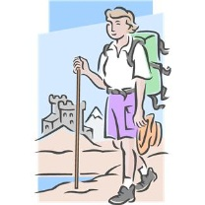 | 15.Finally you can have holidays. You want to go climbing because you love mountains.  What…………………………………………………………………………………….?
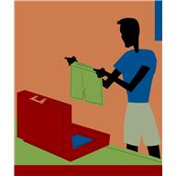 | 16.You are packing your suitcase. You want to be sure if to take green trunks with you so you ask:  Shall…………………………………………………………………………….…………?
 | 17.You know it is raining. But your dog needs to be taken for a walk.  Let´s……………………………………………………………………………………….?
 | 18.You adore winter sports. So you ask your boyfriend to go with you.  Would………………………..like……………………………………………………..?
 | 19.You had a really difficult day at work. You are calling to your friend to say that your meeting will be tomorrow.  Would…………………………..mind………………………………………………..?
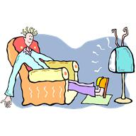 | 20.Your husband is watching TV but it is too loud. You ask him to tur nit down.  What………………………………………………………………………………………..?

RESULTS:
1.What about going to the cinema together to watch a wonderful thriller?
2. Why don´t we attend salsa lessons?
3. Shall we try karaoke?
4.Would you mind having dinner in a restaurant only me and you?
5.Shall I help you?
6.Shall I carry some of the boxes?
7.Would you mind helping me what to choose?
8.Shall I wait?
9.Would you mind hurrying up, darling?
10.Why don´t you take a photo of us?
11.Would you like to play cards with me?
12.Would you mind receiving these flowers?
13.Let´s sunbathe for a while.
14.Let´s say good bye.
15.What about going climbing?
16.Shall I take green trunks with me?
17.Let´s go for a walk.
18.Would you like to go skiing with me?
19.Would you mind meeting tomorrow?
20.What about turning the TV down?

