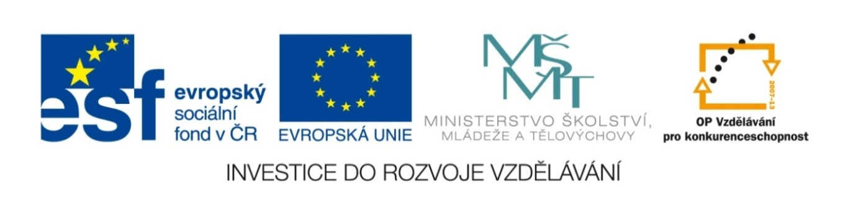

Název školy | Gymnázium, střední odborná škola, střední odborné učiliště a vyšší odborná škola, Hořice
Číslo projektu | CZ.1.07/1.5.00/34.0873
Název materiálu | VY_22_INOVACE_01.01.10  EU2, U2 - Celebrations
Autor | Mgr. Ivana Chalupová
Tematická oblast | Podpora učebnice Eurolingua English
Ročník | druhý
Datum tvorby | 28.10. 2012
Anotace | Cvičení zaměřená na procvičení poslechových dovedností, vycházejí z textů na str.30-31, EU2. Instrukce k písemné domácí kompozici.
Metodický pokyn | Použít cvičení 2 bez učebnice, pouze s poslechovým CD – kontrola následně podle textů v uč.

EUROLINGUA 2, UNIT 2

EXERCISE 1 – SPELLING PRACTICE, PAGE 30

Fill in the missing vowels and then match each holiday with the right day.

- Chr__stm__s D__y a) February 14th
- G__y F__wk__s N__ght b) July 4th
- H__ll__w__ __n c) October 31st
- Ind__p__nd__nc__ D__y d) November 5th
- N__w Y__ __r´s __v__ e) the fourth Thursday in November
- Th__nksg__v__ng D__y f) December 25th
- V__l__nt__n__´s D__y g) December 31st

EXERCISE 2 - LISTENING PRACTICE, PAGES 30-31

Listen and answer the questions.

Valentine´s Day - How do people celebrate it?

Independence Day – Why do people celebrate it? How do people celebrate it?

Halloween - Why? How?

Guy Fawkes Night - Why? How?

Thanksgiving Day - Why? How?

Christmas Day - How?

New Year´s Eve - How?

EXERCISE 3 – WRITING PRACTICE

Home Project – HOLIDAYS

Write about one holiday you particularly like. You could write about a typical Czech holiday or a holiday which is celebrated in English-speaking countries. In your project you have to answer following questions:

1. When do people celebrate the holiday?
2. Why do people celebrate it?
3. How do people celebrate it?
4. How do you personally celebrate the holiday? – if you write about a Czech holiday
5. Why do you like the holiday?

There must be 3-4 paragraphs, 180-200 words altogether. Type your essay in Times New Roman, size 12, spacing of lines 1,5. Add some pictures, at least one. Print your essay – each page on a separate sheet of paper, so that it could be displayed.

KEY TO EXERCISE 1 – SPELLING PRACTICE, PAGE 30

Fill in the missing vowels and then match each holiday with the right day.

- ChrIstmAs DAy - F a) February 14th
- GUy FAwkEs NIght - D b) July 4th
- HAllOwEEn - C c) October 31st
- IndEpEndEncE DAy - B d) November 5th
- NEw YE Ar´s EvE - G e) the fourth Thursday in November
- ThAnksgIvIng DAy - E f) December 25th
- VAlEntInE´s DAy - A g) December 31st

KEY TO EXERCISE 2 - LISTENING PRACTICE, PAGES 30-31

Listen and answer the questions.

Valentine´s Day - How do people celebrate it?
- SEND CARDS, LITTLE PERESENTS OR FLOWERS TO THEIR SWEETHEARTS OR FRIENDS

Independence Day – Why do people celebrate it? How do people celebrate it?
- TO CELEBRATE THEIR COUNTRY´S BIRTHDAY
- WITH PUBLIC FIREWORKS, HAVE PARTIES OR PICNICS WHERE THEY EAT TRADITIONAL AMERICAN FOOD

Halloween - Why? How?
- TO CELEBRATE THE END OF SUMMER, THE FESTIVAL OF THE DEAD
- CHILDREN GO FROM HOUSE TO HOUSE AND ASK ´TRICK OR TREAT´, MAKE JACK-O´-LANTERNS FROM PUMPKINS

Guy Fawkes Night - Why? How?
- TO REMEMBER GUY FAWKES WHO TRIED TO KILL KING OF ENGLAND
- PEOPLE MAKE BONFIRES AND BURN A FIGURE OF GUY FAWKES

Thanksgiving Day - Why? How?
- TO REMEMBER THE ENGLISH PILGRIMS AND THEIR FIRST HARVEST IN AMERICA
- PEOPLE HAVE TRADITIONAL DINNER WITH TURKEY

Christmas Day - How?
- PEOPLE DECORATE CHRISTMAS TREE, HAVE CHRISTMAS DINNER WITH TURKEY AND PUDDING, FIND PRESENTS IN STOCKINGS OR IN FRONT OF THE FIREPLACE

New Year´s Eve - How?
- PEOPLE GO TO TRADITIONAL GATHERING POINTS, JOIN HANDS AND SING ´AULD LANG SYNE´

