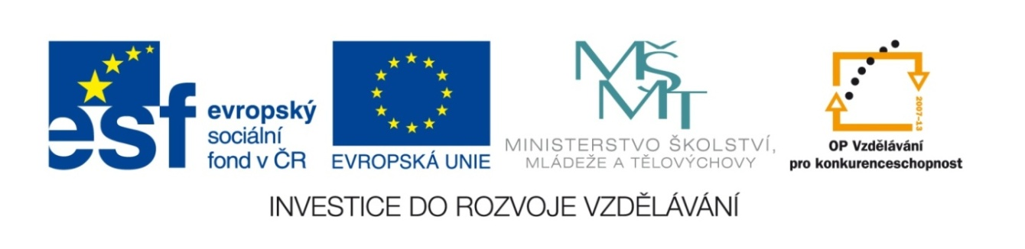

Název školy | Gymnázium, střední odborná škola, střední odborné učiliště a vyšší odborná škola, Hořice
Číslo projektu | CZ.1.07/1.5.00/34.0873
Název materiálu | VY_22_INOVACE_01.01.29  EU3, Unit 14 (part 4) - test
Autor | Mgr. Ivana Chalupová
Tematická oblast | Podpora učebnice Eurolingua English
Ročník | čtvrtý
Datum tvorby | 5.3.2013
Anotace | Čtvrtá sada cvičení k EU3,U14 – test.
Metodický pokyn | Test na slovní zásobu k lekci a trpný rod.

EU3, Unit 14 - test

Vocabulary test 40 points

1. Fill in the gaps with a suitable word. 10p
1. In cities the air is hard to breathe because of … . 2. We should use things again and again – we should … them rather than WASTE them. 3. It would be a good idea to … more trees, not to cut them down. 4. The giant panda is an endangered … . There are fewer than a thousand living in the wild. 5. The problem is that their … - their natural environment – is disappearing. 6. In 1985 it was noticed that there was a hole in the ozone … over the Antarctic. 7. There are now more than 800 nuclear … stations throughout the world. 8. An increase in the amount of carbon … is responsible for about half the total warming. 9. Chemical changes in the atmosphere result in … rain. 10. People should be encouraged to … environment, rather than destroy it.

2. Translate the words and then use them to complete the sentences below: 11p+6p
jedovatý – ochrana – odpadky – skleníkový (2x) - spotřeba - vědci – vláda - vyhynutí – dopravní zácpa - zachránit – (z)ničení –
1. If the amount of … gases is not reduced, the average global temperature will rise. 2. Our car-based transport system leads to … … . 3. … are trying to … Siberian tiger. 4. … of rain forests should be stopped. 5. Private households shouldn´t increase their … . 6. … gases from factories contribute to the … effect. 7. The … of our environment is very important. 8. Which wild animals are most threatened by … ? 9. We should sort out the … and throw it away to special containers. 10. … should force companies to use better technology and alternative sources of energy.

3. Translate the words in boxes in ex. 1,2 into Czech. 10p

4. What animals can you see in the photos? 3p
1 2 3 4
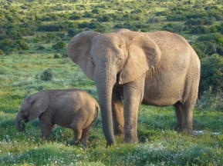
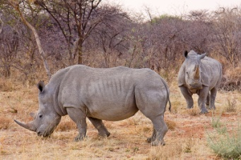
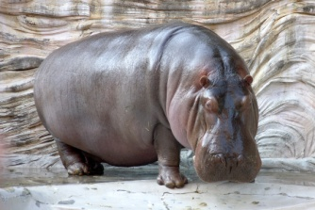
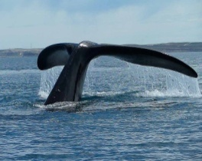

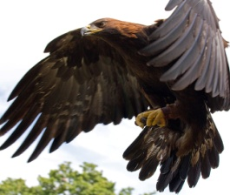
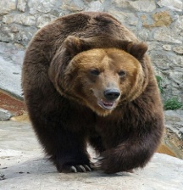

5 6

Grammar test 12 points

1. Put the verbs in brackets into the passive, use the tense as indicated. 4p
1. Edible plants (use – present simple) to fight hunger. 2. A large area of tropical rainforest (cut – past simple) down last year. 3. More cycle paths (create – present perfect simple) in cities. 4. Biological diversity (reduce – present continuous).

2. Transform the imperatives into a passive sentences, using modals (should, must, could). 4p
1. Offer free public transport! 2. Build more cycle paths! 3. Ban cars from city centres! 4. Raise the price of petrol!

3. Change the following active sentences into passives: 4p
1. Students collect the information. 2. Students collected the information. 3. Students have collected the information. 4. Students will collect the information.

VOCABULARY KEY:

Exercise 1
- pollution 2. recycle 3. plant 4. species 5. habitat 6. layer 7. power 8. dioxide 9. acid 10. protect

Exercise 2
1 bod za správný překlad = celkem 11 bodů
0,5 bodu za správné umístění = 6 bodů
- greenhouse 2. traffic jam/congestion 3. scientists, save 4. consumption 6 Toxic/Poisonous, greenhouse 7. protection 8. extinction 9. rubbish/waste/trash 10. government

Exercise 3
plýtvat – ohrožený – mizet – nárůst – zničit – snížit/omezit – zvýšit – domácnosti – ohrožený – zdroje

Exercise 4
- whale 2. elephant 3. rhino – 4. hippo – 5. eagle – 6. bear

Evaluation:
1: 40 – 36
2: 35 – 32
3: 31 – 24
4: 23 – 20
5: 19 - 0

GRAMMAR KEY

Exercise 1
- are used 2. was cut 3. have been created 4. is being reduced

Exercise 2
- Free public transport should/must/could be offered. 2. More cycle paths should/must/could be built. 3. Cars from city centres should/must/could be banned. 4. The price of petrol should/must/could be raised.

Exercise 3
- The information is collected. 2. The info was collected. 2. The info has been collected. 4. The info will be collected.

Evaluation:
1: 12 – 11
2: 10
3: 9 – 7
4: 6
5: 5 – 0

Zdroje obrázků ve cvičení 4:
- http://commons.wikimedia.org/wiki/File:Staart_van_een_Zuidkaper.jpg, licence CC, autor: E. Schreurs
- http://en.wikipedia.org/wiki/File:African_Bush_Elephants.jpg, licence PD
- http://upload.wikimedia.org/wikipedia/commons/1/17/Hippopotamus_-_04.jpg, licence CC, autor: Kabacchi
- http://en.wikipedia.org/wiki/File:Waterberg_Nashorn2.jpg, licence CC, autor: Ikiwaner
- http://en.wikipedia.org/wiki/File:Golden_Eagle_in_flight_-_5.jpg, licence CC, autor: Tony Hisgett
- http://en.wikipedia.org/wiki/File:Medved_mzoo.jpg, licence PD
Staženo 5/3 - 2013

