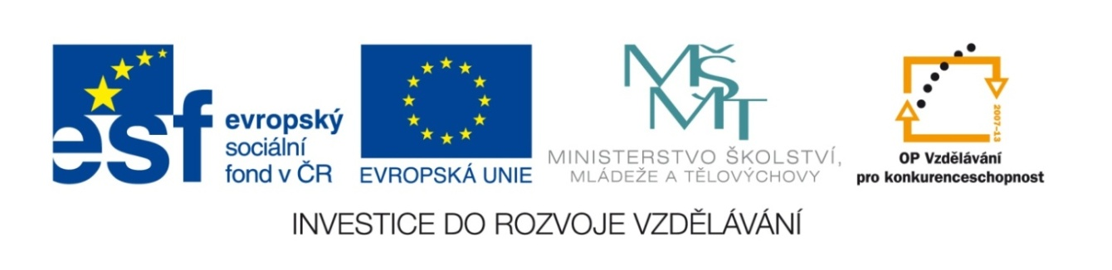

Název školy | Gymnázium, střední odborná škola, střední odborné učiliště a vyšší odborná škola, Hořice
Číslo projektu | CZ.1.07/1.5.00/34.0873
Název materiálu | VY_22_INOVACE_01.01.31  EU2, TEST UNITS 7 – 8
Autor | Mgr. Ivana Chalupová
Tematická oblast | Podpora učebnice Eurolingua English
Ročník | druhý
Datum tvorby | 10.4.2013
Anotace | Test k Units 7- 8.
Metodický pokyn | Testování / opakování mluvnice a slovní zásoby.

TEST UNITS 7 – 8

USE OF ENGLISH TOTAL 40 POINTS

1. Write the correct form of the verbs in brackets. Use the present – simple or continuous. 10 points
1. I … (drive) from London to Brighton three times a week. 2. I … (meet) the headmaster this afternoon. 3. She … (not / have) lunch with Peter tonight. 4. Nick … (want) to go shopping. 5. At the moment Sue … (study) at university. 6. Her father often … (take) an hour to read a newspaper. 7. … (he / buy) a bottle of milk every morning? 8. Jane usually … (wear) jeans and a T-shirt to school. 9. … (they / come) to the party tomorrow morning? 10. Mr Brown … (not like) hamburgers.

2. Choose the correct verb form. 5 points
1. I usually get up / am getting up at 7. 2. This car doesn´t belong / isn´t belonging to me.. 3. He doesn´t watch / isn´t watching TV in the evenings. 4. I know / am knowing her. 5. I have / am having 2 brothers. 6. On Tuesday I leave / am leaving for London. 7. He has / is having a bath just now. 8. Speak up! I can´t hear / am not hearing you! 9. Where do go / are you going on Tuesdays? 10. Where do you you go / are you going every Friday?

3. Give a short answer. 10 points
1. Is there a desk? Yes, … . 2. Were there any plants? No, … 3. Are there any English books? No, … 4. Have your grandparents got a dog? No, … 5. Does your father help you with HW? Yes, … . 6. Did you help him yesterday? Yes, … 7. Can you speak Japanese? No, … 8. Are you sleeping? No, … 9. Is a pumpkin vegetable? Yes, … .10. Was Peter at school last week? No, …

4. Form questions about underlined words. 10 points
1. He is 20 years old. 2. I was at home. 3. He has got 2 children. 4. I fell off the bike yesterday. 5. Mum is preparing supper. 6. Peter left his wife because he stopped loving her. 7. The name of his new lover is Jane. 8. My mum bought meat at the local butcher´s. 9. My dad drives very fast. 10. It´s 4pm.

5. Write the –ing ending. 5 points
1. eat 2. smoke 3. shop 4. cry 5. lie 6. begin 7. buy 8. put 9. read 10. run

VOCABULARY TOTAL 40 POINTS
1. Put the conversation in the correct order. 7 points
- Thank you. How much is it?
- Yes, we have. Here you are.
- Excuse me, can I try this coat on?
- £120.
- I´m afraid this colour isn´t quite what I want. Have you got it in dark blue?
- Yes, of course. You can try it on here. … Any luck?
- Right. I think I´ll have it, please.

1. … 2. … 3. … 4. … 5. … 6. … 7. …

2. Translate following expressions into English. 20 points
- pruhovaná kravata 6. jednobarevný propínací svetr
- puntíkaté punčocháče 7. kostkovaná košile
- vzorovaná šála / šátek 8. šaty a sukně
- boty na podpatku, kozačky 9. pásek, ponožky
- náušnice, hodinky 10. podprsenka, plavky

3. Look at these phrases from a conversation between a shop assistant (=S) and a customer (=C). Who says which phrase? Write S or C. 4 points
- Can I help you? 5. Can I try it on?
- It suits you. 6. It doesn’t fit me.
- It looks nice. 7. The changing rooms are over there.
- How much is it? 8. I’m just looking, thanks.

4. What would you say in the following situations? 4 points
1. You are trying on a jumper but it is too large. 2. You are looking at a green blouse. You like it, but you need a blue blouse to wear it with your trousers. 3. The suit fits and you want to buy it. 4. You are trying on a pair of trousers but they are too tight.

5. Fill in ONE word. 8 points
1. What … are you? – 14, I think. 12 would be too tight for me. 2. You look … in that blouse! It really suits you. 3. This blouse is too long. Do you have a … one? 4. Can I try … those black shoes? 5. It is raining. She is … a raincoat and holding an umbrella. 6. Do you … my help? 7. I think the blouse doesn´t fit. Why … you try another one? 8. I´m looking … a blouse.

KEY TO GRAMMAR TEST

Ex.1:
- drive
- am meeting
- isn´t having
- wants
- is studying
- takes
- Does he buy
- wears
- are they coming
- doesn´t like

Ex.2:
- get up
- doesn´t belong
- doesn´t watch
- know
- have
- am leaving
- is having
- can´t hear
- do you go
- do you go

Ex.3:
- there is
- there weren´t
- there aren´t
- they haven´t
- he does
- I did
- I can´t
- I´m not
- it is
- he wasn´t

Ex.4:
- How old is he?
- Where were you?
- How many children has he got?
- Whe did you fall off the bike?
- What is my preparing?
- Why did Peter leave his wife?
- What is the name of his new lover?
- Where did my mum buy meat?
- How does my dad drive?
- What´s the time?

Ex.5:
- eating
- smoking
- shopping
- crying
- lying
- beginning
- buying
- putting
- reading
- running

EVALUATION
1: 40 – 36
2: 35 – 32
3: 31 – 24
4: 23 – 20
5: 19 – 0

KEY TO VOCABULARY TEST

Ex.1:
1c, 2f, 3e, 4b, 5a, 6d, 7g

Ex.2:
- striped tie
- dotted tights
- patterned scarf
- high heels, boots
- earrings, watch
- solid cardigan
- checked shirt
- dress and skirt
- belt, socks
- bra, swimsuit/trunks

Ex.3:
1S, 2S, 3S, 4C, 5C, 6C, 7S, 8C

Ex.4:
- Have you got a smaller one?
- Have you got this blouse in blue?
- I´ll take it.
- Have you got any bigger ones?

Ex.5:
- size
- wonderful/great
- shorter
- on
- wearing
- need
- don´t
- for

EVALUATION
1: 40 – 36
2: 35 – 32
3: 31 – 24
4: 23 – 20
5: 19 – 0

