Číslo projektu | CZ.1.07/1.5.00/34.0479
Číslo materiálu | VY_32_INOVACE_IVA_DVORAKOVA_Manicure_11
Název školy | Střední škola služeb, obchodu a gastronomie Hradec Králové
Ročník | Třetí, čtvrtý
Vzdělávací oblast | Anglický jazyk
Vzdělávací obor | 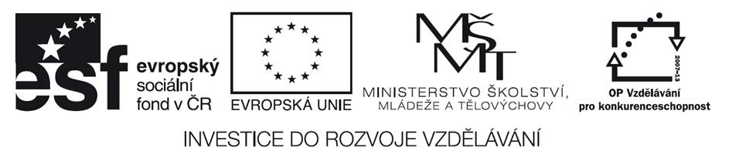  Kosmetické služby
Tematický okruh | Odborná terminologie k oboru
Téma | Manicure
Jméno autora | Mgr. Iva Dvořáková
Vytvořeno dne | 6.4.2013
Metodický popis (anotace) | Pracovní list uvádí a procvičuje novou slovní zásobou týkající se manikúry v salónu. Je vytvořen v programu Microsoft Word 2010.
Manicure

Manicure
- Match the manicure tools with their descriptions.

1. Nail clippers | a) is a bowl in which fingers are soaked before a manicure.
2. Nail brush | b) is applied after manicure to keep cuticles soft.
3. Finger bowl | c) is used to cut nails shorter.
4. Emery board | d) cuts rough cuticles or hangnails.
5. Buffer | e) is a brush used with soap and water to clean the nails.
6. Cuticle oil | f) is used for shaping and smoothing the edges of nails.
7. Orange stick | g) makes nails look very shiny.
8. Cuticle trimmer | h) used to push back the cuticles on the nails

1. |  | 2. |  | 3. |  | 4. |  | 5. |  | 6. |  | 7. |  | 8.

- Complete the text with the words from exercise 1.
Manicure steps
First, trim your nails to the desired length with the 1_______________ . Use an 2 ____________ to shape and smooth the edges of the nails. Be sure to move the board in one direction to avoid rough edges.
Second, fill a 3 __________________ with a warm soapy water and soak fingers or hands. Use 4 ______________ to clean under and around the nails.
Third, put 5 _______________ on your cuticles to make them soft. After that, use an 6 ______________ to push your cuticles back gently. Then, trim cuticles with a 7 _____________________ .
Finally, shine your nails with a 8 ____________ and a massage hands with a moisturizing cream.

- Do the crossword.
We hold things with it. H _ _ _ 4/3
Procedure in which we take care of our nails M _ _ _ _ _ _ _ 8/2
A part of the hand F _ _ _ _ _ 6/2
To put colour on a nail P _ _ _ _ _ 6/3
The thing you wash your hands with. S _ _ _ 4/1
_ _ _ _ _
Key:
1.
1. | c | 2. | e | 3. | a | 4. | f | 5. | g | 6. | b | 7. | h | 8. | d

2.
1.nail clippers, 2.emery board, 3.finger bowl, 4.nail brush, 5.cuticle oil, 6.orange stick, 7.cuticle trimer, 8.buffer
3.
Hand, manicure,finger, polish, soap
Puzzle- NAILS

Použité zdroje :
- DOOLEY, Jenny; EVANS, Virginia. Beauty Salon. Newbury: Express Publishing, 2011, ISBN 978-0-85777-849-9.

Pokud není uvedeno jinak, použitý materiál je z vlastních zdrojů autora



