Skincare
Číslo projektu | CZ.1.07/1.5.00/34.0479
Číslo materiálu | VY_32_INOVACE_IVA_DVORAKOVA_SKINCARE_20
Název školy | Střední škola služeb, obchodu a gastronomie Hradec Králové
Ročník | Třetí, čtvrtý
Vzdělávací oblast | Anglický jazyk
Vzdělávací obor | 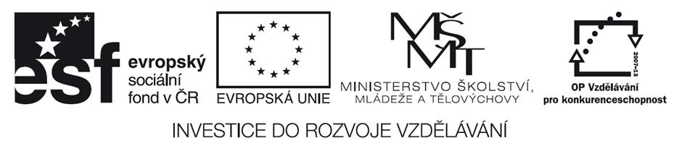  Kosmetické služby
Tematický okruh | Odborná terminologie k oboru
Téma | Skincare
Jméno autora | Mgr. Iva Dvořáková
Vytvořeno dne | 15.10.2013
Metodický popis (anotace) | Pracovní list uvádí a procvičuje novou slovní zásobou týkající se péče o pleť v salónu. Může navazovat na prezentaci Skincare. Je vytvořen v programu Microsoft Word 2010.

SKINCARE
- Match the skin treatments with their descriptions.

moisturizing | removing makeup, refining and minimizing pores
cleansing | applying skin cream to make skin look smooth and moisturised
anti-aging | Scrubbing off dead skin cells
toning | removing makeup , cleaning pores
exfoliate | a strong protection against the sun

- Put the facial treatments in a salon in the right order. Write numbers 1-8 in the first column.

deep pore cleansing
a relaxing face massage
moisturising
cleansing
applying a mask
steaming
applying makeup
gentle scrub

- Match the words with the titles they are connected to.

acne, normal, dry, blackheads, T- zone, toning, capillaries, cleansing, mask, rash, a mascara, nightcream, self tanning cream, combination, scrub, foundation

Skin problems | Facial treatments | Skin types | Cosmetic products

- Do the puzzle.

- A skin type 3/6 (N)
- It hides skin problems on your face 2/9 (C)
- A treatment which removes dead skin cells 4/5 (S)
- A liquid that reduces oiliness 1/5 (T)
- A natural cover of a person, animal, etc. 3/4 (S)
- A skin problem especially at teen age 3/4 (A)
- A liner that defines eyes 1/8 (E)

Skin _ _ _ _ _ _ _ _
Key:
1.
moisturizing | applying skin cream to make skin look smooth and moisturised
cleansing | removing makeup , cleaning pores
anti-aging | a strong protection against the sun
toning | removing makeup, refining and minimizing pores
exfoliate | scrubbing off dead skin cells

2.
3 | deep pore cleansing
5 | a relaxing face massage
7 | moisturising
1 | cleansing
6 | applying a mask
2 | steaming
8 | applying makeup
4 | gentle scrub

3.
Skin problems | Facial treatments | Skin types | Cosmetic products
acne | mask | normal | self tanning cream
blackheads | scrub | dry | nightcream
rashes | cleansing | T-zone | a mascara
capillaries | toning | combination | foundation

4.
a) normal b)concealer c)scrub d)toner e)skin f)acne g)eyeliner
SKIN ROUTINE

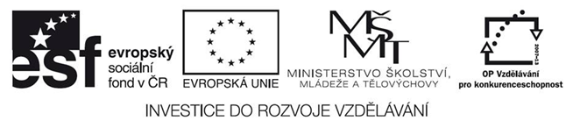
Použité zdroje :
- DOOLEY, Jenny; EVANS, Virginia. Beauty Salon. Newbury: Express Publishing, 2011, ISBN 978-0-85777-849-9.

Pokud není uvedeno jinak, použitý materiál je z vlastních zdrojů autora

