Název školy: Základní škola T. G. Masaryka a Mateřská škola Poříčany, okr. Kolín
Autor: Mgr. Alena Černá
Název: VY_32_INOVACE_AJ_14_Slumdog millionaire

Číslo projektu: CZ1.07/1.4.00/21.3085

Anotace:
Materiál slouží jako pracovní list k ověření pochopení a porozumění autentického videozáznamu – ukázky z filmu Milionář z chatrče.

Použité zdroje:
Ukázky z filmu Slumdog Millionaire (Milionář z chatrče, Velká Británie, 2008. Režie: Danny Boyle, Scénář: Simon Beaufoy)
Obrázky jsou dostupné z Wikipedia Commons online [cit. 2013-21-05]:
- obr. 1
http://commons.wikimedia.org/wiki/File:Emblem_of_India.svg?uselang=cs
Státní znak je majetkem státu Indie

- obr. 2
http://commons.wikimedia.org/wiki/File:Usdollar100.jpg

- obr. 3
http://commons.wikimedia.org/wiki/File:Colt_1630.jpg

- obr. 4
http://commons.wikimedia.org/wiki/File:Taj_Mahal_in_March_2004.jpg
Copyright (C) 2004 Dhirad


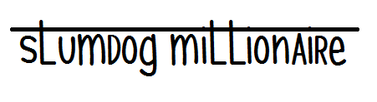

In the show “Who wants to be a Millionaire”, people get 3 lifelines
ask the audience fifty-fifty phone a friend

Now, imagine you are on the show, could you answer these questions? Go on and try:

1. Who was the star in the 1973 hit film "Zanjeer"?
a) …………………………………………… …………………………………………rupees
obr.1
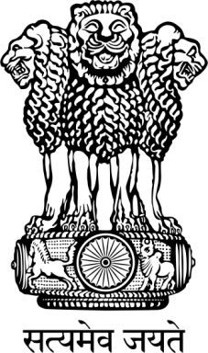
2. A picture of three lions is seen in the national emblem of India. What is written underneath it?
a) The truth alone triumphs
b) Lies alone triumph
c) Fashion alone triumphs
d) Money alone triumphs …………………………………………Rs
3. In depiction of God Rama, he is famously holding what in his right hand?
a) A flower
b) A sword
c) A child
d) A bow and arrow …………………………………………Rs
4. The song "Darshan Do Ghanshyam" was written by which famous Indian poet?
a) Surdas
b) Tulsidas
c) Mira Bai
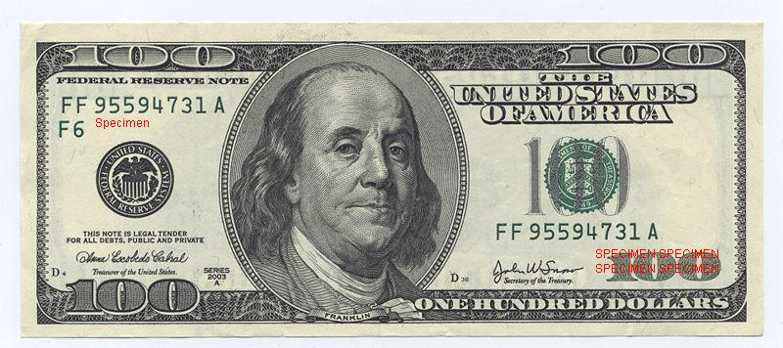
d) Kabir …………………………………………Rs
5. On an American One Hundred Dollar Bill, there is a portrait of which American statesman?
a) George Washington
b) Franklin Roosevelt
c) Benjamin Franklin
d) Abraham Lincoln
obr.2
…………………………………………Rs
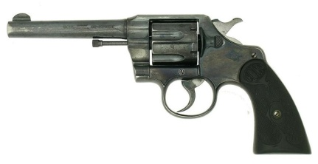
6. Who invented the revolver?
a) Samuel Colt
obr.3
b) Bruce Browning
c) Dan Wesson
d) James Revolver …………………………………………Rs
7. Cambridge Circus is in which UK City?
a) Oxford
b) Leeds
c) Cambridge
d) London …………………………………………Rs
8. Which cricketer has scored the most first-class centuries in history?
a) Sachin Tendulkar
b) Ricky Ponting
c) Michael Slater
d) Jack Hobbs …………………………………………Rs
9. In Alexander Dumas' book "The Three Musketeers", two of the musketeers are called Athos and Porthos. What is the name of the third Musketeer?
a) Aramis
b) Cardinal Richelieu
c) D’Artagnan
d) Planchet …………………………………………Rs
Now watch the film and
- Check your answers
- Complete the amount of money (in rupees) each question was worth (…………………Rs)
- Draw the signs of the lifelines with the questions they were used for

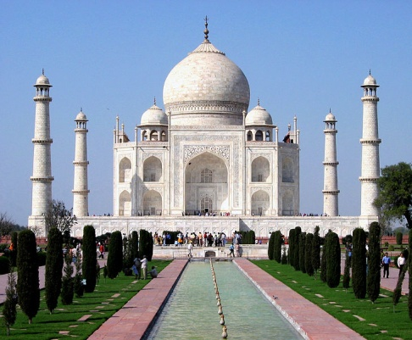

What is the name of this Palace?

……………………………………………
obr.4

