Název školy: Základní škola T. G. Masaryka a Mateřská škola Poříčany, okr. Kolín
Autor: Mgr. Alena Černá
Název: VY_32_INOVACE_AJ_18_Tour the States

Číslo projektu: CZ1.07/1.4.00/21.3085

Anotace:
Pracovní list zaměřený na zajímavosti USA, aktivity spojené s audio a video ukázkou, porozumění autentickému materiálu volně dostupnému na webových stránkách youtube.com na adrese: http://www.youtube.com/watch?v=_E2CNZIlVIg


Tour the USA Worksheet
Pre-watching activity:
1. Make a list of words and images which flash in your head when you hear „the USA“.
………………………………………………………………………………………………………………………………………………………………………………………………………………………………………………………………………………………………………………………………………………………………………………………………………………………………………………………………………………………

2. How many states of the USA can you name? Can you label them in the map?
………………………………………………………………………………………………………………………………………………………………………………………………………………………………………………………………………………………………………………………………………………………………………………………………………………………………………………………………………………………
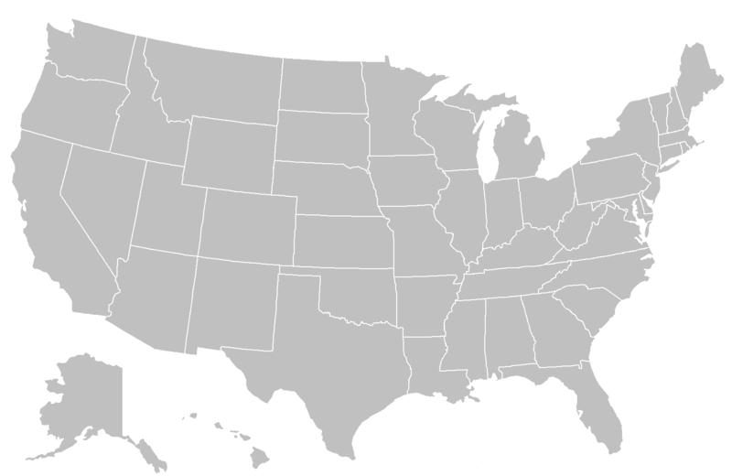
http://commons.wikimedia.org/wiki/File:BlankMap-USA-states.PNG

While-watching activity:
Read the instructions of following tasks, play YouTube video http://www.youtube.com/watch?v=_E2CNZIlVIg
3times and try to complete as many information as you can while watching it.
1. Write down the capitals of the states:

a) California ……………………………………………
b) Florida ……………………………………………
c) Texas ……………………………………………
d) Tennessee ……………………………………………
e)Nevada ……………………………………………
f)Arizona ……………………………………………
g) New York ……………………………………………

How does the person travel from Madison Wisconsin to Trenton, New Jersey? ……………………….…………

2. Complete with the correct state.
Springfield is the capital city of ……………………………………………
Where do people live in igloos? ……………………………………………
Where can you travel by steamboat? ……………………………………………
Where can you find Mount Rushmore National Memorial with sculptures of the heads of four United States presidents: George Washington, Thomas Jefferson, Theodore Roosevelt and Abraham Lincoln? ……………………………………………

3. What states are these attributes typical for?

a) sunshine ……………………………………………
b)surfing ……………………………………………
c) skiing ……………………………………………
d) president Lincoln ……………………………………………
e) fishing ……………………………………………
f) capitol ……………………………………………
g) pine trees ……………………………………………
h)alligators ……………………………………………

Post-watching actvities:
1. Get back to the map of the USA, can you label some more of the states? Sure you can, so go ahead.
2. Watch the video again, pause when necessary and check you aswers.
3. What did you find interesting? What did you like?
………………………………………………………………………………………………………………………………………………………………………………………………………………………………………………………………………………………………………………………………………………………………………………………………………………………………………………………………………………………………………………………………………………………………………………………………………………………………………………………………………………………………………………………………………………………………………………………………………………………………………………………………………………………………………………………………………………………………………………

