Název školy: Základní škola T. G. Masaryka a Mateřská škola Poříčany, okr. Kolín
Autor: Mgr. Alena Černá
Název: VY_32_INOVACE_AJ_20_Donald Duck

Číslo projektu: CZ1.07/1.4.00/21.3085

Anotace:
Materiál slouží jako pracovní list k ověření pochopení a porozumění autentického čteného textu. Dále slouží jako zdroj informací pro diskusi zjištěných informací, žáci tak rozvíjí nejen dovednost čtení, ale také mluvení.

Použité zdroje:
Zdroj informací pro text na plakátu: The Disney wiki: Donald Duck. [online]. [cit. 2013-05-23]. Dostupné z: http://disney.wikia.com/wiki/Donald_Duck
Obrázek na plakátu:

Donald Duck - The Spirit of '43. In In: Wikimedia commons [online]. [cit. 2013-05-23]. Dostupné z: http://commons.wikimedia.org/wiki/File:Donald_Duck_-_The_Spirit_of_%2743_%28cropped_version%29.jpg?uselang=cs

 Obrázek Worksheet: galerie Microsoft Office Klipart Gallery online [cit. 2013-05-23].
Worksheet:
Look at that, there is something going on with Donald Duck. Act like a great detective and find out what it is. There is a poster somewhere in the school. Go on, find the poster and you figure it all out.
So what is the big fuss about? ……………………………………………………………………
…………………………………………………………………………………………………………………………………………
Use the poster as a source of information and answer the following questions.
1. What is Donald Duck’s whole name?
…………………………………………………………………………………………………………………………………………
2. When is Donald Duck’s birthday?
…………………………………………………………………………………………………………………………………………
3. What is the title of Donald Duck’s first film?
…………………………………………………………………………………………………………………………………………
4. What is Donald Duck’s most famous personality trait?
…………………………………………………………………………………………………………………………………………

Well done Now can you draw Donald Duck in some crazy situation?

Poster

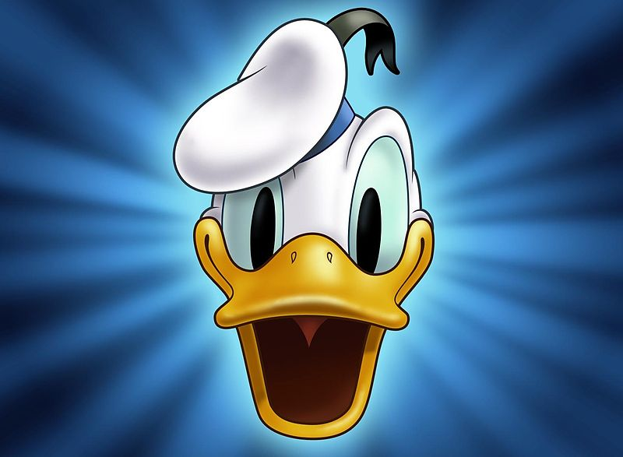Hey,
Welcome to our
Birthday party

9th June is a great day
What happened?
One of the most famous and very popular cartoon characters was born.
So I say, let’s get the party started…

Donald Fauntleroy Duck is an American cartoon character created by Walt Disney and Dick Lundy. Donald is a white duck with a yellow-orange bill, legs, and feet. He typically wears a sailor suit with a cap and a black or red bow tie. Donald's most famous personality trait is his easily provoked and explosive temper. He also experiences bad luck in almost all his cartoon appearances.
Along with his friend Mickey Mouse, Donald is one of the most popular Disney characters and was included in TV Guide's (which is a famous TV magazine) list of the 50 greatest cartoon characters of all time in 2002.
Donald's birthday is officially recognized as June 9, 1934, the day his debut film, The Wise Little Hen, was presented.

