EU peníze školám
  - Základní škola Čachovice a Mateřská škola Struhy, Komenského 96, příspěvková organizace
Označení: VY_32_INOVACE_43_PoSlzAj8
Předmět: Anglický jazyk
Ročník: 8.
Téma: Music in English
Název: Marc Cohn - True Companion
Autor: Mgr. Vlasta Kouříková
Popis: Pracovní list s textem se záměrnými chybami, jednoduchá cvičení a křížovka na slovní zásobu písně

Metodika k materiálu:
Žáci během prvního poslechu podtrhají chyby v textu. Při druhém poslechu zapisují správné slovo vedle řádku, ve kterém je chyba. Dále pracují se slovní zásobou článku podle zadání jednotlivých úkolů.

Marc Cohn - True Companion
Baby I've been looking like everyone else
Can't say nothing else about myself
Sometimes I'm an devil
And sometime I'm mean
And when it goes to love
I'm just another idiot
Yes I'll climb a hill
I'm gonna swim the ocean
There ain't no act of God woman
Could protect you safe from me

My hands are reaching out
Out across the valley
I'm telling you to be my true companion
True companion
True companion

So don't you dare and try to run away
I've got my heart set on our wedding night
I've got this vision of a girl in black
Made my decision that it's you o.k.
And when I have your hand
I'll see my heart set sail
I'll take my shaking fingers
And I'll lift up you veil
Then I'll take you to your house
And with wild abandon
Make love to you just as a true companion
You are my true companion
True companion

When the years have done
Irreparable damage
I can see us walking quickly arm in arm
Just like that couple on the corner make
'Cause women I will always be in love with you
And when I watch in your eyes
I'll still see that light
Until the shadows fall
Until the room grows light
Then when I leave this planet
I'll be with the devil standin'
I'll be out there looking
For my true companion
True companion
True companion

1. Write parts of the body from the text.
2. Look up 5 new words in the dictionary.
3. Make a spidergram on the word LOVE. Use the words from the text and add some other.
4. Fill in the puzzle.
The words from the song
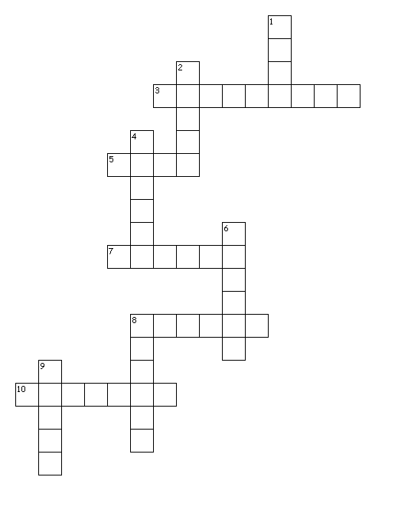
Across
3. shaking
5. a person who behaves silly
7. look
8. a large valley
10. a festive day
Down
1. it is wearing on a face
2. extremely unkind and unpleseant
4. two people
6. area of darknes
8. it is formed by two streets
9. the opossite word is angel

Marc Cohn - True Companion
Baby I've been searching like everyone else
Can't say nothing different about myself
Sometimes I'm an angel
And sometime I'm cruel
And when it comes to love
I'm just another fool
Yes I'll climb a mountain
I'm gonna swim the sea
There ain't no act of God girl
Could keep you safe from me

My arms are reaching out
Out across the canyon
I'm asking you to be my true companion
True companion
True companion

So don't you dare and try to walk away
I've got my heart set on our wedding day
I've got this vision of a girl in white
Made my decision that it's you allright
And when I take your hand
I'll watch my heart set sail
I'll take my trembling fingers
And I'll lift up you veil
Then I'll take you home
And with wild abandon
Make love to you just like a true companion
You are my true companion
True companion

When the years have done
Irreparable harm
I can see us walking slowly arm in arm
Just like that couple on the corner do
'Cause girl I will always be in love with you
And when I look in your eyes
I'll still see that spark
Until the shadows fall
Until the room grows dark
Then when I leave this Earth
I'll be with the angels standin'
I'll be out there waiting
For my true companion
True companion
True companion

The words from the song

Across
3. trembling
5. fool
7. look
8. canyon
10.wedding
Down
1. veil
2. cruel
4. cuple
6. shadow
8. corner
9. devil

Zdroje:
[online]. [cit. 2013-04-02]. Dostupné z: http://puzzlemaker.discoveryeducation.com/code/BuildCrissCross.asp

[online]. [cit. 2013-04-02]. Dostupné z: http://www.karaoketexty.cz/texty-pisni/cohn-marc/true-companion-323368

