EU peníze školám
  - Základní škola Čachovice a Mateřská škola Struhy, Komenského 96, příspěvková organizace
Označení: VY_32_INOVACE_55_SlzČtAj8,9
Předmět: Anglický jazyk
Ročník: 8.,9.
Téma: Film
Název: Finding Nemo
Autor: Mgr. Vlasta Kouříková
Popis: Pracovní list s textem na doplnění a křížovka se slovní zásobou

Metodika k materiálu:
Žáci doplní text s použitím slov z nabídky. Následuje kontrola společným přečtením textu a vysvětlením, popřípadě vyhledáním neznámé slovní zásoby článku. Ve dvojicích pak mohou žáci spolupracovat na přípravě odpovědi na otázku v závěru textu, pokud obsah filmu znají. Dalším úkolem je doplnění křížovky na procvičení slovíček z oblasti mořští živočichové.

Fill in the right words. Use the list of the missing words.

story, world, son, shark, father, little, school, happy, dentist, fish, to, friend, long, jumps, ocean

Finding Nemo

The film tells us the ________ about a father-son relationship and invites us into a magic underwater _________.

Father Marlin has only one ________, Nemo, whose mother died after a ________ attack. Marlin is a good and loving ________ and believes that he himself can protect his ________ boy.

But on Nemo’s first ________ day ,when all the children, teachers and parents are so_______ – Nemo is caught by a scuba diver. He is taken to live in a ________ office’s fish tank with many other ________. Desperate Marlin knows he has________save his little son and together with his good ________ Dora sets off to find Nemo. It’s very ________and dangerous journey.

But Nemo and his tank-mates are trying to escape too. Nemo _________ out of the tank and land in the washbasin and washed down through the drain back to the_________.

Will father and son meet again?

The Ocean
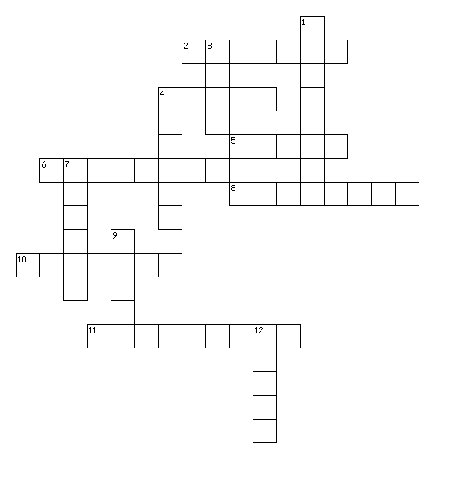
Across
2. chobotnice
4. žralok
5. oliheň
6. hvězdice
8. mořský koník
10. delfín
11. medůza
Down
1. tuňák
3. krab
4. kreveta
7. želva
9. velryba
12. mušle

Finding Nemo

The film tells us the story about a father-son relationship and invites us into a magic underwater world.
Father Marlin has only one son, Nemo, whose mother died after a shark attack. Marlin is a good and loving father and believes that he himself can protect his little boy.
But on Nemo’s first school day, when all the children, teachers and parents are so happy – Nemo is caught by a scuba diver. He is taken to live in a dentist office’s fish tank with many other fish. Desperate Marlin knows he has to save his little son and together with his good friend Dora sets off to find Nemo. It’s very long and dangerous journey.
But Nemo and his tank-mates are trying to escape too. Nemo jumps out of the tank and land in the washbasin and washed down through the drain back to the ocean.
Will father and son meet again?

1. tuna fish
2. octopus
3. crab
4. shrimp
5. squid
6. starfish
7. turtle
8. sea horse
9. whale
10. dolphin
11. jelly fish
12. shell

l

Zdroje:

R&R: An English Magazine For You. Praha: Rainbow, 2005, XVl, č. 3. ISSN MK ČR E 1048.

[online]. [cit. 2013-06-21]. Dostupné z: http://puzzlemaker.discoveryeducation.com/code/BuildCrissCross.asp

