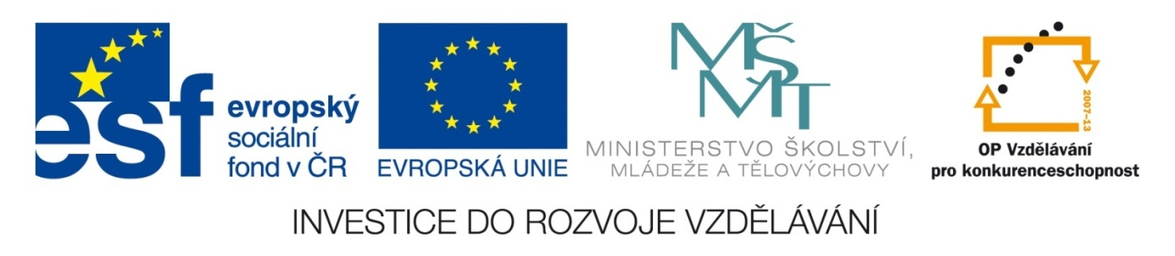

Škola | Katolické gymnázium Třebíč, Otmarova 22, Třebíč 674 01
Název projektu | Moderní škola
Číslo projektu | CZ.1.07/1.5.00/34.0464
Šablona | III/2 Inovace a zkvalitnění výuky prostřednictvím ICT
Autor DUM | Paula Torresan
Název DUM | Test on the EU
Kód DUM | VY_32_INOVACE_ 1.1.4_Test_on_the_EU
Datum vytvoření | 31/08/2013
Předmět | Anglický jazyk
Tematická oblast | Reálie anglicky mluvících zemí
Výstup ŠVP | Žák uvede správné odpovědi.
Anotace DUM | Vědomostní test
Metodický popis | Test slouží jako zpětná vazba pro vyučujícího.
Hodnocení | DŮM přispěl k procvičení učiva.
Autor prohlašuje, že řádně uvedl všechny použité zdroje. Pokud není uvedeno jinak, použitý materiál je z vlastních zdrojů autora.

TEST ON THE EUROPEAN UNION
- ... new countries joined the EU in 2004 (How many?)
- The EU institutions are mainly based in …. (which city?)
- The Czech Republic joined the EU in… (which year?)
- How many are the European commissioners?
- The Treaties of Rome creating the European Economic Community (EEC) and the European Atomic Energy Community (EURATOM) were signed in … (which year?)
- Which institution makes formal proposals?
- The European Central Bank is situated in … (which city?)
- The motto of the EU is …
- The meetings of the presidents and/or prime ministers, who represent the European Council, are called …
- The Treaty of Paris creating the ECSC was signed in … (which year?)
- Who is now the President of the European Commission? (only surname)
- In the EU there are ... member states and 24 official languages.
- The voice of the people is the … (which institution?)
- The voice of the Member States is the … (which institution?)
- Europe Day is celebrated on … (which day?)
- The Council of the European Union and the ... pass European laws. (Which institution?)
- The countries of the Schengen Area share what kind of border? (Internal or external?)
- When was the Euro first used as national currency? Total: …/18
CORRECT ANSWERS
- 10…
- …Bruxelles (Belgium)
- …2004
- 28
- …1957.
- The European Commission
- …Frankfurt am Main (Germany).
- …United in Diversity.
- …summits.
- …1951.
- Barroso.
- …28…
- …European Parliament.
- …Council of the European Union.
- …9 May.
- …European Parliament…
- External.
- 1 January 2002.

