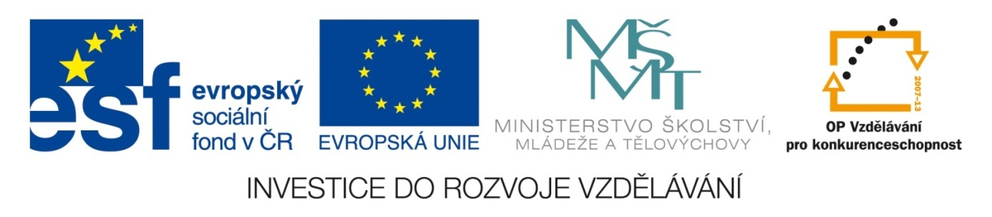

Škola | Katolické gymnázium Třebíč, Otmarova 22, Třebíč 674 01
Název projektu | Moderní škola
Číslo projektu | CZ.1.07/1.5.00/34.0464
Šablona | III/2 Inovace a zkvalitnění výuky prostřednictvím ICT
Autor DUM | Paula Torresan
Název DUM | Test on the Church Year
Kód DUM | VY_32_INOVACE_ 1.1.14_Test_on_the_Church_Year
Datum vytvoření | 31/08/2013
Předmět | Anglický jazyk
Tematická oblast | Reálie anglicky mluvících zemí
Výstup ŠVP | Žák uvede správné odpovědi
Anotace DUM | Vědomostní test
Metodický popis | Test slouží jako zpětná vazba pro vyučujícího.
Hodnocení | DŮM přispěl k procvičení učiva.
Autor prohlašuje, že řádně uvedl všechny použité zdroje. Pokud není uvedeno jinak, použitý materiál je z vlastních zdrojů autora.

TEST ON THE CHURCH YEAR

- When does the Church year begin and end? (2 points)
- What is the most important celebration for Christians? Why? (2 points)
- What are the differences between the Czech and the British traditional Christmas?
- When should Christians fast?
- Name at least three events in Jesus´ life connected with Easter. (3 points)
- What do we celebrate on 6 January?
- Which feasts find their roots in Celtic Halloween?
- What are the origins of the celebration of Svatý Mikulaš?
- Can you name at least two celebrations dedicated to St. Mary?
- What happened at Pentecost?
- Who are Christians? What is the task they are asked to carry out? (2 points)
Total: …/16

CORRECT ANSWERS
- It begins on the first Advent Sunday (end of November/beginning of December) and it ends on the last Sunday before Advent, with the feast of Christ the King.
- Easter, because Christians celebrate the passion, the death and the resurrection of Jesus.
- The main differences are the following:
- The Czech Christmas is celebrated mainly on 24 December, while the British one is celebrated the following day, 25 December.
- In the Czech republic the main meal consists of fish soup and fried carp, while in Britain turkey and Christmas pudding cannot miss.
- It´s Baby Jesus (Ježíšek) who brings the gifts in Czechia, while Father Christmas brings them to English children.
- Christians should fast at Lent and on Good Friday.
- The most important events are:
- the Last Supper;
- Jesus’ arrest in the Gethsemane garden;
- the trial;
- Jesus carrying the cross to the Golgotha;
- his resurrection on the third day after his death.
- Epiphany or Three Kings.
- All Saints’ Day and All Souls’ Day.
- The life and deeds of Saint Nicholas of Myra.
- These are the most important celebrations.
- the Ascension to heaven, on 15 August;
- the Feast of the Immaculate Conception; on 8 December;
- Mary, Mother of God, Queen of Peace, on 1 January.
- The Holy Spirit descended on the Twelve Apostles.
- Christians are those who believe that Jesus is God and the Lord of every living being. They live to spread the message of love of Jesus Christ.

