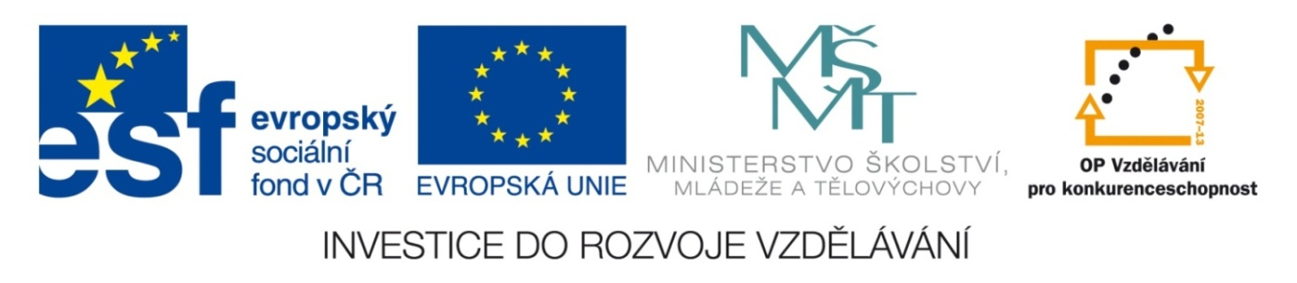

Škola | Katolické gymnázium Třebíč, Otmarova 22, Třebíč 674 01
Název projektu | Moderní škola
Číslo projektu | CZ.1.07/1.5.00/34.0464
Šablona | III/2 Inovace a zkvalitnění výuky prostřednictvím ICT
Autor DUM | Paula Torresan
Název DUM | Test on Canada
Kód DUM | VY_32_INOVACE_ 1.1.16_Test_on_Canada
Datum vytvoření | 31/08/2013
Předmět | Anglický jazyk
Tematická oblast | Reálie anglicky mluvících zemí
Výstup ŠVP | Žák uvede správné odpovědi.
Anotace DUM | Vědomostní test
Metodický popis | Test slouží jako zpětná vazba pro vyučujícího.
Hodnocení | DŮM přispěl k procvičení učiva.
Autor prohlašuje, že řádně uvedl všechny použité zdroje. Pokud není uvedeno jinak, použitý materiál je z vlastních zdrojů autora.

TEST ON CANADA
- What’s the capital of Canada?
- Ottawa (1 mil. people)
- Montréal (4 mil. people)
- Toronto (4, 5 mil. people)

- Which of the Great Lakes are shared by Canada and the USA?
- Lake Superior, Lake Michigan, Lake Erie and Lake Ontario
- Lake Superior, Lake Huron, Lake Erie and Lake Ontario
- Lake Superior, Lake Louise, Lake Erie and Lake Ontario

- Why is the date of July 1st, 1867 important for Canada?
- Canada became a colony of the British Kingdom.
- Canada became a Dominion.
- The Republic of Canada was established.

- Gold wad discovered in 1896 in
- Northwest Territories.
- Alberta.
- Yukon.

- Canada is the ...largest country in the world.
- ...first...
- ..second...
- ...third...
- Canada borders the USA and…
- the Pacific and the Arctic Ocean.
- the Pacific and the Atlantic Ocean.
- the Pacific, the Arctic and the Atlantic Ocean.

- One of the national symbols of Canada is the following animal:
- salmon
- beaver
- grizzly bear

- Among the Asian descendants we find
- Native Americans, or First Nations.
- Inuits.
- both.

- Canada is divided into
- ten provinces and three territories.
- ten provinces and two territories.
- ten provinces and one territory.

- Major exported goods are
- food.
- computers.
- wood.

- Canada is a federal state and
- a constitutional monarchy.
- a parliamentary democracy.
- a constitutional monarchy and parliamentary democracy.

- Who is the Head of State?
- The British Queen
- The President
- The Prime Minister

- The word Canada is originally a Native American word meaning
- maple tree.
- canoe,
- village.

- Who and when claimed the Canadian land for the British crown?
- Christopher Columbus in 1492
- John Cabot in 1497
- Jacques Cartier in 1534

- The first peoples to settle in Canada were
- Asians during the last ice age.
- Vikings around the year 1000 AD.
- the British in 1497.

- Canada is the world second exporter of
- gold.
- petroleum.
- grain.

- The parliament consists of two houses:
- House of Lords and House of Commons
- Senate and House of Representatives
- Senate and House of Commons

- What happened in 1999?
- Canada became fully independent.
- There was a referendum in Québec for the province to achieve independence.
- A large region of the Northwest Territories became the territory of Nunavut.

- What’s the population of Canada?
- 28 million people
- 31 million people
- 35 million people

Total …/19

CORRECT ANSWERS
A.1., B. 2, C. 2, D. 3, E. 2, F. 3, G. 2, H. 3, I. 1, J. 3, K. 3, L. 1, M. 3, N. 2, O. 1,P. 3, Q. 3, R. 3, S. 3.

