

Škola | Katolické gymnázium Třebíč, Otmarova 22, Třebíč 674 01
Název projektu | Moderní škola
Číslo projektu | CZ.1.07/1.5.00/34.0464
Šablona | III/2 Inovace a zkvalitnění výuky prostřednictvím ICT
Autor DUM | Paula Torresan
Název DUM | British literature
Kód DUM | VY_32_INOVACE_ 1.1.19_British_literature
Datum vytvoření | 31/08/2013
Předmět | Anglický jazyk
Tematická oblast | Britská literatura
Výstup ŠVP | Reálie anglicky mluvících zemí
Anotace DUM | Přehled britské literatury
Metodický popis | Prezentace slouží k seznámení studentů s nejdůležitějšími díly i autory britské literatury.
Hodnocení | DUM přispěl k hlubšímu zapamatování či procvičení učiva.
Autor prohlašuje, že řádně uvedl všechny použité zdroje. Pokud není uvedeno jinak, použitý materiál je z vlastních zdrojů autora.

An outline of British literature

Old English literature 449–1066
The earliest form of English literature is known as Old English or Anglo-Saxon. Caedmon's Hymn, the earliest English poem to survive as a text, belongs to the latter part of the seventh century.
Beowulf (sometime between 8th and 11th century) The epic poem Beowulf is the most famous work in Old English. Before it was written, Anglo-Saxon, or Old English, was only spoken by peasants. The story: Beowulf is a warrior who helps king Hrothgar get rid of Grendel, a monster. Beowulf succeeds, but Grendel's mother starts to get her revenge. Beowulf kills her, too. Then, later in the poem, Beowulf fights a Dragon and is fatally wounded. There are no „English“ characters in the poem as it takes place in Denmark. To memorize the poem alliteration (e.g. Martin made a man of mud) and kenning (e.g. „blood“ becomes „battle-sweat“) were used.
Late medieval literature
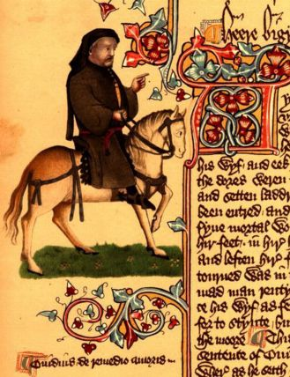 Picture 1
Geoffrey Chaucer is the the most significant Middle English writer. The Canterbury Tales (1387) is his masterpiece. The plot: a group of pilgrims leave London to go to Canterbury, to see the Shrine of Thomas Beckett. On their way they tell each other tales, two going and two on the way back. In fact, Chaucer was only able to complete 20 tales (plus four which are incomplete). There are 29 pilgrims who belong to three social groups: feudal (f.e. the Knight), ecclesiastical (f.e. the Monk) and urban (f.e. the Wife of Bath). Most of the stories are funny, as the characters are ironically described, and some are even rude.
Elizabethan and Jacobean periods
William Shakespeare
Christopher Marlowe He is a playwright, like Shakespeare. He is famous for his rebellious spirit, for being violent and hot-headed, and he died being stabbed and mortally wounded in a tavern. Puritan moralists saw the murder of Marlowe, who had a dangerous reputation for atheism, as a sign of God's judgment. In 1589- 1593 he wrote The Tragical History of the Life and Death of Doctor Faustus. It is a tragedy about a German doctor interested in black magic, who signed a contract with the Devil and sold his body and soul in order to have power and more knowledge. After 24 years, when Lucifer arrives to get what promised, Faustus regrets what he has done, but it´s too late.
John Milton He composed poems, elegies, treaties, pamphlets, etc. He was a rigid Puritan. His religious epic Paradise Lost was first published in 1667. It is an epic poem in 12 books. The subject is religious, from the Bible: a) the rebellion of Angels led by Satan, and their expulsion from Heaven; b) the fall of Man (Adam and Eve) and the consequent loss of Eden and the divine grace. Satan is the central figure of the poem, and he develops from his heroic defeat to a disgusting figure, a toad, in the end. That is his punishment. The language used in the poem is classicized English language, with Latinized structures that give majesty to the poem.
XVIII century
The English novel developed during the 18th century, partly in response to the new cultivated middle-class reading public.
Daniel Defoe He was a merchant, who travelled largely, and used some of his adventures in his novel Robinson Crusoe (1719). It is considered the first English novel. It was suggested to him by the adventures of a Scottish sailor, Alexander Selkirk. It is a fictional autobiografy. Robinson Crusoe can be considered the first capitalist hero, as he uses the tools Western European civilization has given to him to build a prosperous life. The plot: Robinson Crusoe is a merchant shipwrecked on a small island. His practical sense and his energy help him to survive. He doesn´t lose time looking at the beauty of the island; instead he organizes all he has to do, and builds a habitation, keeps a calendar, grows corn, makes pottery, etc. He also makes friends with an indigenous man, that he calls Friday, and converts him to Christianity.
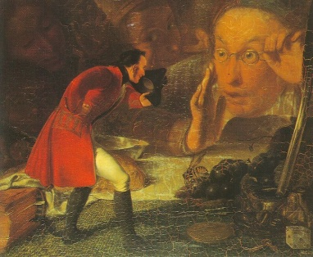 Picture 2
Gulliver´s Travels, or Travels into Several Remote Nations of the Word, in four parts, by Lemuel Gulliver (1726) is a satire written by Jonathan Swift, an Irishman who lived part of his life in England. Swift was an acknowledged satirist of high class society. Swift felt the contrast between the idealist concept of mankind and what was happening around him. Gulliver´s Travels is a novel, a travel story in four books with a common character, Lemuel Gulliver. He visits 1) Lilliput (and Blefuscu), the country of tiny men (15 cm. tall); 2) Brobdingnag, the land of giants (22 m. tall); 3) Laputa, the flying island, where people are learned but have no practical sense; and 4) Houyhnhnms, the land of wise and noble horses, who are served by Yahoos, an inferior human race. This novel gives Swift the opportunity to satirize the Church, the State, human customs, prejudices, weaknesses.
Jane Austen wrote highly polished novels about the life of the country gentry, seen from a woman's point of view, and focused on practical social issues, especially marriage and money. Austen´s novels present the 18th century world which characterized England before the Industrial Revolution. The background of her stories are quiet little towns and the beauty of the countryside. Pride and Prejudice (1813) describes the small world of a few families living in a country village, engaged in their routine of visits, balls, walks and gossip. Elizabeth Bennet, the heroine, is a charming character. The events develop into happy conclusions: „good“ marriages and clearing up of all awkward situations and uncertainties. Other famous works by Jane Austen include Sense and Sensibility, Mansfield Park, Persuasion and Emma.
Romanticism
Major political and social changes at the end of the 18th century, particularly the French, the American and the Industrial Revolution, inspired a new kind of writing known as Romanticism. As a reaction to urbanism and industrialisation, poets explore nature with a new concentration on the individual and the common man. The main features of Romanticism are a) the importance of feelings (rather than classical rules) and imagination; b) a return to Nature; c) „the Gothic“ (dark images, terrifying experiences in mysterious places in radical opposition to the Enlightenment ideals of order, decorum, and rational control) and d) a return to the popular tradition. Poetry became a major Romantic form.
The representatives of Romanticism belong to two generations: the 1st with Wordsworth and Coleridge, who were critical of many social conventions but attached importance to many of the current English values; and the 2nd with Shelley, Keats, Byron, who were all exiles, who exiled from the moral, social and political customs prevailing in English life, and kept their revolutionary spirit to the end.
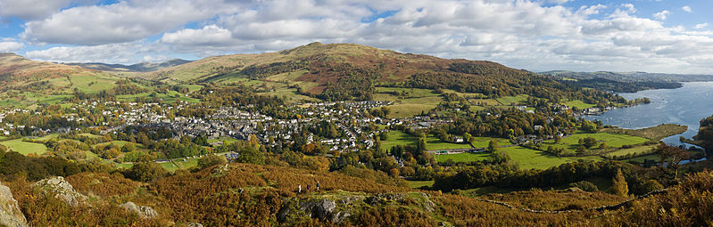 Picture 3
Wordsworth and Coleridge’s wrote the Lyrical Ballads (1798), which revolutionized the theory and practice of poetry. William Wordsworth wrote that the source of a poem is not in outer nature but in the psychology and emotions of the individual poet. For Wordsworth poetry was ´the spontaneous overflow of powerful feelings´ which were ´recollected in tranquillity´. Nature is personified. His poem „The Daffodils“ closes the Lyrical Ballads.
S. T. Coleridge´s most famous poem is The Rime of the Ancient Mariner, the story of an ancient mariner who killed an albatross for no reason during a journey on a ship to the South Pole. As a consequence the ship is met by Death and Life-in-Death, all his shipmates die and he now has to tell the world what has happened in order to be forgiven.
P. B. Shelley was a rebel, against any type of law, and he hated tyranny. He believed that man can express himself only if he´s free. He believed in the Universal Ideas of love, beauty, justice and truth. For Shelley the inspiration is immediate, the product of direct perception. One of his most famous poems is Ode to the West Wind.
The only consolation that J. Keats found in his short life was beauty. According to him, through beauty, which we find in art, we are find truth. His famous poem Ode to a Grecian Urn captures the aspects of his aesthetic theory of negative capability: we do not know who are the figures on the urn, what they are doing, where they are going. The poet can only imagine what is happening in the scenes. Keats is convinced that art is eternal, immortal, has a power superior to that of man, who is linked to life, which ends.
G. G. Byron, 6th Baron Byron, known as Lord Byron, wrote the two narrative poems Childe Harold's Pilgrimage (1812) and Don Juan (unfinished). Childe Harold is the description of an hero who became the incarnation of the romantic hero, solitary, melancholic, tormented by the past, a dandy, a unique individual in the world of mass production. Everybody imitated him. In Don Juan the image changes radically, as this is a satire against the romantic hero.
Victorian period
It was in the Victorian era (1837–1901) that the novel became the leading form of literature in English. Most of the novels concerned problems of contemporary society. We find mainly three different types of novel: novel of manner (Thackeray, Trollope), humanitarian novel (Dickens) and naturalistic novel (Hardy).
The humanitarian novel, or novel of purpose, was interested in the social ills of society. The novel was a vehicle for the criticism of society. The most famous author of this genre is Charles Dickens. His stories of the working class poor were directed toward middle class audiences to encourage sympathy and action for legal and moral change. His novels were published in serial form. Oliver Twist (1838) is a novel about the orphan, Oliver, who grows up in an orphanage. Because he asks for more food, he is sent to live on the streets of London, where he will be exploited by a gang of thieves (pickpockets). Eventually, Mr. Brownlow and Mrs. Roza help him, and find out that Oliver belongs to a wealthy family and is to inherit a fortune. Other famous works are A Christmas Carol, Great Expectations, David Copperfield and The Pickwick Papers.
The Brontë sisters also wrote at that time, publishing their works under the assumed names of Currer, Ellis and Acton Bell. Charlotte's Jane Eyre, Emily's Wuthering Heights (and Anne's Agnes Grey) were published in 1847. The sisters lived in a remote and wild area of Yorkshire, a landscape which we find in their novels. They wrote about imaginary worlds. Jane Eyre is the story of an orphan who later takes a job as a governess and falls in love with her employer, Mr. Rochester, a rough man. Eventually Rochester asks her to marry him, but the wedding cerimony is interrupted as Mr. Rochester still has a wife living. She is a lunatic and one night she burns the house to the ground. Rochester loses one hand, one eye and the sight of the other eye in the fire, bur Jane still accepts to marry him.
George Bernard Shaw and Oscar Wilde are both Irish writers who lived mainly in England and wrote in English, with the exception of some works in French by Wilde.
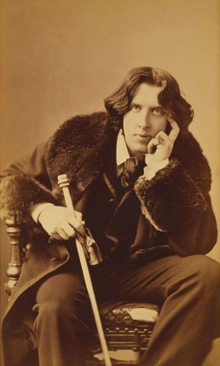 Picture 4
Oscar Wilde did everything possible to become the centre of attention. He was an extravagant, he dressed exotically, wearing sunflowers, lilies…He´s famous for his philosophy of „art for art´s sake“, becoming the leader of the Aesthetic Movement. („It´s better to be beautiful than to be good…“). He challenged the Victorian moralism. Although he was married, he had an homosexual relationship and was inprisoned. His major works are the collection of fairy tales The Happy Prince, the play The Importance of Being Earnest and the only novel The Picture of Dorian Gray (1890). It is the story of Dorian Gray, who becomes the model and muse of a painter, Basil Howard. Basil paints a portrait of Dorian, and Dorian expresses the wish to stay forever young and beautiful, while the painting will decay instead of him. The wish becomes true. In the end the portrait is destroyed, while Dorian will carry all the signs of old age and of the bad things he commited in life.
G. B. Shaw is a playwright and a novelist. He was one of the founders of the Fabian Society, for the promotion of socialism without violent revolutions. Pygmalion (1912) is a play which became a musical bearing the title My Fair Lady in 1956. The plot: a professor of phonetics, H. Higgings, meets a flower girl with a cockney accent and boasts to a friend of his that after three months of his professional training he will be able to pass her off as an aristocratic lady. The change in the girl, Eliza, is complete and she becomes a lady. Higgings wins his bet; Eliza finds out chat has really happened and feels exploited, but she will leave Higgings showing to be a truly independent lady.
Sir Arthur Conan Doyle was born in Scotland of Irish parents but his Sherlock Holmes stories have typified a fog-filled London for readers worldwide. His Sherlock Holmes is a brilliant London-based "consulting detective", famous for his intellectual skill, use of astute observation, deductive reasoning and forensic skills to solve difficult cases. Sherlock Holmes has become a by-word for a detective. Conan Doyle wrote four novels and fifty-six short stories featuring Holmes, from 1880 up to 1907, with a final case in 1914. When Doyle tried to kill off Sherlock Holmes in The Final Problem in 1893 there was such a public outcry that he was forced to bring him back from the dead. All but four Conan Doyle stories are narrated by Holmes' friend, assistant, and biographer, Dr. J. H. Watson („Elementary, my dear Watson“). His most famous crime novel is The Hound of the Baskervilles (1901-1902).
Modernism
From around 1910, the Modernist Movement began to influence English literature. Modernism was against the middle classes and their values. A new generation of poets and novelists felt alienated from society, and in the period of the two world wars writers felt hopeless, empty and pessimistic.
Major poets of this period in Britain included the American-born T. S. Eliot and Irishman W. B. Yeats.
T. S. Eliot rejected ´romantic´ conventions and evolved a new poetic technique. His poetry is rich in symbols, in quotations from works of the European literary tradition. The Waste Land (1922) is considered Eliot´s masterpiece. It uses the medieval Grail legend and has two main themes: 1) the meaningful link with the past and 2) the emptiness and sterility of modern life. There is no plot but only a sequence of images. Eliot received great success not only as a poet but as a critic and a playwright as well.
As English fiction is concerned, „Modernism“ usually refers to those novelists who experimented with new forms and who developed the „stream of consciousness“ technique. According to Bergson, time is not a sequence of separate points, but a flowing continuity. The novelist has to explore what starts and constitutes the mental process (e.g. memories, dreams, etc.) and analyse how this process works. The technique used to depict consciousness is the interior monologue.
James Joyce went deeper into experimentation by using the ´direct interior monologue´ where he shifted from thought to thought, without an apparent connection of verb, subject or even punctuation. Joyce's complex works included Ulysses (1922), probably the most important work of Modernist literature. It is an interpretation of the Odyssey set in Dublin on a single day, June 16, 1904. The main characters are Stephen Dedalus (Telemachus), Leopold Bloom (Ulysses) and his wife Molly (Penelope). Bloom is a modern Ulysses, who can stand for everyman. The book documents the various events and impressions of a single day in the life of his characters.
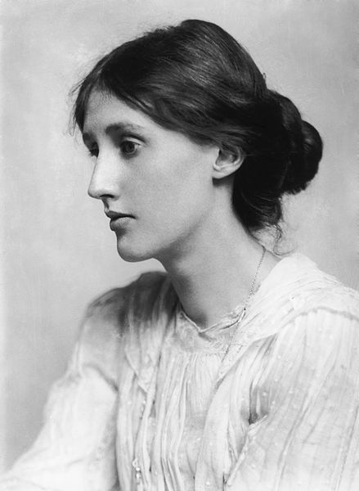 Picture 5
Virginia Woolf was an influential feminist. Her novels included Mrs Dalloway, To the Lighthouse (1927), Orlando, The Waves, and A Room of One's Own. Her house was a meeting place for writers and artists, and with her husband they established the literary Bloomsbury Group. She also developed the stream of consciousness technique, the representation of reality through the sequence of ideas and thoughts in people´s minds. To the Lighthouse is about the Ramsay family and their visit to the Hebrides. There are three parts. In the first one Mrs. Ramsay and her son, James, plan to visit the lighthouse the next day. This will not take place as the weather will not allow it. The second part is only to give a sense of time passing. We learn that three of the characters have died (one of them being Mrs. Ramsay). In the third part some of the remaining Ramsays return to the summer house ten years after the events in part one, to fulfill the visit to the lighthouse. The events in the novel are not important, what is important is what the characters are thinking, what´s in their minds.
Agatha Christie is a crime writer of novels, short stories and plays, best remembered for her 80 detective novels and her successful West End theatre plays like The Mousetrap. Christie's works, particularly featuring the detectives Hercule Poirot, Miss Marple and Mr. Parker Pyne, have given her the title the 'Queen of Crime' and made her one of the most important and innovative writers in the development of the genre. Christie's works include the novels Murder on the Orient Express (1934), Death on the Nile (1937). 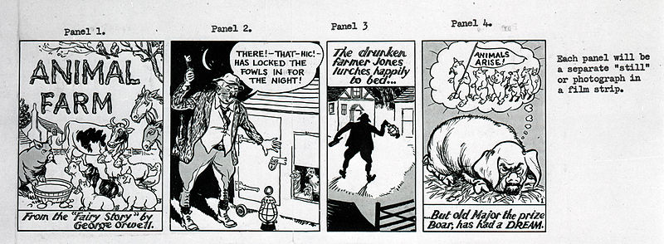 Picture 6
Another significant English writer is George Orwell. An essayist and novelist, Orwell's works are considered among the most important social and political commentaries of the 20th century. He dealt with issues such as poverty in Down and Out in Paris and London, totalitarianism in Nineteen Eighty-Four (1948) and Animal Farm (1945), and colonialism in Burmese Days. Orwell's works were often semi-autobiographical. Animal Farm is a well-written political allegory. The rebellion of animals against people on Manor Farm reflects the Russian Revolution. Animals are given human characters. The sheep represent the stupid party supporters as they endlessly bleat the slogan „Four legs good, two legs bad“. Ironically, pigs eventually become superior to other animals. The pig´s leader strongly resembles Stalin. Orwell, although politically Left, was aware of the evil system that communists in Russia had developed.

Použitá literatura:
- ANSALDO, Mariella a Patrizia MAGNI. Working out literature: A task oriented approach to literary appreciation. 1984. vyd. Torino: Petrini editore, 1984. ISBN 8849402163, 9788849402162.
- Bridge. Praha: Nakladatelství Bridge, 2007-2008, Issue 3, 6 and 8, volume 11.
- Bridge. Praha: Nakladatelství Bridge, 2008-2009, Issue 4, volume 12.
- British literature. In: Wikipedia: the free encyclopedia [online]. San Francisco (CA): Wikimedia Foundation, 2001- [cit. 2013-08-21]. Dostupné z: http://en.wikipedia.org/wiki/British_literature
- The Norton Anthology of English Literature. In: Norton literature online [online]. 2010 - 2013 [cit. 2013-08-21]. Dostupné z: http://www.wwnorton.com/college/english/nael/
Obrázky:
- Picture 1: Chaucer ellesmere. In: Wikipedia: the free encyclopedia [online]. San Francisco (CA): Wikimedia Foundation, 2001- [cit. 2013-08-21]. Dostupné z: http://commons.wikimedia.org/wiki/File:Chaucer_ellesmere.jpg
- Picture 2:REDGRAVE, Richard. Szene aus Gulliver's Reisen - Gulliver in Brobdingnag. In: Wikipedia: the free encyclopedia [online]. San Francisco (CA): Wikimedia Foundation, 2001- [cit. 2013-08-21]. Dostupné z: http://commons.wikimedia.org/wiki/File:Szene_aus_Gulliver%27s_Reisen_-_Gulliver_in_Brobdingnag.jpg
- Picture 3: DILIFF. Ambleside & Waterhead Panorama, Cumbria, England. In: Wikipedia: the free encyclopedia [online]. San Francisco (CA): Wikimedia Foundation, 2001- [cit. 2013-08-21]. Dostupné z: http://commons.wikimedia.org/wiki/File:Ambleside_%26_Waterhead_Panorama,_Cumbria,_England_-_Oct_2009.jpg?uselang=cs
- Picture 4: SARONY, Napoleon. Oscar Wilde portrait by Napoleon Sarony - albumen. In: Wikipedia: the free encyclopedia [online]. San Francisco (CA): Wikimedia Foundation, 2001- [cit. 2013-08-21]. Dostupné z: http://commons.wikimedia.org/wiki/File:Oscar_Wilde_portrait_by_Napoleon_Sarony_-_albumen.jpg
- Picture 5: BERESFORD, George Charles. VirginiaWoolf. In: Wikipedia: the free encyclopedia [online]. San Francisco (CA): Wikimedia Foundation, 2001- [cit. 2013-08-21]. Dostupné z: http://commons.wikimedia.org/wiki/File:VirginiaWoolf.jpg
- Picture 6: THE NATIONAL ARCHIVES UK. Animal Farm strip cartoon. In: Wikipedia: the free encyclopedia [online]. San Francisco (CA): Wikimedia Foundation, 2001- [cit. 2013-08-21]. Dostupné z: http://commons.wikimedia.org/wiki/File:Animal_Farm_strip_cartoon.jpg

