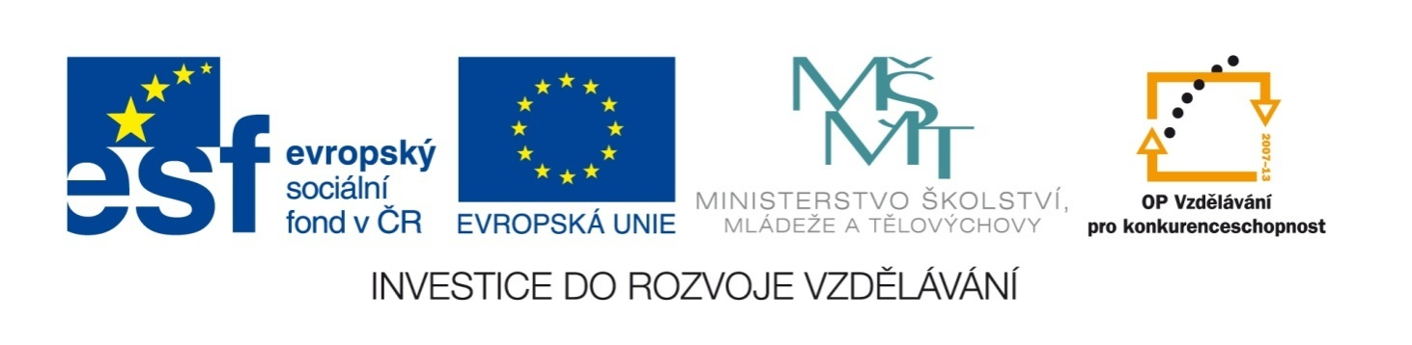

Název školy | ZÁKLADNÍ ŠKOLA, JIČÍN, HUSOVA 170
Číslo projektu | CZ.1.07/1.4.00/21.2862
Číslo a název klíčové aktivity | 3.2 Inovace a zkvalitnění výuky prostřednictvím ICT

Název DUM: | VY_32_INOVACE_XIV_3_4_ANIMALS
Šablona číslo: | XIV. |  | Sada číslo: | 3 | Pořadové číslo DUM: | 4
Autor: |  | Mgr. Zdeněk Jareš
Anotace: |  | Rozšíření slovní zásoby – zvířata
Očekávaný výstup: |  | Žáci si osvojí novou slovní zásobu; žáci jsou schopni pracovat s definicemi; vysvětlují význam přísloví
Druh učebního materiálu: |  | pracovní list
Typická věková skupina: |  | 8. ročník, 13 – 14 let
Klíčová slova: |  | animals, proverbs, adjectives
Pomůcky a materiál: |  | pracovní list, psací potřeby
Potřebný čas pro výuku DUM: |  | 90 minut
Metodické zhodnocení a popis práce s digitálním učebním materiálem:
- Žáci doplní přísloví a pokusí se je vysvětlit a použít na příkladu.
- Žáci přiřazují k daným zvířatům jejich typické vlastnosti. Mohou také vytvářet přirovnání (as proud as a peacock, ...)
- Žáci vyřeší definice, neznámá slova z tajenky si mohou vyhledat ve slovníku.

Zdroje:

Complete these idiomatic expressions and proverbs with a suitable animal:
sheep * chickens * cat * horse * mice * wolf * bird * fish * bird * dog

- Let the sleeping __________ lie.
- The early __________ catches the worm.
- Don’t count __________ before they are hatched.
- Don’t look a gift __________ in the mouth.
- I feel like a __________ out of water.
- He’s a __________ in sheep’s clothing.
- He’s the black __________ of the family.
- A __________ in the hand is worth two in the bush.
- When the __________’s away, the __________ will play.

Match the animals and their typical qualities.
PEACOCK |  | INDEPENDENT
BEE |  | BRAVE
FOX |  | GREEDY
DONKEY |  | PROUD
OWL |  | SLY
LION |  | WISE
PIG |  | STUBBORN
BIRD |  | BLIND
DOG |  | CHEEKY
BAT |  | HARD-WORKING
MONKEY |  | LOYAL
Complete these idiomatic expressions and proverbs with a suitable animal:
sheep * chickens * cat * horse * mice * wolf * bird * fish * bird * dog

- Let the sleeping DOG lie.
- The early BIRD catches the worm.
- Don’t count CHICKENS before they are hatched.
- Don’t look a gift HORSE in the mouth.
- I feel like a FISH out of water.
- He’s a WOLF in sheep’s clothing.
- He’s the black SHEEP of the family.
- A BIRD in the hand is worth two in the bush.
- When the CAT’s away, the MICE will play.

Match the animals and their typical qualities.
PEACOCK |  | PROUD
BEE |  | HARD-WORKING
FOX |  | SLY
DONKEY |  | STUBBORN
OWL |  | WISE
LION |  | BRAVE
PIG |  | GREEDY
BIRD |  | INDEPENDENT
DOG |  | LOYAL
BAT |  | BLIND
MONKEY |  | CHEEKY
Complete the crossword.
 |  |  |  |  |  |  | 1 | K | A | N | G | A | R | O | O
 |  |  |  |  |  |  | 2 | A | N | A | C | O | N | D | A
 |  |  |  |  |  | 3 | S | P | I | D | E | R
 |  |  |  |  |  |  |  | 4 | M | O | U | S | E
 |  |  |  |  |  | 5 | S | N | A | K | E
 |  |  |  |  |  |  |  | 6 | L | I | O | N
 |  |  |  |  | 7 | L | O | U | S | E
 |  |  |  |  |  |  | 8 | P | I | G
 |  |  |  |  |  | 9 | P | E | N | G | U | I | N
 |  |  |  |  |  | 10 | O | C | T | O | P | U | S
 |  |  |  |  |  |  |  | 11 | H | E | D | G | E | H | O | G
 |  |  |  |  |  | 12 | C | H | E | E | T | A | H
 |  |  |  |  |  |  |  | 13 | W | A | S | P
 |  |  |  | 14 | P | I | G | E | O | N
 |  |  |  |  | 15 | S | H | A | R | K
 |  |  |  |  |  |  |  | 16 | L | A | M | B
17 | B | L | A | C | K | B | I | R | D

Complete the crossword.
1
2
3
4
5
6
7
8
9
10
11
12
13
14
15
16
17

1.
It lives in Australia and it has become a recognisable symbol of this country. The typical feature of this animal is its poach (pocket).
3.
This animal has eight legs. It makes cobwebs to catch some insects.
2.
It is the largest snake in the world. It can be dangerous but it is not poisonous. It lives in tropical South America.
5.
It is a reptile. It has no legs. Some of them are poisonous and can be very dangerous.
4.
This animal lives nearly everywhere. It is small and grey. It’s said to love cheese.
6.
It is a big cat. It lives in Africa. It is said to be the king of all animals.
7.
It is a kind of insect. It is very small. It can be very unpleasant. It lives in your hair feeding on your skin.
8.
It is a farm animal. Its meat is called pork.
9.  It is a bird but it cannot fly. It lives in Antarctica. It can swim very well. It spends half of its life in the ocean and half on land. It eats fish, squids and so on. |  |  |  |  |  |  | 10.  This animal lives in seas and oceans. It’s characterized by their eight arms. It can hide, camouflage or eject black ink and escape from predators. |  |  |  |  |  |  | 11.  It is a mammal. It has spines all around its body. It eats insect. It lives in Europe, Africa and Asia.
13.
It’s an insect. It has two pairs of wings. It is yellow and black. It is omnivore (it eats everything). When it stings you it hurts a lot.
12.
It is a large feline (cat). It lives in Africa and the Middle East. It is the fastest animal on land. It can run as fast as 120 kilometres per hour.
 |  |  |  |  |  |  |  |  | 15.  It is a large fish. It lives in seas and oceans. It can be very dangerous and it can attack people. You could see this animal in a famous horror movie The Jaws. |  |  |  |  |  |  | 16.  It is a young sheep.
14.
It is a bird. It lives in towns and cities. In the past this bird was used for carrying messages.
17.
It is a bird. It has black feathers and an orange beak. It eats insects and fruit. You can see it very often in the garden.

