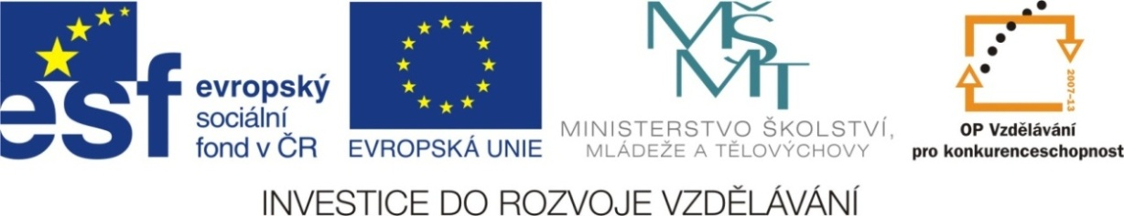

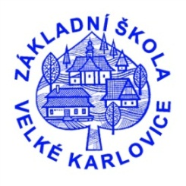

Výukový materiál: | EUPŠ _OP VK_Gavlíková_AJ,4_06_Být
Šablona: | III/2
Sada: | AJ,4
Autor: | Mgr. Zdenka Gavlíková
Vytvořeno: | Únor 2013
Ověřeno: | 2. 5. 2013 - IV
Ročník: | 4
Druh učebního materiálu: | Pracovní list
Vzdělávací oblast: | Jazyk a jazyková komunikace
Předmět: | Anglický jazyk
Tematický okruh: | Introduction
Téma: | Verb to be
Anotace: | Žáci si vyplňením pracovního listu zdokonalí své znalosti o popoužívání
 | používání slovesa to be.
Poznámky:

SLOVESO TO BE
1. Match (Spoj )
am are is

Lucy he we they it I you Tom and Peter mother she brother

2. Fill in „am“, „is“ , „are“ ( Doplň „am“, „is“, „are“)
My mum ____ in the kitchen. Lucy and Tom ____ at school.
I____ 10 years old. My brother ____ tall.
You ____ happy. Our cat _____ black.
He ___ at work. We ___ on the beach.
I ___ at school. She ___ at home.
It ___ a doll. Susan ___ tall.
Ann and Mary ____ from Poland. Prague ___ in the Czech Republic.
The dog ____ in the garden. We ____ happy.

3. Qestion (Otázka)
Where ____ they from? ____ I happy?
_____ she young? ____ you at home?
How old ___ he? How ____ you?
What colour ____ it? _____ he in the living room?
____ they at school? ____ Lucy and Tom on the farm?

ŘEŠENÍ

1. Match (Spoj )
am are is

Lucy he we they it I you Tom and Peter mother she brother

2. Fill in „am“, „is“ , „are“ ( Doplň „am“, „is“, „are“)
My mum is in the kitchen. Lucy and Tom are at school.
I am 10 years old. My brother is tall.
You are happy. Our cat is black.
He is at work. We are on the beach.
I am at school. She is at home.
It is a doll. Susan is tall.
Ann and Mary are from Poland. Prague is in the Czech Republic.
The dog is in the garden. We are happy.

3. Qestion (Otázka)
Where are they from? Am I happy?
Is she young? Are you at home?
How old is he? How are you?
What colour is it? Is he in the living room?
Are they at school? Are Lucy and Tom on the farm?

