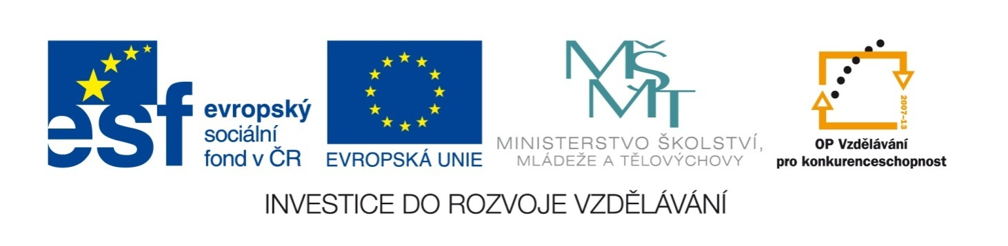

Název školy | ZÁKLADNÍ ŠKOLA, JIČÍN, HUSOVA 170
Číslo projektu | CZ.1.07/1.4.00/21.2862
Číslo a název klíčové aktivity | 3.2 Inovace a zkvalitnění výuky prostřednictvím ICT

Název DUM: | VY_32_INOVACE_XIV_1_16_WORD PHRASES
Šablona číslo: | XIV. |  | Sada číslo: | 1 | Pořadové číslo DUM: | 16
Autor: |  | Mgr. Lucie Velešovská
Anotace: |  | Rozšíření slovní zásoby – užití frázových sloves
Očekávaný výstup: |  | Žáci si osvojí základní frázová slovesa a slovních frází
Druh učebního materiálu: |  | pracovní list
Typická věková skupina: |  | 8. ročník, 13 – 14 let
Klíčová slova: |  | word phrases, phrasal verbs
Pomůcky a materiál: |  | pracovní list, psací potřeby
Potřebný čas pro výuku DUM: |  | 45 minut
Metodické zhodnocení a popis práce s digitálním učebním materiálem:
- Žáci spojuje sloveso s vhodnou předložkou a doplňuje vhodné výrazy do textu.

Zdroje:

WORD PHRASES

I.Put the words together, you can make more combinations:

out
up
for
down
off
after
on
look
turn
put
get
give
break
take

II. Complete the sentences with some of the verbs above:
- You can ____________________ your coat, it’s quite hot here.
- I was late, because my car ____________________.
- Doctors____________________ sick people.
- I must ____________________ very early every day.
- Can you ____________________ the lights, please?
- I am ____________________ my keys, where are they?

III. Fill in a suitable word:
- I don´t have ______________ , because I am not hungry in the morning.
- Look ______________ the man, do you know him?
- They often talk ______________ their work.
- My uncle is interested ______________ fishing.
- My children are afraid ______________ dogs.
- We took many ______________ on holiday.
- Hurry ______________ , we are waiting ______________ you.

IV. Match the opposite phrases:
- put on a) come in time
- turn off b) take off
- be late c) get up
- have breakfast d) take out of
- go to bed e) have dinner
- work hard f) have a rest
- put into g) turn on

V. Divide the words among the following verbs:
DO –
photos, the homework, off the bus, a chance, mistakes, the exercises, ready, the shopping, friends, someone home, angry, a reservation

MAKE –
GET –
TAKE –

VI. Think of other possible phrases:
Have – breakfast, …
Drive – a car, …
Ride – a bike, …
Go – shopping, …
Tell – the truth, …
Listen to- music, …
Play – the guitar, …

WORD PHRASES

I.Put the words together, you can make more combinations:

look after, look up, look for, look out
turn on, turn off, turn up, turn down …
put on, put out, put down, put up …
get out, get up, get down, get off, get on
give up
break down, break up, break out …

II. Complete the sentences with some of the verbs above:
- You can take off your coat, it’s quite hot here.
- I was late, because my car broke down.
- Doctors look after sick people.
- I must get up very early every day.
- Can you turn on/off the lights, please?
- I am looking for my keys, where are they?

III. Fill in a suitable word:
- I don´t have breakfast, because I am not hungry in the morning.
- Look at the man, do you know him?
- They often talk about their work.
- My uncle is interested in fishing.
- My children are afraid of dogs.
- We took many photos on holiday.
- Hurry up, we are waiting for you.

IV. Match the opposite phrases:
- put on take off
- turn off turn on
- be late come in time
- have breakfasthave dinner
- go to bed get up
- work hardhave a rest
- put into take out of

V. Divide the words among the following verbs:
DO –the homework, the exercises, the shopping
photos, the homework, off the bus, a chance, mistakes, the exercises, ready, the shopping, friends, someone home, angry, a reservation

MAKE –mistakes, friends, areservation
GET –off the bus, ready, angry
TAKE –photos, a chance, someone home

VI. Think of other possible phrases:
Have – breakfast, lunch, dinner, a shower, a bath, a nice time
Drive – a car, a lorry, a van, a taxi, an ambulance
Ride – a bike, a motorbike, a horse
Go – shopping, swimming, skiing, skating
Tell – the truth, a lie, a joke, a story
Listen to - music, radio, song
Play – the guitar, the piano, the violin, football, chess …

