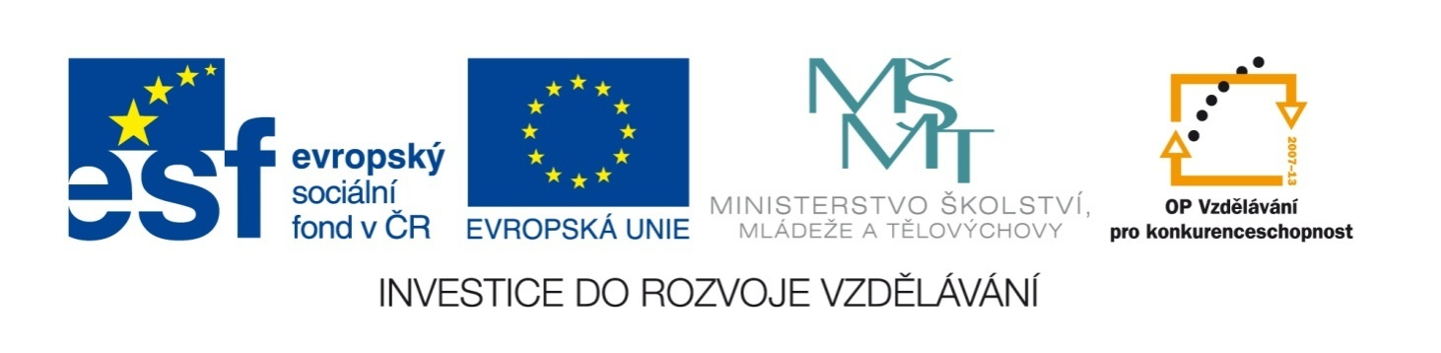

Název školy | ZÁKLADNÍ ŠKOLA, JIČÍN, HUSOVA 170
Číslo projektu | CZ.1.07/1.4.00/21.2862
Číslo a název klíčové aktivity | 3.2 Inovace a zkvalitnění výuky prostřednictvím ICT

Název DUM: | VY_32_INOVACE_XIV_1_17_PAST SIMPLE
Šablona číslo: | XIV. |  | Sada číslo: | 1 | Pořadové číslo DUM: | 17
Autor: |  | Mgr. Lucie Velešovská
Anotace: |  | Procvičení minulého času prostého
Očekávaný výstup: |  | Žáci si procvičí formu a užití minulého času prostého, slovesa pravidelná i nepravidelná.
Druh učebního materiálu: |  | pracovní list
Typická věková skupina: |  | 8. ročník, 13 – 14 let
Klíčová slova: |  | past simple, regular verbs, irregular verbs
Pomůcky a materiál: |  | pracovní list, psací potřeby
Potřebný čas pro výuku DUM: |  | 45 minut
Metodické zhodnocení a popis práce s digitálním učebním materiálem:
- Žáci si procvičí formu minulého času prostého – pravidelná a nepravidelná slovesa, zápor a otázku a doplňují text vhodnými slovesy v minulém čase.
Zdroje:

PAST SIMPLE

I. Write the verbs in the Past Simple:

open
stop
run
say
know
marry
stay
come
read
think
cut
make
find
sleep
visit
carry
pay
cost
spend
sell
travel
hear
ride
buy

II. Use both forms of the verbs above in the following sentences:
- It wasn’t expensive. It ___________ just a few crowns, so I ___________ it.
- We ___________ our last holiday in France. It was wonderful, we ___________ there by a luxurious bus, ___________ in a five-star hotel and ___________ many places.
- I ___________ 7 hours every night.
- I ___________ that news on the radio this morning.
- Our school ___________ at 7:00 every day.
- He asked her to ___________ him and she ___________ yes.
- When he ___________ into the room, everyone ___________ talking.
- This morning I ___________ my lost key!
- My Dad sometimes ___________ dinner.
- Many people don’t ___________ newspapers, because they use the Internet.
- Yesterday I ___________ my bike to school.
- I ___________ my friend Peter very well.
- This car can___________ seven people.
- My new knife ___________ very well.

III. Put the underlined verbs into the negatives…
- He ________________ on Saturday, he came…
- I met Henry, but I ________________…
- I swam100 metres, but I ________________…
- My children ate the sweets, but they ________________…
- And they drank the juice, but they ________________…
- They brought some bread, but they ________________…
- Our team lost four matches, but their team ________________…
- I sold the blue shoes, but I ________________…

… and choose the correct ending:
the tea / any match at all / 200 metres / on Sunday / any butter / his girlfriend / the black ones /the vegetable

IV. Make questions to these answers:
- _________________________________________________ ? I bought some milk.
- _________________________________________________ ? They left at 2:30.
- _________________________________________________ ? We flew to Mexico.
- _________________________________________________ ? He was born in 2003.
- _________________________________________________ ? She had only yoghurt.
- _________________________________________________ ? Because it was cheap.
- _________________________________________________ ? We went there by bus.
- _________________________________________________ ? We spoke about food.

V. Complete the text with suitable verbs in the Past Simple:
Five years ago we ________________ a new house. After we ________________ all the material, we ________________ no money at all. But when we ________________ our old flat, we ________________ the money again. I ________________the house with my brother and we ________________ hard every day. My wife ________________ meals for us. We ________________ the rooms in white, yellow, blue and green, so they look really nice. A year later we ________________ into the house and we are very happy there.

PAST SIMPLE

I. Write the verbs in the Past Simple:

open | opened
stop | stopped
run | ran
say | said
know | knew
marry | married
stay | stayed
come | came
read | read
think | thought
cut | cut
make | made
find | found
sleep | slept
visit | visited
carry | carried
pay | paid
cost | cost
spend | spent
sell | sold
travel | travelled
hear | heard
ride | rode
buy | bought

II. Use both forms of the verbs above in the following sentences:
- It wasn’t expensive. It cost just a few crowns, so I bought it.
- We spent our last holiday in France. It was wonderful, we travelled there
by a luxurious bus, stayed in a five-star hotel and visited many places.
- I sleep 7 hours every night.
- I heard that news on the radio this morning.
- Our school opens at 7:00 every day.
- He asked her to marry him and she said yes.
- When he came into the room, everyone stopped talking.
- This morning I found my lost key!
- My Dad sometimes makes dinner.
- Many people don’t read newspapers, because they use the Internet.
- Yesterday I rode my bike to school.
- I know my friend Peter very well.
- This car can carry seven people.
- My new knife cuts very well.

III. Put the underlined verbs into the negatives…
- He didn’t come on Saturday, he came on Sunday.
- I met Henry, but I didn’t meet his girlfriend.
- I swam 100 metres, but I didn’t swim 200 metres.
- My children ate the sweets, but they didn’t eat the vegetable.
- And they drank the juice, but they didn’t drink the tea.
- They brought some bread, but they didn’t bring any butter.
- Our team lost four matches, but their team didn’t lose any match at all.
- I sold the blue shoes, but I didn’t sell the black ones.

… and choose the correct ending:
the tea / any match at all / 200 metres / on Sunday / any butter / his girlfriend / the black ones /the vegetable

IV. Make questions to these answers:
- What did you buy? I bought some milk.
- When/What time did they leave? They left at 2:30.
- Where did you fly? We flew to Mexico.
- When was he born? He was born in 2003.
- What did she have for breakfast/snack/supper… ? She had only yoghurt.
- Why did he/she/you/they buy it? Because it was cheap.
- How did you go there? We went there by bus.
- What did you speak about? We spoke about food.

V. Complete the text with suitable verbs in the Past Simple:
Five years ago we built a new house. After we bought all the material, we had no money at all. But when we sold our old flat, we had/got the money again. I built the house with my brother and we worked hard every day. My wife made meals for us. We painted the rooms in white, yellow, blue and green, so they look really nice. A year later we moved into the house and we are very happy there.

