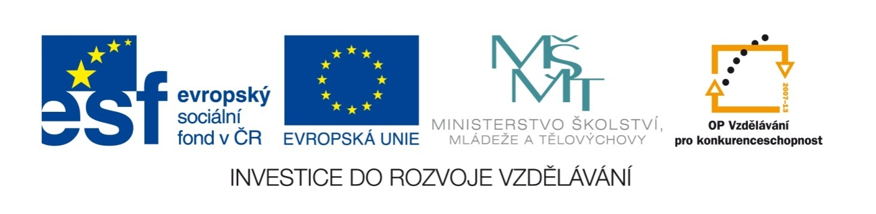
Název školy | ZÁKLADNÍ ŠKOLA, JIČÍN, HUSOVA 170
Číslo projektu | CZ.1.07/1.4.00/21.2862
Číslo a název klíčové aktivity | 3.2 Inovace a zkvalitnění výuky prostřednictvím ICT

Název DUM: | VY_32_INOVACE_XIV_2_13_THE SECOND CONDITIONAL
Šablona číslo: | XIV. |  | Sada číslo: | 2 | Pořadové číslo DUM: | 13
Autor: |  | Mgr. Lucie Velešovská
Anotace: |  | Používání druhé podmínkové věty.
Očekávaný výstup: |  | Žáci jsou schopni popisovat své chování v hypotetických nebo málo pravděpodobných situacích.
Druh učebního materiálu: |  | pracovní list
Typická věková skupina: |  | 9. ročník, 14 – 15 let
Klíčová slova: |  | second conditional, if, would
Pomůcky a materiál: |  | pracovní list, psací potřeby
Potřebný čas pro výuku DUM: |  | 45 minut
Metodické zhodnocení a popis práce s digitálním učebním materiálem:
- Žáci procvičují tvorbu druhé podmínkové věty – dávají si pozor na formu slovesa ve větě hlavní a vedlejší.
- Žáci vhodně doplňují konkrétní text.
Zdroje:

2nd CONDITIONAL

I. Put the verbs into the correct form:
- If I _________________ (have) lots of money, I _________________ (travel) round the world.
- If I_________________ (speak) English perfectly, I _________________ (work) abroad.
- If I _________________ (be) you, I _________________ (apologize) to her.
- If you _________________ (not hurry), you _________________
(not break) that cup.
- If I _________________ (know) the answer, I _________________ (not ask) you.
- If I _________________ (can) drive, I _________________ (go) to school by car.

II. Rewrite the sentences in 2nd Conditional:
Example: I don’t have any money. I will not buy it. - If I had some money, I would buy it.
- He plays PC games all night. He is tired in the morning.
- He doesn’t do any sport. He isn’t fit.
- He doesn’t read books. He isn’t clever.
- They sometimes lose a match. They aren’t the best team.
- We aren’t careful. We often break some cups.
- She is often late. She lost her job.
- They spend so much money on clothes. They won’t save any money.

- __________________________________________________________________
- __________________________________________________________________
- __________________________________________________________________
- __________________________________________________________________
- __________________________________________________________________
- __________________________________________________________________
- __________________________________________________________________

III. Make your answers to the following questions:
- What would you do if you won five million crowns?
_________________________________________________________________
- What would you do if were a teacher?
_________________________________________________________________
- What would you do if you became a president?
_________________________________________________________________
- What would you do if you saw a car accident?
_________________________________________________________________
- What would you do if you were invisible?
_________________________________________________________________
- What would you do if you didn’t have to come to school tomorrow?
_________________________________________________________________

IV. Complete the sentences with your own ideas:
- If I were rich
- I would ___________________________________________________
- I would ___________________________________________________
- I would ___________________________________________________
- I wouldn‘t _________________________________________________
- I wouldn‘t _________________________________________________
- I wouldn‘t _________________________________________________

- If I could travel round the world
- I would visit ____________________________________________in Europe.
- I would visit ____________________________________________in Africa.
- I would visit ____________________________________________in Asia.
- I would visit ______________________________________in North America.
- I would visit ______________________________________in South America.

2nd CONDITIONAL

I. Put the verbs into the correct form:
- If I had lots of money, I would travel round the world.
- If I spoke English perfectly, I would work abroad.
- If I were you, I would apologize to her.
- If you didn’t hurry, you wouldn’t break that cup.
- If I knew the answer, I wouldn’t ask you.
- If I could drive, I would go to school by car.

II. Rewrite the sentences in 2nd Conditional:
Example: I don’t have any money. I will not buy it. - If I had some money, I would buy it.
- If he didn’t play PC games all night, he wouldn’t be tired in the morning.
- If he did some sports, he would be fit.
- If he read books, he would be clever.
- If they didn’t lose any matches, they would be the best team.
- If we were careful, we wouldn’t break any cups.
- If she wasn’t often late, she wouldn’t lose her job.
- If they didn’t spend so much money on clothes, they would save some money.

III. Make your answers to the following questions:
more possible answers

IV. Complete the sentences with your own ideas:
more possible answers

