Škola: Základní škola Trávníky Otrokovice, příspěvková organizace
Číslo projektu: CZ.1.07/1.4.00/21.2637
Název výukového materiálu: Great Britain
Autor: Mgr. Miluše Šicnerová
Vytvořeno: 4. června 2012
Ročník: 6. – 9.
Vzdělávací oblast: Jazyk a jazyková komunikace
Vzdělávací obor: Anglický jazyk
Tematický okruh: Receptivní a produktivní řečové dovednosti
Téma: My country – Great Britain
Pomůcky: počítač, dataprojektor, bílá tabule, kopírovací papíry, psací potřeby, Fakta o Velké Británii – nástěnná mapa
Anotace: Materiál slouží žákům k seznámení se základními údaji o Velké Británii. Při výkladu učiva žáci ukazují na mapě probíraná místa.

Tato práce je šířena pod licencí CC BY-SA 3.0. Odkazy a citace jsou platné k datu vytvoření této práce.
Všechny objekty použité k vytvoření tohoto materiálu jsou součástí softwaru Microsoft® Office.
Texty jsou vlastní originální tvorbou autora.

The United Kingdom of Great Britain and Northern Ireland

Read the text and answer the questions below the text. Přečtěte si text a odpovězte na otázky za textem.
The United Kingdom of Great Britain and Northern Ireland consists of four countries: England, Scotland, Wales and Northern Ireland. The Republic of Ireland is not a part of the UK. About 62 million people live in the UK. More people live in the south and in the central part of Great Britain.
London is the capital city of England and the United Kingdom. Three other countries have their own capital cities, too. They are Edinburgh, Cardiff and Belfast. Except London there are other main cities – Manchester in the West Midlands, Birmingham near the Welsh border, Glasgow in Scotland and Bristol in the south-west.

Union Jack is the national flag of Britain officially adopted in 1801. It is a composition of the three flags of England, Scotland and Ireland.

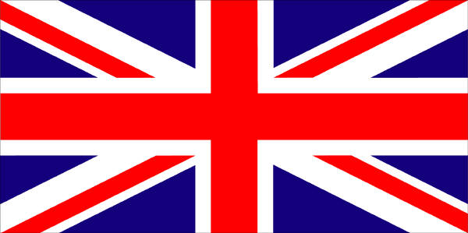
[1] Union Jack

ENGLAND
England is the largest and richest country in the United Kingdom. There are some national parks, historic towns, buildings and places, forests and gardens.
Stonehenge is one of the most well-known places. It is an ancient circle of stones situated on Salisbury Plain.
Salisbury Cathedral stands not far from Stonehenge. It is a beautiful gothic cathedral which was built in the 12th century.
Oxford and Cambridge – there are the oldest English universities in both these English cities.
Stratford-upon-Avon is known as the birthplace of Shakespeare.

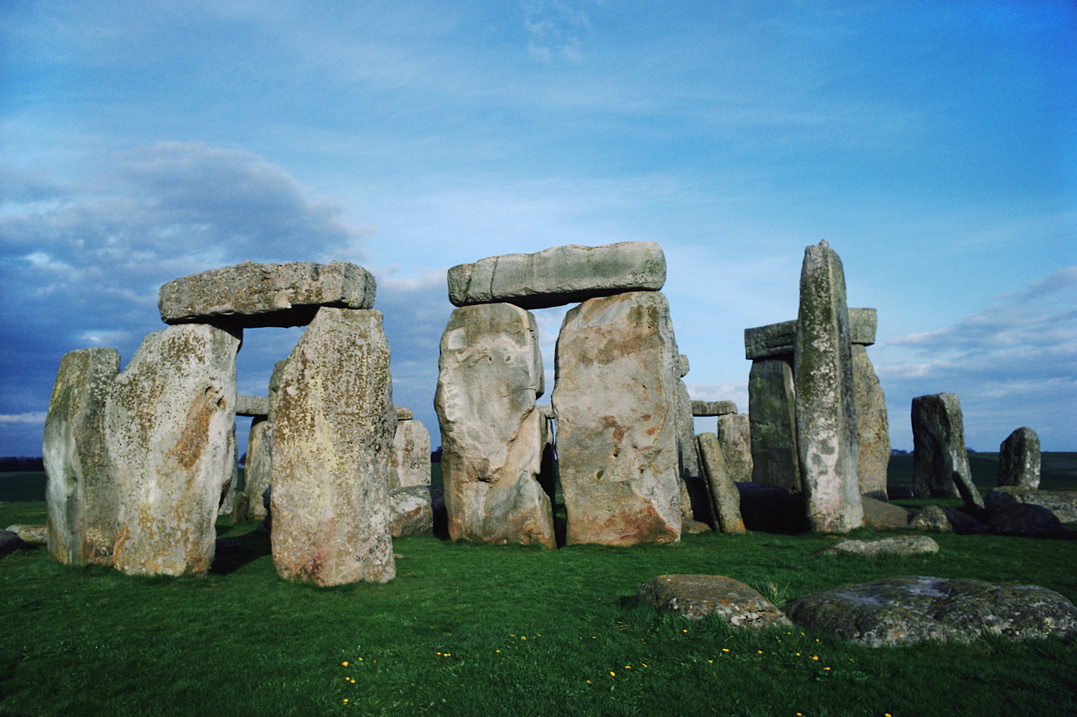
[2] Stonehenge

WALES
It is a small country to the west of England.
Cardiff is the capital and largest city. It is situated on the south coast. For many years it was a very important port from which Welsh coal was exported to many parts of the world.

SCOTLAND
Scotland is situated in the north of England. Scotland´s landscape is very nice. There are a lof of hills, mountains and lakes. Loch Ness is the most famous lake – it is said that a monster called Nessie lives in the lake.
Edinburgh is the capital of Scotland. It is a romantic city with a big contrast between the Old Town with narrow streets and the New Town with wide avenues.
Glasgow is the third largest city of the United Kingdom situated on the river Clyde.

NORTHERN IRELAND
It is the smallest country in the United Kingdom also called Ulster. It is situated in the north-east part of Ireland.
Belfast is the capital city and a very important port on the north-east coast. It is also an industrial and commercial centre.

Answer the following questions. Use the map Fakta o Velké Británii
How many countries are there in the UK? _______________________________
Which are they? ___________________________________________________
What is the capital of the UK? ________________________________________
Is Cardiff the capital of Wales? ________________________________________
What is the capital of Scotland? _______________________________________
What is the population of the UK? _____________________________________
Is the Republic of Ireland a part of the UK? ______________________________
What is the name of the national flag of Britain? _________________________
Where was Shakespeare born? _______________________________________
An ancient circle of stones is called ____________________________________
What are the names of the two university towns? ________________________

Draw the national flag of Britain. Nakresli vlajku Británie.

Řešení
Answer the following questions.
How many countries are there in the UK? There are 4 countries in the UK.
Which are they? England, Scotland, Wales and Northern Ireland
What is the capital of the UK? London is the capital of the UK.
Is Cardiff the capital of Wales? Yes, it is.
What is the capital of Scotland? Edindburgh is the capital of Scotland.
What is the population of the UK? The population is about 62 million people.
Is the Republic of Ireland a part of the UK? No, it isn´t.
What is the name of the national flag of Britain? Union Jack.
Where was Shakespeare born? He was born in Stratford-upon-Avon.
An ancient circle of stones is called Stonehenge.
What are the names of the two university towns? The towns are called Oxford and Cambridge.

