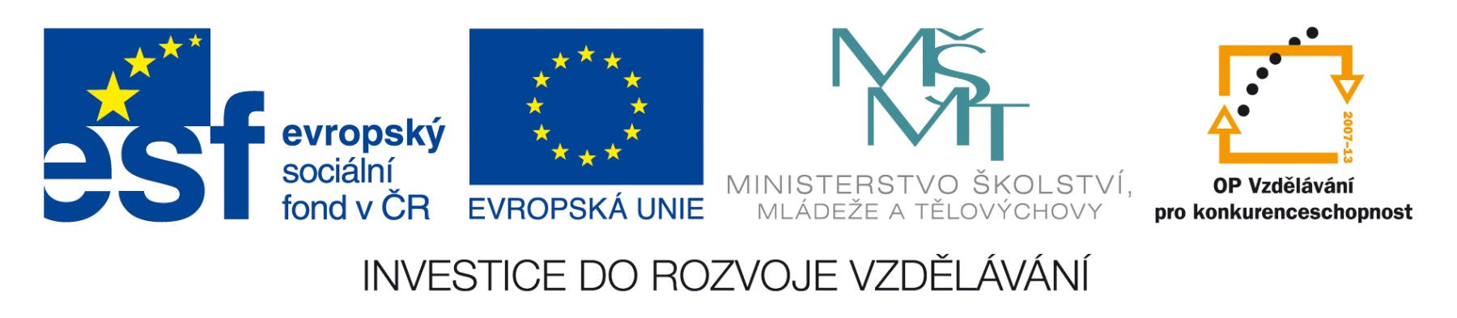


Obchodní akademie a Jazyková škola
s právem státní jazykové zkoušky Jihlava

Šablona 32
VY_32_INOVACE_147.ANJ.34
Domov

- Číslo projektu: CZ.1.07/1.5.00/34.0744
- Šablona: VY_32_INOVACE
- Číslo DUMU: 147.ANJ.34
- Předmět: Anglický jazyk
- Název materiálu: Domov
- Autor: Jiří Karafiát
- Formát: Microsoft Office Word
- Velikost: 143 kB
- Stupeň a typ vzdělávání: SŠ – odborné vzdělávání
- Licence k obrazovému materiálu: CC BY
- Datum vytvoření: 4. 12. 2012
- Klíčová slova: parts of a house, types of houses and flats, condition and size, location, renting a flat, housework
- Anotace: Je to test z učebnice Maturita Activator. Žáci překládají, odpovídají na otázky a konají podle pokynů.
HOME (Activator Unit 2)
- Name at least 8 things in a kitchen.
- Name at least 8 things in a bedroom.
- What do you usually vacuum?
- Skliď ten nepořádek ze stolu.
- When do people feel homesick?
- Discuss or write as a dictation and then choose one expression that is very importatnt, quite importatnt and not very importatnt for living in a flat and why/ why not: spacious rooms, a bathroom with only a shower, south-facing garden, easy access to local shopping and transport facilities, fitted wardrobes, a leather sofa, no furniture.
- What do the surroundings of your house/flat look like?
- What household chores should teenagers do?
- What relationship do you have with your neighbours?
- Describe a semi-detached house.
- Describe terraced houses.
- Describe a detached house.
- Descibe a skyscraper.
- Describe a cottage.
- What are the advantages and disadvantages of living in the centre of a city/town, in the suburb of a city or in the countryside.
- Describe your ideal house in 80-100 words.
- What is the opposite to SPACIOUS ?
- What is the opposite to IN BAD CONDITION?
- What does a real estate agent do?
- Explain in English: Everything in the house is powered by solar energy.

KEY:
- cooker, cupboard, dishwasher, fridge, freezer, microwave oven, oven, sink, rubbish bin, toaster, plates, dishes, pots, pans, knives, spoons, forks
- bed, bedside table, blanket, chair, chest of drawers. dressing table, lamp, pillow, rug, sheet, wardrobe, shelf
- The floor.
- Clear away the mess from the table.
- When they’re away from their family and friends.
- Students‘ own answers.
- Students‘ own answers.
- Possible answer: They should tidy up their room, vacuum the floors, do the washing up, help parents with cooking, lay the table, take the rubbish bin out to the dustbin.
- Students‘ own answers
- That’s a house joined to another house.
- They are several houses in a row joined to each other.
- That’s a house not joined to another house.
- That’s a very tall city building with many floors.
- That’s a small house in the country.
- Possible answer:
the centre of a city/town – transport, schools, jobs, culture facilities are near, higher rent, noisy streets
in the suburb – most facilities are further away, usually quieter streets and not so much traffic
in the country – more space in the house and around, very few jobs, educational and cultural opportunities, lower cost of living
- Students‘ own answers.
- tiny/small
- in good condition
- They sell and buy houses and flats.
- You only use the energy from the sun for heating, electricity and cooking.

Použitý materiál:
Vlastní práce
Autorem materiálu a všech jeho částí, není-li uvedeno jinak, je Jiří Karafiát

