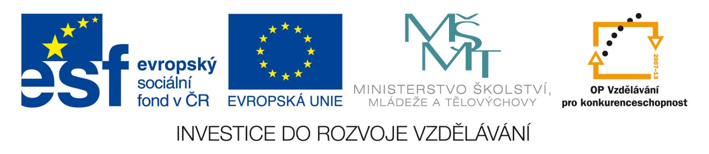


Obchodní akademie a Jazyková škola
s právem státní jazykové zkoušky Jihlava

Šablona 32
VY_32_INOVACE_148.ANJ.34
Škola

- Číslo projektu: CZ.1.07/1.5.00/34.0744
- Šablona: VY_32_INOVACE
- Číslo DUMU: 148.ANJ.34
- Předmět: Anglický jazyk
- Název materiálu: Škola
- Autor: Jiří Karafiát
- Formát: Microsoft Office Word
- Velikost: 143 kB
- Stupeň a typ vzdělávání: SŠ – odborné vzdělávání
- Licence k obrazovému materiálu: CC BY
- Datum vytvoření: 9. 12. 2012
- Klíčová slova: types of school, places in a school, people in a school, subjects, school objects, exams, teachers and students
- Anotace: Je to test z učebnice Maturita Activator. Žáci překládají, odpovídají na otázky a konají podle pokynů.
SCHOOL (ACTIVATOR Unit 3)
- Write what you can do in a library?
- Write what you can do in a science lab?
- Letos maturuji. Stres je hrozný.
- Who is more important at school: a deputy head or head teacher?
- In which subject do you draw and paint?
- In which subject do you do experiments?
- What do you do in geography?
- What do students get if they pass exams at the end of their studies?
- Match DO and MAKE with the following words?
……….. exercises ……….. my best ……….. progress
……….. homework ……….. notes ……….. well
- What do you like and don’t like in your school? (write 60-70 words)
- Which subjects do you have to study: OPTIONAL or COMPULSORY?
- Translate: She set us an essay on the causes of World War II.
- What qualities should a good teacher have? (give at least 3)
- How can students cheat at school?
- Explain in English: TIMETABLE/SCHEDULE
- Who visits school and who attends it?
- Explain in English: He GRADUATED FROM university.
- Describe your school facilities.
- Jeden důvod, proč jsou studenti úspěšní, je, že mají víc hodin než v jiné škole.
- Četl jsem váš inzerát a zajímám se o váš kurz.

Key:
- You can borrow a give back books and magazines, you can work on a computer or listen to CDs.
- You can do experiments.
- I am taking the school-leaving/graduation exam this year. The stress is dreadful.
- head teacher
- in art
- in science/chemistry
- You read maps.
- the school certificate
- do exercises, do my best, make progress, do homework, make notes, do well
- Students’own answers.
- compulsory
- Zadala nám referát/slohovou práci o příčinách 2. světové války.
- Possible answer: patient, demanding but fair, punctual, systematic
- They can copy from other students or textbooks or use a crib.
- It is a plan of subjects and times that are taught.
- Parents and other guests visit school, students attend it.
- He finished school successfully with final examinations.
- Students’own answers.
- One reason why students are successful is that they have more lessons than in other schools.
- I have read your advertisement and I am interested in taking a course.
Použitý materiál:
Vlastní práce
Autorem materiálu a všech jeho částí, není-li uvedeno jinak, je Jiří Karafiát

