


Název školy: | Střední škola sociální PERSPEKTIVA a Vyšší odborná škola, s.r.o.
Adresa: | Mírová 218/6, Dubí III Pozorka
Název projektu | KLÍČE K POZNÁVÁNÍ
Registrační číslo projektu: | CZ.1.07/1.5.00/34.0928
Šablona: | II/2 Inovace a zkvalitnění výuky cizích jazyků na středních školách
Název a číslo materiálu: | VY_22_INOVACE_AJ3A_15
Vytvořeno: | 7. 8. 2013
Autor: | Mgr. Jaroslava Jelínková
Vyučovací předmět: | Anglický jazyk
Ročník: | I.-IV.
Anotace: | Didaktický učební materiál je určen pro žáky maturitních oborů SOŠ. Je zaměřen na procvičení slovní zásoby, slovních obratů a frází, tvoření otázek.
Klíčová slova: | Check-in  Boarding  At the airport
Výsledky vzdělávání dle RVP: | Žák dovede klást účelné otázky, umí sdělit potřebné informace a vhodně reaguje. Dovede používat vhodné gramatické vazby.
Typ interakce: | aktivita
Druh výukového zdroje: | Pracovní list

1. Fill in the correct word and translate the sentences.
- Hello, it´s Prague ………………. How can I help you? – I would like to ……………… a flight to London.
- How long does it ……………… to fly to Kairo? – Ten ………………. .
- What time will we ……………… in Moscow? – We will be there at 3 p.m.
- I often ……………… to Spain.
- Where shall I put my ……………… ? – Put it on the ……………… .
- Dear passengers, our plane is now moving to the ……………… .
- Show me your ……………… , please.
2. Put the sentences into correct order to make a conversation.
a) At the window, please.
b) Just a minute! Where is my ticket? Oh, here. Here it is.
c) Yes, of course. Where would you like to sit?
d) Good morning. Your ticket and ID, please.
e) Yes, here´s the suitcase. Can I take this as hand luggage?
f) Thank you. Do you want to hand in your luggage?
g) At the window ..... Yes it is OK. Here is your boarding pass. It is the gate nr. G22. Have a good flight!

a) | b) | c) | d) | e) | f) | g)

3. Prepare two dialogues, use given vocabulary.

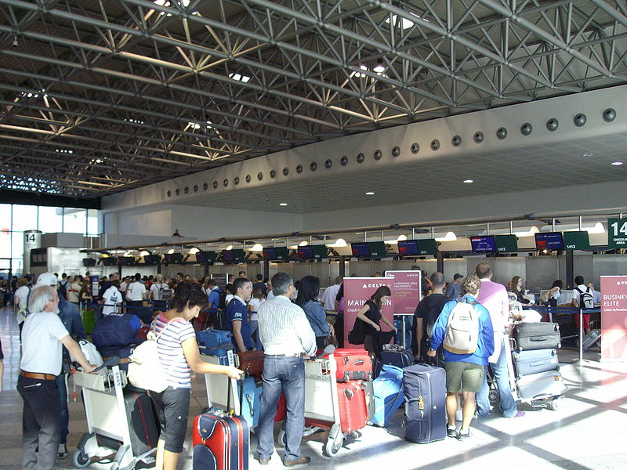
- What – do- for you-can-I?
- Want to – I - Book - flight to Berlin.
- Flying – you – alone- are ?
- How long – the flight – take – does?
- does - how much - cost -plane ticket?
- it – direct flight – is ?
- I- have - please - your – can – ID card.
- where – I – put – my luggage - can?
- the belt - on – it- please - put.
10.the plane - when – take off - does?

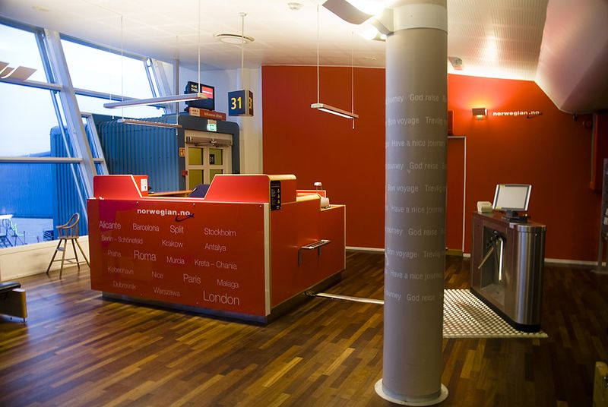
- show – luggage - good - plane tickets – can – morning - please – me - your - you – and?
- where - the ticket – just a moment - is ?
- here - I – it - Oh,- have.
- have - thank you – you – do – any - luggage?
- One suitcase - Yes, - here. This one – can - hand - take - I - baggage - as - please?
- You - sure - can. want to – you – do - where - sit?
- Would - at the window – like to - sit - I.
- here - your - is - Boarding Pass - Ok. - gate G 22. - Flight - good!

Řešení:
Task 2
a) | b) | c) | d) | e) | f) | g)
6 | 2 | 5 | 1 | 4 | 3 | 7

Additional exercise. Print out the sentences, cut it in pieces for students to arrange them in correct order. Students then can practice the dialogue.

Hello! What can I do for you?
I have book a flight to Madrid.
OK. Can you show me your plane tickets/ID?
Sure, just a moment. Here it is.
Thank you. Have you got any luggage?
Yes, one suitcase here and can I take this one as a hand luggage?
Yes, it´s no problem. Are you flying alone?
No, we are two.
OK. Where would you like to sit?
At the window. That´d be great.
Fine. Here´s your boarding pass. It´s Gate G 22. Good flight!

Zdroje:

MAILANDER00. Wikimedia commons [online]. [cit. 14.5.2013]. Dostupný na WWW: http://commons.wikimedia.org/wiki/File:New_Check-In_Aerea.JPG

MCLELLAN, Alasdair. Wikimedia commons [online]. [cit. 14.5.2013]. Dostupný na WWW: http://commons.wikimedia.org/wiki/File:Bergen_Airport_Gate_31.jpg

