


Název školy: | Střední škola sociální PERSPEKTIVA a Vyšší odborná škola, s.r.o.
Adresa: | Mírová 218/6, Dubí III Pozorka
Název projektu | KLÍČE K POZNÁVÁNÍ
Registrační číslo projektu: | CZ.1.07/1.5.00/34.0928
Šablona: | II/2 Inovace a zkvalitnění výuky cizích jazyků na středních školách
Název a číslo materiálu: | VY_32_INOVACE_AJ2A_17
Vytvořeno: | 7. 8. 2013
Autor: | Mgr. Jaroslava Jelínková
Vyučovací předmět: | Anglický jazyk
Ročník: | I.-IV.
Anotace: | Didaktický učební materiál je určen pro žáky maturitních oborů SOŠ. Je zaměřen na procvičení slovní zásoby a tvoření otázek. Je možné ho využít mnoha způsoby - práce na interaktivní tabuli či pro práci ve dvojicích v lavicích atd. Cvičení 2 obsahuje okna formulářů, ve cv. 3 lze se slovy pohybovat a skládat věty.
Klíčová slova: | directions  town
Výsledky vzdělávání dle RVP: | Žák dovede popsat směr, cestu z jednoho bodu do druhého. Je schopen se dotázat na informace, které jsou pro něj/ní relevantní a ujistit se, že informacím porozuměl.
Typ interakce: | Aktivita
Druh výukového zdroje: | Pracovní list

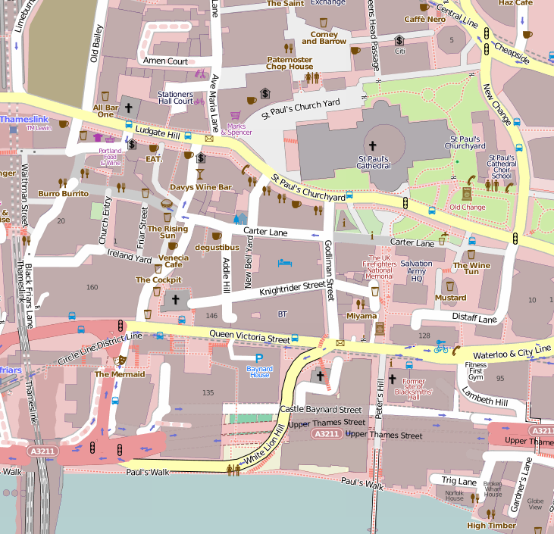
- Read the way description and mark the way in the map.

NEUVEDEN. Openstreetmap [online]. [cit. 2.6.2013]. Dostupný na WWW: http://www.openstreetmap.org
A: Excuse me, how can I get to .........................................? (You are at The Mermaid.)
B: Well, go towards the traffic lights,
cross the street and go straight on.
You´ll pass a few coffee shops.
After a few meters turn right and take the first turning left.
After few meters you´ll see it.

A: Excuse me, is there a .......................near here? (You are at the Baynar House.)
B: Let me think. Ok.
Go towards the main street,
turn right and go straight on.
You´ll come to a big crossroads – turn left there and
go along the Godliman Street.
Take the first turning right and there is a very good one.

A: Excuse me, how do I get to the river? (You are at St. Paul´s Cathedral.)
B: Hi! It´s easy!
Pass the information centre and
Go straight on until you reach the crossroads.
Turn left and then
take the first turning right into the Peter´s hill street.
Go straight on and you´ll see it from a distance.
There´s a relaxing Paul´s Walk along the river.

- Choose the correct option

- Excuse me, how can I get to the cathedral?
- Ok, go on until you reach the crossroads. Then turn left. Then take the second turning right. There you can see the St. Paul´s cathedral.

- Excuse me , where is the city museum?
- At the Castle square. You have to pass the shopping mall and then turn right. Go along the park and until you reach the bus stop. It is just opposite the bus stop.

- Excuse me, is there a language school near here?
- Yes, it is in the city centre in Page Street. You have to cross the river. Go straight on, take the second turning right and you come to the marketplace. You´ll see a bridge. Cross it and turn right. Go towards the church and then you are there. The language school is the third building on the left.

- Make sentences
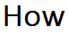
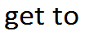
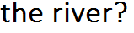
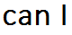

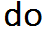
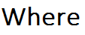
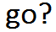
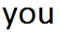

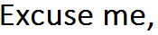
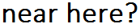
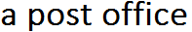
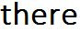

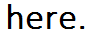
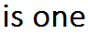
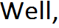
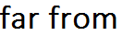
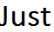
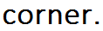

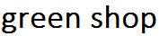

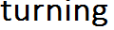
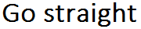
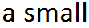
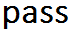

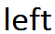
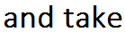
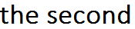

- Use the city plan from exercise one and describe the way from spot A to spot B.

- A = St.Paul´s Cathedral B = Venecia Caffé

- A = Trig Lane; B = The UK Firefighters National Memorial

- A = Salvation Army HQ; B = The Rising Sun

Solution:

Ex. 1

A: Excuse me, how can I get to St. Paul´s Cathedral?
B: Well, go towards the traffic lights, cross the street and go straight on. You´ll pass a few coffee shops. After a few meters turn right and take the first turning left. After few meters you´ll see it.
A: Excuse me, is there a coffee shop near here? (You are at the Baynar House.)
B: Let me think. Ok. Go towards the main street, turn right and go straight on. You´ll come to a big crossroads – turn left there and go along the Godliman Street. Take the first turning right and there is a very good one.
A: Excuse me, how do I get to the river? (You are at St. Paul´s Cathedral.)
B: Hi! It´s easy! Pass the information centre and go straight on until you reach the crossroads. Turn left and then take the first turning right into the Peter´s hill street. Go straight on and you´ll see it from a distance. There´s a relaxing Paul´s Walk along the river.

Ex.2

- Excuse me, how can I get to the cathedral?
- Ok, go on until you reach the crossroads. Then turn left. Then take the second turning right. There you can see the St. Paul´s cathedral.
- Excuse me , where is the city museum?
- At the Castle square. You have to pass the shopping mall and then turn right. Go along the park and until you reach the bus stop. It is just opposite the bus stop.

- Excuse me, is there a language school near here?
- Yes, it is in the city centre in Page Street. You have to cross the river. Go straight on, take the second turning right and you come to the marketplace. You´ll see a bridge. Cross it and turn right. Go towards the church and then you are there. The language school is the third building on the left.

Ex.3
- How can I get to the river?
- Where do you want to go?
- Excuse me, is there a post office near here?
- Well, there is one not far from here. Just over the corner.
- Go straight on, pass a small green shop and take the second turning left.

