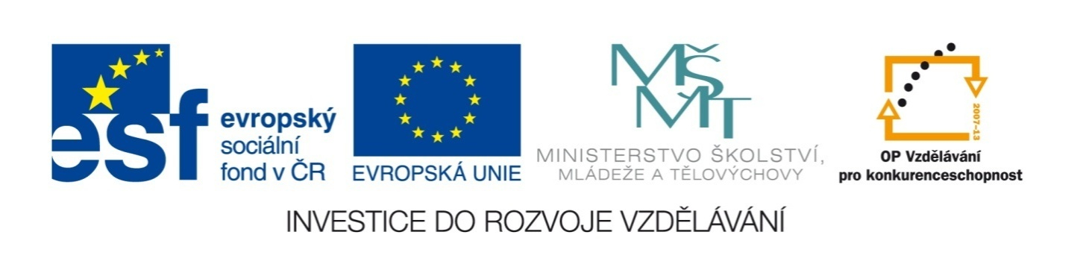

Název školy | ZÁKLADNÍ ŠKOLA, JIČÍN, HUSOVA 170
Číslo projektu | CZ.1.07/1.4.00/21.2862
Číslo a název klíčové aktivity | 3.2 Inovace a zkvalitnění výuky prostřednictvím ICT

Název DUM: | VY_32_INOVACE_XIV_3_15_MONEY AND BANKING
Šablona číslo: | XIV. |  | Sada číslo: | 3 | Pořadové číslo DUM: | 15
Autor: |  | Mgr. Zdeněk Jareš
Anotace: |  | Rozšíření slovní zásoby – peníze and bankovnictví.
Očekávaný výstup: |  | Žáci si osvojí novou slovní zásobu. Žáci jsou schopni porozumět definicím.
Druh učebního materiálu: |  | pracovní list
Typická věková skupina: |  | 8. - 9. ročník, 13 – 15 let
Klíčová slova: |  | money
Pomůcky a materiál: |  | pracovní list, psací potřeby
Potřebný čas pro výuku DUM: |  | 60 minut
Metodické zhodnocení a popis práce s digitálním učebním materiálem:
- Žáci se nejprve snaží vysvětlit význam přísloví a rčení, kterým rozumí.
- Žáci vyřeší definice, neznámá slova z tajenky si mohou vyhledat ve slovníku.

Zdroje:

Read the following sayings about money and try to explain their meaning:

Complete this crossword:
1
2
3
4
5
6
7
8
9
10
11
12
13
14
15
16
17
18
19
20
21
22
23

Complete this crossword:
 |  |  |  |  |  |  |  |  | 1 | M | O | R | T | G | A | G | E
 |  |  |  |  |  | 2 | A | C | C | O | U | N | T
 |  |  |  |  |  |  | 3 | B | A | N | K
 |  |  |  |  |  | 4 | S | A | F | E
 |  |  |  | 5 | S | A | L | A | R | Y
 |  |  |  |  |  |  |  |  | 6 | I | N | T | E | R | E | S | T
 |  |  |  |  |  |  | 7 | C | A | S | H |  | M | A | C | H | I | N | E
 |  |  |  | 8 | W | A | L | L | E | T
 |  |  |  |  |  | 9 | C | A | S | H
 |  |  |  |  |  |  |  | 10 | P | E | N | N | I | L | E | S | S
 |  |  |  |  |  |  | 11 | C | U | R | R | E | N | C | Y
 |  |  |  |  |  |  |  | 12 | C | O | I | N
 |  |  |  | 13 | P | E | N | S | I | O | N
 |  |  | 14 | B | A | N | K | N | O | T | E
 |  |  |  |  |  |  |  | 15 | P | O | C | K | E | T |  | M | O | N | E | Y
 |  | 16 | O | V | E | R | D | R | A | F | T
 |  |  |  |  |  |  |  | 17 | W | A | G | E
 |  |  |  |  |  |  | 18 | B | I | L | L
 |  |  |  |  |  | 19 | T | I | L | L
 |  |  |  |  |  |  |  | 20 | D | E | B | T
 |  |  |  |  |  |  | 21 | I | N | V | E | S | T | M | E | N | T
 |  |  |  |  |  |  |  |  | 22 | I | N | S | U | R | A | N | C | E
 |  |  |  |  |  |  |  |  | 23 | L | O | A | N

1 | The money which you borrow from a bank so that you can build a house.
2 | The arrangement with your bank to keep your money there. You can deposit or withdraw your money from it.
3 | The building where you keep your money and where you can get other financial services.
4 | A strong metal box where you keeps your money and valuable things.
5 | Money which you are given every months in exchange for your work.
6 | Extra money which you have to pay when you take a loan.
7 | The machine from which you can withdraw money from your bank account. It is usually place in a street or a supermarket.
8 | A small case where you have your money, credit cards, ...
9 | Money in the form of coins and bank notes.
10 | Someone who has no money.
11 | Type of money which is used in a particular country (e.g. dollar, euro, ...)
12 | A small round piece of metal which is used for paying.
13 | Money that you get from the state every month after you retire.
14 | A piece of paper money.
15 | Money that you regularly get from your parents (usually weekly or monthly).
16 | The agreement with your bank that you can spend more money that is on your bank account.
17 | Money you earn which is paid according to the number of hour you work.
18 | The list showing how much you have to pay for the work and services you have received.
19 | Machine in a shop which is used for calculating the money you have to pay.
20 | Money that you owe to somebody.
21 | Money which you put into a company or some business in order to get a profit.
22 | The arrangement with a company that you regularly pay them some money and they will help you if something bad happens to you (e.g. when your house burns down, your car is stolen, you are injured on holiday, ....)
23 | Money that you borrow from a bank.

