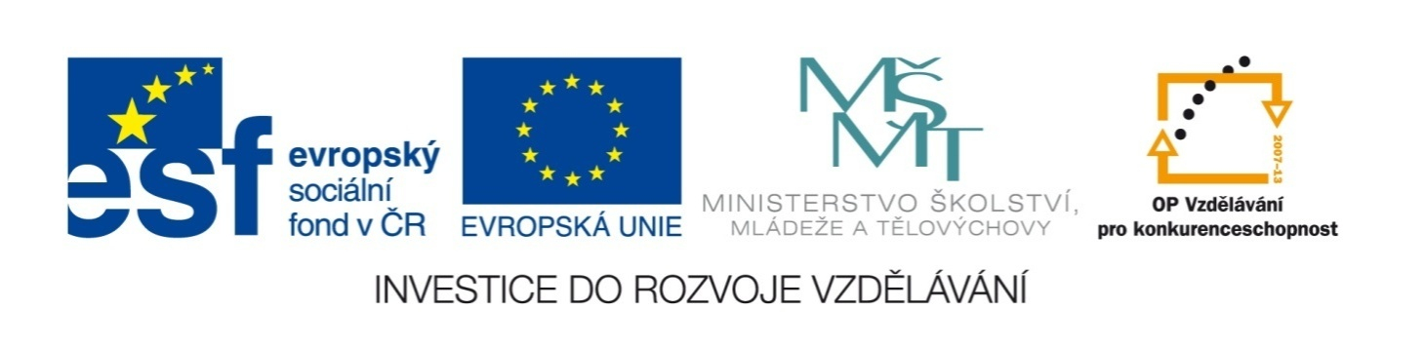

Název školy | ZÁKLADNÍ ŠKOLA, JIČÍN, HUSOVA 170
Číslo projektu | CZ.1.07/1.4.00/21.2862
Číslo a název klíčové aktivity | 3.2 Inovace a zkvalitnění výuky prostřednictvím ICT

Název DUM: | VY_32_INOVACE_XIV_3_17_AT THE HOSPITAL
Šablona číslo: | XIV. |  | Sada číslo: | 3 | Pořadové číslo DUM: | 17
Autor: |  | Mgr. Zdeněk Jareš
Anotace: |  | Rozšíření slovní zásoby – v nemocnici, nemocniční oddělení
Očekávaný výstup: |  | Žáci si osvojí novou slovní zásobu z oblasti zdravotnictví.
Druh učebního materiálu: |  | pracovní list
Typická věková skupina: |  | 8. - 9. ročník, 13 – 15 let
Klíčová slova: |  | hospital
Pomůcky a materiál: |  | pracovní list, psací potřeby
Potřebný čas pro výuku DUM: |  | 45 minut
Metodické zhodnocení a popis práce s digitálním učebním materiálem:
- Žáci vyřeší s pomocí slovníku křížovku.
- Žáci spojují jednotlivá nemocniční oddělení s popisem jejich pracovní náplně.
Zdroje:

 |  |  |  |  | 1 | D | O | C | T | O | R
 |  |  |  |  |  |  |  | 2 | H | O | S | P | I | T | A | L
 |  |  |  |  | 3 | I | N | J | E | C | T | I | O | N
 |  |  |  |  | 4 | S | U | R | G | I | C | A | L |  | M | A | S | K
 |  |  |  |  |  | 5 | N | U | R | S | E
6 | P | A | I | N | K | I | L | L | E | R
 |  |  |  |  |  |  | 7 | B | A | N | D | A | G | E
 |  |  |  |  | 8 | D | E | N | T | I | S | T
 |  |  |  |  | 9 | D | I | S | E | A | S | E
 |  |  |  | 10 | T | R | A | N | S | F | U | S | I | O | N
 |  |  | 11 | T | E | S | T |  | T | U | B | E
 |  |  |  |  |  |  |  | 12 | W | A | R | D |  | R | O | U | N | D
 |  |  |  | 13 | S | U | R | G | E | R | Y
 |  |  | 14 | A | M | B | U | L | A | N | C | E
 |  |  |  |  | 15 | S | C | A | L | P | E | L
 |  |  | 16 | S | P | L | I | N | T
 |  | 17 | W | H | E | E | L | C | H | A | I | R
 |  |  |  |  | 18 | A | N | T | I | B | I | O | T | I | C
 |  |  |  |  |  |  |  | 19 | S | U | C | T | I | O | N
 |  |  |  |  |  | 20 | A | D | H | E | S | I | V | E |  | P | L | A | S | T | E | R
 |  |  |  | 21 | R | U | B | B | E | R |  | G | L | O | V | E | S
 |  |  |  |  |  | 22 | P | L | A | S | T | E | R |  | C | A | S | T
 |  |  | 23 | O | R | D | E | R | L | Y
24 | D | I | S | I | N | F | E | C | T | A | N | T
 |  |  | 25 | C | R | U | T | C | H

1
2
3
4
5
6
7
8
9
10
11
12
13
14
15
16
17
18
19
20
21
22
23
24
25

1 | lékař | 9 | choroba | 17 | invalidní vozík
2 | nemocnice | 10 | transfuze | 18 | antibiotika
3 | injekce | 11 | zkumavka | 19 | odsávání
4 | rouška | 12 | vizita | 20 | náplast
5 | zdravotní sestra | 13 | operace | 21 | gumové rukavice
6 | léky na bolest | 14 | sanitka | 22 | sádra
7 | obvaz | 15 | skalpel | 23 | nemocniční zřízenec
8 | zubař | 16 | dlaha | 24 | dezinfekční prostředek
 |  |  |  | 25 | berle

Match the names of the following departments with their descriptions:
ACCIDENT AND EMERGENCY |  | Here doctors treat problems that affect your muscles, joints, bones, ligaments, tendons and nerves. They set bones fractures, replace hips, …
CARDIOLOGY |  | The department for the most seriously ill or injured patients. Patients need non-stop intensive care there.
CRITICAL CARE |  | In this department doctors test samples (blood, urine, …) sent to them from other departments. They look for bacterial and viral infections.
ENT |  | In this department they give you treatment that uses rubbing, taking exercises, heat etc. to help your problems with muscles.
ELDERLY SERVICES DEPARTMENT |  | This department operates 24 hours a day. People are taken there after accidents when they need immediate help.
HAEMATOLOGY |  | In this department they deal with the disorder of your nervous system (your brain, spinal cord).
MATERNITY DEPARTMENT |  | In this department doctors deal with problems with your heart and blood circulation.
MICROBIOLOGY |  | In this department doctors treat kidney and bladder problems.
NEUROLOGY |  | In this department they deal with skin diseases and their treatment.
DERMATOLOGY |  | In this department they look after old patients with various long-term problems, who can’t be looked after at home or old people’s home.
ORTHOPAEDICS |  | Women give birth there. This ward provides care during childbirth and gives postnatal support.
PHYSIOTHERAPY |  | In this department doctors treat blood diseases.
UROLOGY |  | In this department they deal with general ear, nose and throat diseases, they can treat hearing disorder, snoring, …

Match the names of the following departments with their descriptions: ANSWER KEY
ORTHOPAEDICS |  | Here doctors treat problems that affect your muscles, joints, bones, ligaments, tendons and nerves. They set bones fractures, replace hips, …
CRITICAL CARE |  | The department for the most seriously ill or injured patients. Patients need non-stop intensive care there.
MICROBIOLOGY |  | In this department doctors test samples (blood, urine, …) sent to them from other departments. They look for bacterial and viral infections.
PHYSIOTHERAPY |  | In this department they give you treatment that uses rubbing, taking exercises, heat etc. to help your problems with muscles.
ACCIDENT AND EMERGENCY |  | This department operates 24 hours a day. People are taken there after accidents when they need immediate help.
NEUROLOGY |  | In this department they deal with the disorder of your nervous system (your brain, spinal cord).
CARDIOLOGY |  | In this department doctors deal with problems with your heart and blood circulation.
UROLOGY |  | In this department doctors treat kidney and bladder problems.
DERMATOLOGY |  | In this department they deal with skin diseases and their treatment.
ELDERLY SERVICES DEPARTMENT |  | In this department they look after old patients with various long-term problems, who can’t be looked after at home or old people’s home.
MATERNITY DEPARTMENT |  | Women give birth there. This ward provides care during childbirth and gives postnatal support.
HAEMATOLOGY |  | In this department doctors treat blood diseases.
ENT (EAR, NOSE AND THROAT) |  | In this department they deal with general ear, nose and throat diseases, they can treat hearing disorder, snoring, …

