

Název školy | ZÁKLADNÍ ŠKOLA, JIČÍN, HUSOVA 170
Číslo projektu | CZ.1.07/1.4.00/21.2862
Číslo a název klíčové aktivity | 3.2 Inovace a zkvalitnění výuky prostřednictvím ICT

Název DUM: | VY_32_INOVACE_XIV_3_19_ENGLISH SPEAKING COUNTRIES QUIZ
Šablona číslo: | XIV. |  | Sada číslo: | 3 | Pořadové číslo DUM: | 19
Autor: |  | Mgr. Zdeněk Jareš
Anotace: |  | Reálie anglicky mluvících zemí – kvíz.
Očekávaný výstup: |  | Žáci získají některé informace o anglicky mluvících zemích.
Druh učebního materiálu: |  | pracovní list
Typická věková skupina: |  | 8. - 9. ročník, 13 – 15 let
Klíčová slova: |  | the USA, the United Kingdom, Canada, Australia, New Zealand
Pomůcky a materiál: |  | pracovní list, psací potřeby
Potřebný čas pro výuku DUM: |  | 60 minut
Metodické zhodnocení a popis práce s digitálním učebním materiálem:
- Žáci pracují ve skupinkách a snaží se vybrat správnou odpověď ze čtyř možností. Podle obtížnosti otázky získávají svou výhru. Tým, který získá nejvíce „dolarů“ zvítězí.
- Některé odpovědi je nutné průběžně aktualizovat!
Zdroje: http://en.wikipedia.org/wiki/File:USDnotes.png

1) Which of these American fast food restaurant chains is the oldest? |  | $10
a) Burger King | c) Pizza Hut
b) Mc Donald’s | d) KFC

2) Which of these mountains is the highest? |  | $5
a)Ben Nevis (Scotland) | c)Mount Kosciuszko (Australia)
b)Mount McKinley (Alaska, the USA) | d)Mount Logan (Canada)

3) Which of these official residences of presidents, monarchs and governors is the youngest? |  | $10
a)Buckingham Palace (London) | c)Government House (Canberra)
b)The White House (Washington D.C.) | d)Rideau Hall (Ottawa)

4) In which of the following cities can you find the highest building in the USA? |  | $5
a)Chicago | c)New York
b)Boston | d)Los Angeles

5) Which American city is nicknamed Valley of the Sun? |  | $10
a)Phoenix | c)San Francisco
b)Atlanta | d)Dallas

6) A teetotaller is someone who ... |  | $10
a)loves tea | c)doesn’t drink any alcohol
b)hates tea | d)sells tea in the market

7) London hosted the Olympic Games in the years ... |  | $10
a)1900, 1932, 2008 | c)1908, 1948, 2012
b)1952, 1980, 2012 | d)1912, 1960, 2000

8) Who is the current Prime Minister of the United Kingdom? |  | $5
a)David Cameron | c)Tony Blair
b)Sir John Major | d)Gordon Brown

9) Who was the first American President? |  | $5
a)Thomas Jefferson | c)George Washington
b)Abraham Lincoln | d)John Adams

10) How many British colonies in America declared independence and formed the USA in 1776? |  | $5
a)6 | c)13
b)10 | d)50

11) When did the USA join the Second World War? |  | $5
a)6th June 1944 | c)1st September 1939
b)7th December 1941 | d)7th December 1940

12) Which of the following US universities is the oldest? |  | $10
a)Yale University | c)Harvard University
b)Princeton University | d)MIT

13) Which American actor lived in Australia? |  | $5
a)Russell Crowe | c)Paul Hogan
b)Tom Hanks | d)Mel Gibson

14) When did the popular US animated sitcom the Simpsons start? |  | $10
a)1978 | c)1989
b)1985 | d)1994

15) The population of the USA is nearly ... |  | $5
a)290, 000, 000 people | c)310, 000, 000 people
b)300, 000, 000 people | d)320, 000, 000 people

16) Barack Hussein Obama became the 44th president of the USA in ... |  | $5
a)2008 | c)2010
b)2009 | d)2011

17) The population of New Zealand is nearly ... |  | $5
a)2, 500, 000 | c)6, 750, 000
b)4, 500, 000 | d)10, 000, 000

18) What is the largest city in New Zealand? |  | $5
a)Auckland | c)Wellington
b)Christchurch | d)Hamilton

19) All Blacks is the name of the New Zealand national team of ... |  | $10
a)cricket | c)rugby
b)football | d)water polo

20) At the beginning of each match this team performs a challenge dance called ... |  | $20
a)cibi | c)siva tau
b)hula | d)haka

21) Most of the first settlers in Australia were ... |  | $10
a)pilgrims | c)gold-diggers
b)convicts | d)refugees

22) The famous British director Ridley Scott didn’t make only one of these films. Which one was it? |  | $20
a)Gladiator (starring actor – Russell Crowe) | c)Robin Hood (starring actor – Russell Crowe)
b)Kingdom of Heaven (starring actor – Orlando Bloom) | d)Braveheart (starring actor – Mel Gibson)

23) Which noble family does Queen Elisabeth II come from? |  | $10
a)the House of Tudor | c)the House of York
b)the House of Windsor | d)the House of Hanover

24) Union Jack is the national flag of ... |  | $5
a)The United States of America | c)Commonwealth of Australia
b)The United Kingdom of Great Britain and Northern Ireland | d)New Zealand

25) When did the UK join the European Union? |  | $10
a)1965 | c)1973
b)1967 | d)1979

26) What is the capital city of the Australian state Queensland? |  | $10
a)Perth | c)Melbourne
b)Sydney | d)Brisbane

27) Who can you find on 100 USD bill? |  | $10
a)Andrew Jackson | c)Thomas Jefferson
b)Benjamin Franklin | d)Ulysses S. Grant

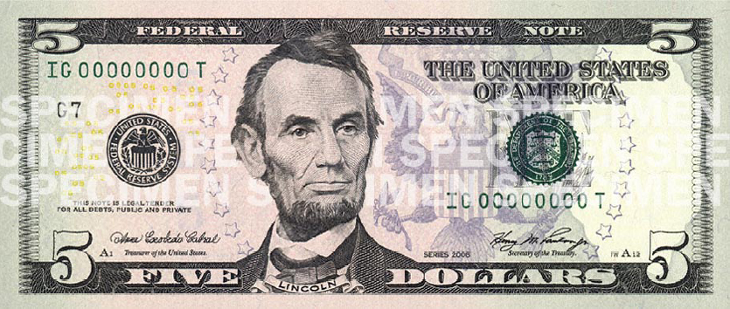

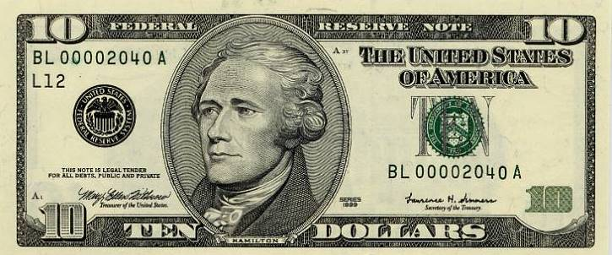

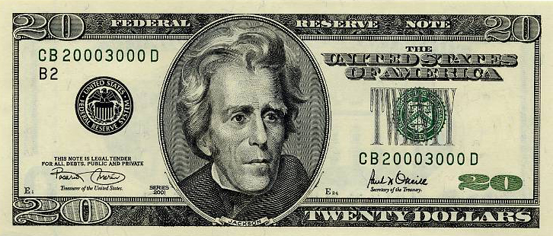

1) Which of these American fast food restaurant chains is the oldest? |  | $10
a) Burger King (1953) | c) Pizza Hut (1958)
b) Mc Donald’s (1940) | d) KFC (1930)

2) Which of these mountains is the highest? |  | $5
a)Ben Nevis (Scotland) 1,344 m | c)Mount Kosciuszko (Australia) 2,228 m
b)Mount McKinley (Alaska, the USA) 6,194 m | d)Mount Logan (Canada) 5, 959 m

3) Which of these official residences of presidents, monarchs and governors is the youngest? |  | $10
a)Buckingham Palace (London) 1703 | c)Government House (Canberra) 1859
b)The White House (Washington D.C.) 1792 | d)Rideau Hall (Ottawa) 1838

4) In which of the following cities can you find the highest building in the USA? |  | $5
a)Chicago | c)New York (One World Trade Centre – 541 m)
b)Boston | d)Los Angeles

5) Which American city is nicknamed Valley of the Sun? |  | $10
a)Phoenix | c)San Francisco
b)Atlanta | d)Dallas

6) Who is a teetotaller is someone who ... |  | $10
a)loves tea | c)doesn’t drink any alcohol
b)hates tea | d)sells tea in the market

7) London hosted the Olympic Games in the years ... |  | $10
a)1900, 1932, 2008 | c)1908, 1948, 2012
b)1952, 1980, 2012 | d)1912, 1960, 2000

8) Who is the current Prime Minister of the United Kingdom? |  | $5
a)David Cameron | c)Tony Blair
b)Sir John Major | d)Gordon Brown

9) Who was the first American President? |  | $5
a)Thomas Jefferson | c)George Washington
b)Abraham Lincoln | d)John Adams

10) How many British colonies in America declared independence and formed the USA in 1776? |  | $5
a)6 | c)13
b)10 | d)50

11) When did the USA join the Second World War? |  | $5
a)6th June 1944 | c)1st September 1939
b)7th December 1941 | d)7th December 1940

12) Which of the following US universities is the oldest? |  | $10
a)Yale University (1701) | c)Harvard University (1636)
b)Princeton University (1746) | d)MIT (1861)

13) Which American actor lived in Australia? |  | $5
a)Russell Crowe | c)Paul Hogan
b)Tom Hanks | d)Mel Gibson

14) When did the popular US animated sitcom the Simpsons start? |  | $10
a)1978 | c)1989
b)1985 | d)1994

15) The population of the USA is nearly ... |  | $5
a)290, 000, 000 people | c)310, 000, 000 people
b)300, 000, 000 people | d)320, 000, 000 people

16) Barack Hussein Obama became the 44th president of the USA in ... |  | $5
a)2008 | c)2010
b)2009 | d)2011

17) The population of New Zealand is nearly ... |  | $5
a)2, 500, 000 | c)6, 750, 000
b)4, 500, 000 | d)10, 000, 000

18) What is the largest city in New Zealand? |  | $5
a)Auckland (1,418,000) | c)Wellington (397,900)
b)Christchurch (379,100) | d)Hamilton (212,000)

19) All Blacks is the name of the New Zealand national team of ... |  | $10
a)cricket | c)rugby
b)football | d)water polo

20) At the beginning of each match this team performs a challenge dance called ... |  | $20
a)cibi (Fijian challenge dance) | c)siva tau (Samoan challenge dance)
b)hula (Hawaiian challenge dance) | d)haka

21) Most of the first settlers in Australia were ... |  | $10
a)pilgrims | c)gold-diggers
b)convicts | d)refugees

22) The famous British director Ridley Scott didn’t make only one of these films. Which one was it? |  | $20
a)Gladiator (starring actor – Russell Crowe) | c)Robin Hood (starring actor – Russell Crowe)
b)Kingdom of Heaven (starring actor – Orlando Bloom) | d)Braveheart (starring actor – Mel Gibson)

23) Which noble family does Queen Elisabeth II come from? |  | $10
a)the House of Tudor | c)the House of York
b)the House of Windsor | d)the House of Hanover

24) Union Jack is the national flag of ... |  | $5
a)The United States of America | c)Commonwealth of Australia
b)The United Kingdom of Great Britain and Northern Ireland | d)New Zealand

25) When did the UK join the European Union? |  | $10
a)1965 | c)1973
b)1967 | d)1979

26) What is the capital city of the Australian state Queensland? |  | $10
a)Perth | c)Melbourne
b)Sydney | d)Brisbane

27) Who can you find on 100 USD bill? |  | $10
a)Andrew Jackson | c)Thomas Jefferson
b)Benjamin Franklin | d)Ulysses S. Grant

