Tento materiál byl vytvořen v rámci projektu Operačního programu Vzdělávání pro konkurenceschopnost.
Projekt MŠMT ČR | EU PENÍZE ŠKOLÁM
Číslo projektu | CZ.1.07/1.4.00/21.2079
Název projektu školy | Inovace ZŠ Bílé Podolí
Šablona III/2 | Inovace a zkvalitnění výuky prostřednictvím ICT

SADA č. II
Identifikátor: VY_32_INOVACE_SADA II_MI., DUM 12
Vzdělávací oblast: Matematika a její aplikace
Vzdělávací obor: Matematika

Autor: Stanislava Šindelářová
Základní škola a Mateřská škola Bílé Podolí, okres Kutná Hora
Hodina byla pilotně odučena 11. 4. 2013 v třídě I., 2. ročníku.



METODICKÝ LIST

Název: MATEMATICKÝ SLALOM, 2. ročník
Stručná anotace: Procvičování násobilky formou hry

Postup práce:
- První list je herní plán, zbývající listy obsahují karty s příklady na procvičení násobení i dělení.
- Herní plán je možné zvětšit. Karty je nutné vystříhat a nejlépe zalaminovat.
- Pro samotnou hru využijeme figurky ze stolní hry Člověče, nezlob se.
- Hráči si svoji figurku postaví na start Matematického slalomu.
- Hra spočívá v tom, že si hráči postupně berou z hromádky karty s příklady. Když příklad vypočítají správně, postupují na další políčko. V případě, že odpoví špatně, o jedno políčko se vrací. Cílem hry je dostat se do cíle co nejdříve a s nejmenším počtem chyb.
(Karty je možné využít i samostatně i individuálnímu procvičování žáků.)

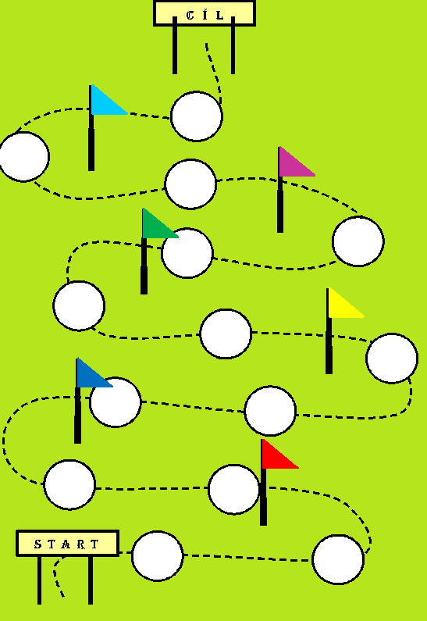
0 ⋅ 1 = ? | 0 ⋅ 2 = ?
0 ⋅ 3 = ? | 0 ⋅ 4 = ?
0 ⋅ 5 = ? | 0 ⋅ 6 = ?
0 ⋅ 7 = ? | 0 ⋅ 8 = ?
0 ⋅ 9 = ? | 0 ⋅ 10 = ?
1 ⋅ 1 = ? | 1 ⋅ 2 = ?
1 ⋅ 3 = ? | 1 ⋅ 4 = ?
1 ⋅ 5 = ? | 1 ⋅ 6 = ?
1 ⋅ 7 = ? | 1 ⋅ 8 = ?
1 ⋅ 9 = ? | 1 ⋅ 10 = ?
2 ⋅ 1 = ? | 2 ⋅ 2 = ?
2 ⋅ 3 = ? | 2 ⋅ 4 = ?
2 ⋅ 5 = ? | 2 ⋅ 6 = ?
2 ⋅ 7 = ? | 2 ⋅ 8 = ?
2 ⋅ 9 = ? | 2 ⋅ 10 = ?
3 ⋅ 1 = ? | 3 ⋅ 2 = ?
3 ⋅ 3 = ? | 3 ⋅ 4 = ?
3 ⋅ 5 = ? | 3 ⋅ 6 = ?
3 ⋅ 7 = ? | 3 ⋅ 8 = ?
3 ⋅ 9 = ? | 3 ⋅ 10 = ?
4 ⋅ 1 = ? | 4 ⋅ 2 = ?
4 ⋅ 3 = ? | 4 ⋅ 4 = ?
4 ⋅ 5 = ? | 4 ⋅ 6 = ?
4 ⋅ 7 = ? | 4 ⋅ 8 = ?
4 ⋅ 9 = ? | 4 ⋅ 10 = ?
5 ⋅ 1 = ? | 5 ⋅ 2 = ?
5 ⋅ 3 = ? | 5 ⋅ 4 = ?
5 ⋅ 5 = ? | 5 ⋅ 6 = ?
5 ⋅ 7 = ? | 5 ⋅ 8 = ?
5 ⋅ 9 = ? | 5 ⋅ 10 = ?
20 : 2 = ? | 18 : 2 = ?
16 : 2 = ? | 14 : 2 = ?
12 : 2 = ? | 10 : 2 = ?
8 : 2 = ? | 6 : 2 = ?
4 : 2 = ? | 2 : 2 = ?
30 : 3 = ? | 27 : 3 = ?
24 : 3 = ? | 21 : 3 = ?
18 : 3 = ? | 15 : 3 = ?
12 : 3 = ? | 9 : 3 = ?
6 : 3 = ? | 3 : 3 = ?
40 : 4 = ? | 36 : 4 = ?
32 : 4 = ? | 28 : 4 = ?
24 : 4 = ? | 20 : 4 = ?
16 : 4 = ? | 12 : 4 = ?
8 : 4 = ? | 4 : 4 = ?
50 : 5 = ? | 45 : 5 = ?
40 : 5 = ? | 35 : 5 = ?
30 : 5 = ? | 25 : 5 = ?
20 : 5 = ? | 15 : 5 = ?
10 : 5 = ? | 5 : 5 = ?
2 ⋅ ? = 0 | 2 ⋅ ? = 2
2 ⋅ ? = 4 | 2 ⋅ ? = 6
2 ⋅ ? = 8 | 2 ⋅ ? = 10
2 ⋅ ? = 12 | 2 ⋅ ? = 14
2 ⋅ ? = 16 | 2 ⋅ ? = 18
2 ⋅ ? = 20 | 3 ⋅ ? = 0
3 ⋅ ? = 3 | 3 ⋅ ? = 6
3 ⋅ ? = 9 | 3 ⋅ ? = 12
3 ⋅ ? = 15 | 3 ⋅ ? = 18
3 ⋅ ? = 21 | 3 ⋅ ? = 24
3 ⋅ ? = 27 | 3 ⋅ ? = 30
4 ⋅ ? = 0 | 4 ⋅ ? = 4
4 ⋅ ? = 8 | 4 ⋅ ? = 12
4 ⋅ ? = 16 | 4 ⋅ ? = 20
4 ⋅ ? = 24 | 4 ⋅ ? = 28
4 ⋅ ? = 32 | 4 ⋅ ? = 36
4 ⋅ ? = 40 | 5 ⋅ ? = 0
5 ⋅ ? = 5 | 5 ⋅ ? = 10
5 ⋅ ? = 15 | 5 ⋅ ? = 20
5 ⋅ ? = 25 | 5 ⋅ ? = 30
5 ⋅ ? = 35 | 5 ⋅ ? = 40
5 ⋅ ? = 45 | 5 ⋅ ? = 50

řešení
0 ⋅ 1 = 0 | 0 ⋅ 2 = 0
0 ⋅ 3 = 0 | 0 ⋅ 4 = 0
0 ⋅ 5 = 0 | 0 ⋅ 6 = 0
0 ⋅ 7 = 0 | 0 ⋅ 8 = 0
0 ⋅ 9 = 0 | 0 ⋅ 10 = 0
1 ⋅ 1 = 1 | 1 ⋅ 2 = 2
1 ⋅ 3 = 3 | 1 ⋅ 4 = 4
1 ⋅ 5 = 5 | 1 ⋅ 6 = 6
1 ⋅ 7 = 7 | 1 ⋅ 8 = 8
1 ⋅ 9 = 9 | 1 ⋅ 10 = 10
2 ⋅ 1 = 2 | 2 ⋅ 2 = 4
2 ⋅ 3 = 6 | 2 ⋅ 4 = 8
2 ⋅ 5 = 10 | 2 ⋅ 6 = 12
2 ⋅ 7 = 14 | 2 ⋅ 8 = 16
2 ⋅ 9 = 18 | 2 ⋅ 10 = 20
3 ⋅ 1 = 3 | 3 ⋅ 2 = 6
3 ⋅ 3 = 9 | 3 ⋅ 4 = 12
3 ⋅ 5 = 15 | 3 ⋅ 6 = 18
3 ⋅ 7 = 21 | 3 ⋅ 8 = 24
3 ⋅ 9 = 27 | 3 ⋅ 10 = 30
4 ⋅ 1 = 4 | 4 ⋅ 2 = 8
4 ⋅ 3 = 12 | 4 ⋅ 4 = 16
4 ⋅ 5 = 20 | 4 ⋅ 6 = 24
4 ⋅ 7 = 28 | 4 ⋅ 8 = 32
4 ⋅ 9 = 36 | 4 ⋅ 10 = 40
5 ⋅ 1 = 5 | 5 ⋅ 2 = 10
5 ⋅ 3 = 15 | 5 ⋅ 4 = 20
5 ⋅ 5 = 25 | 5 ⋅ 6 = 30
5 ⋅ 7 = 35 | 5 ⋅ 8 = 40
5 ⋅ 9 = 45 | 5 ⋅ 10 = 50
20 : 2 = 10 | 18 : 2 = 9
16 : 2 = 8 | 14 : 2 = 7
12 : 2 = 6 | 10 : 2 = 5
8 : 2 = 4 | 6 : 2 = 3
4 : 2 = 2 | 2 : 2 = 1
30 : 3 = 10 | 27 : 3 = 9
24 : 3 = 8 | 21 : 3 = 7
18 : 3 = 6 | 15 : 3 = 5
12 : 3 = 4 | 9 : 3 = 3
6 : 3 = 2 | 3 : 3 = 1
40 : 4 = 10 | 36 : 4 = 9
32 : 4 = 8 | 28 : 4 = 7
24 : 4 = 6 | 20 : 4 = 5
16 : 4 = 4 | 12 : 4 = 3
8 : 4 = 2 | 4 : 4 = 1
50 : 5 = 10 | 45 : 5 = 9
40 : 5 = 8 | 35 : 5 = 7
30 : 5 = 6 | 25 : 5 = 5
20 : 5 = 4 | 15 : 5 = 3
10 : 5 = 2 | 5 : 5 = 1
2 ⋅ 0 = 0 | 2 ⋅ 1 = 2
2 ⋅ 2 = 4 | 2 ⋅ 3 = 6
2 ⋅ 4 = 8 | 2 ⋅ 5 = 10
2 ⋅ 6 = 12 | 2 ⋅ 7 = 14
2 ⋅ 8 = 16 | 2 ⋅ 9 = 18
2 ⋅ 10 = 20 | 3 ⋅ 0 = 0
3 ⋅ 1 = 3 | 3 ⋅ 2 = 6
3 ⋅ 3 = 9 | 3 ⋅ 4 = 12
3 ⋅ 5 = 15 | 3 ⋅ 6 = 18
3 ⋅ 7 = 21 | 3 ⋅ 8 = 24
3 ⋅ 9 = 27 | 3 ⋅ 10 = 30
4 ⋅ 0 = 0 | 4 ⋅ 1 = 4
4 ⋅ 2 = 8 | 4 ⋅ 3 = 12
4 ⋅ 4 = 16 | 4 ⋅ 5 = 20
4 ⋅ 6 = 24 | 4 ⋅ 7 = 28
4 ⋅ 8 = 32 | 4 ⋅ 9 = 36
4 ⋅ 10 = 40 | 5 ⋅ 0 = 0
5 ⋅ 1 = 5 | 5 ⋅ 2 = 10
5 ⋅ 3 = 15 | 5 ⋅ 4 = 20
5 ⋅ 5 = 25 | 5 ⋅ 6 = 30
5 ⋅ 7 = 35 | 5 ⋅ 8 = 40
5 ⋅ 9 = 45 | 5 ⋅ 10 = 50

