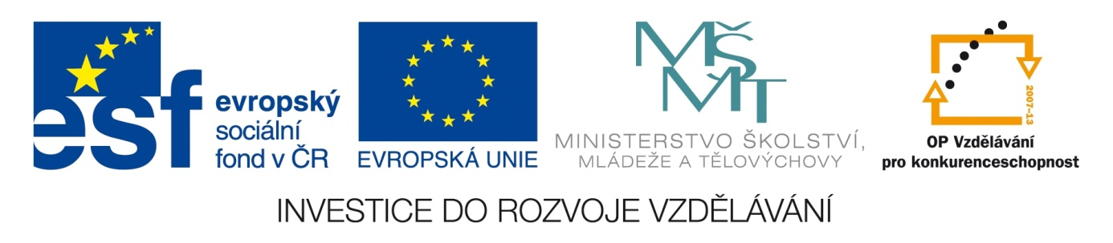

ŠKOLA: Městská střední odborná škola, Klobouky u Brna
nám. Míru 6, příspěvková organizace
ČÍSLO PROJEKTU: CZ.1.07/1.5.00/34.1020
NÁZEV PROJEKTU: Peníze do škol
ČÍSLO ŠABLONY: II/2 Inovace a zkvalitnění výuky cizích jazyků
na středních školách
AUTOR: Mgr. Veronika Krůzová
REALIZACE: Pracovní listy k maturitním otázkám
TÉMATICKÁ OBLAST: Všeobecná témata
NÁZEV DUMu: Applying for a job
POŘADOVÉ ČÍSLO DUMu: 02
KÓD DUMu: VY_22_INOVACE_3_1_02_KRU
DATUM TVORBY: 2012/2013
ANOTACE: Pracovní list je určen pro použití v předmětu anglický jazyk. Je zaměřen na procvičení slovní zásoby týkající se žádosti o nové zaměstnání. Studenti tvoří stručnou osnovu životopisu, vybírají oblečení vhodné pro pracovní pohovor a popisují, jak se vhodně chovat při pohovoru. Tento pracovní list je studentům kopírován pro samostatnou práci, která je následně kontrolována v rámci třídy za pomoci vyučujícího.

2. Applying for a job
A) Which of these facts would you mention in your CV?

education
bad habits
date
hobbies
e-mail
family
phone number
name
interests
language level
working experience
sports

B) Read the descriptions and decide, which clothes are best for the interview in a company

1. You should wear a ladies suit with a skirt and a jacket. Don´t wear nylons, they aren´t necessary. It also doesn´t matter what shoes you put on. If you have trainers in which you feel comfortable, take them. It is very important for you to feel ok.
2. Put on a tracksuit and perfectly polished shoes. They aren´t comfortable but the tracksuit can save everything. Remember that if you are asked unpleasant questions, you´ll feel comfortable which is very important.
3. It is good to put on a suit and polished shoes. Even if you probably don´t feel very comfortable, you will show that you have a real interest in the position in the company.
4. If it´s hot put on a mini skirt and a t-shirt with a deep neck. If you have a prefect figure you´ll definitely impress your future boss.
5. Put on a skirt and a jacket which fits you really well. You should also wear pumps and nylons.

C) How would you behave during the interview?

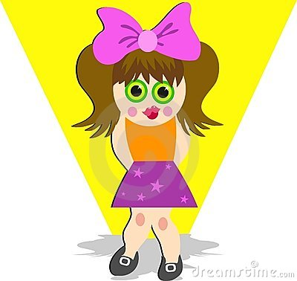shy
embarrassed
confident
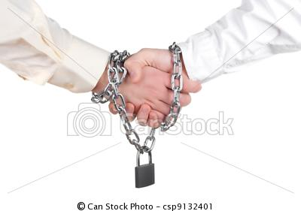reliable
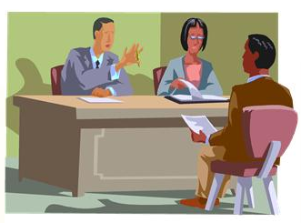interested
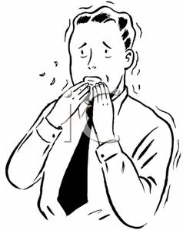nervous
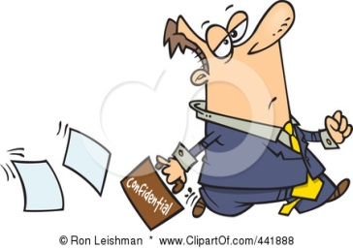lax
enthusiastic

Zdroje:
1. Shy girl. Dreamstime [online]. 2004 [cit. 2013-04-20]. Dostupné z: <http://www.dreamstime.com/stock-image-shy-girl-image44771>

2. Embarrassed Man Blushing Because His Pants Fell Down. Best-of-web [online]. [cit. 2013-04-20]. Dostupné z: <http://best-of-web.com/pages/100911-215426-096042.html>

3. Confidence executive hands on hip. 123RF [online]. [cit. 2013-04-20]. Dostupné z: <http://www.123rf.com/photo_4085714_confidence-executive-hands-on-hip.html>

4. Reliable agreement. Canstockphoto [online]. 2012 [cit.2013]. Dostupné z: <http://www.canstockphoto.com/reliable-agreement-9132401.html>
5. Gradpost [online]. [cit.2013-04-20]. Dostupné z: <http://gradpost.ucsb.edu/career/2012/1/27/interview-skills-workshop-for-graduate-students.html>

6. Vintage Nervous Man Biting His Fingernails. Best-of-web [online]. [cit. 2013-04-20]. Dostupné z: <http://www.best-of-web.com/pages/100604-006346-539042.html>

7. Leishman, R. A lax businessman dropping confidential paperwork, on a white background. Clipartof [online]. [cit. 2013-04-20]. Dostupné z: <http://www.clipartof.com/portfolio/toonaday/illustration/cartoon-lax-businessman-dropping-confidential-paperwork-441888.html>

8. Kate, A. An enthusiastic business teem meeting in a city office. Clipartof [online]. [cit. 2013-04-20]. Dostupné z: <http://www.clipartof.com/portfolio/amandakate/illustration/enthusiastic-business-teem-meeting-in-a-city-office-1107315.html>

