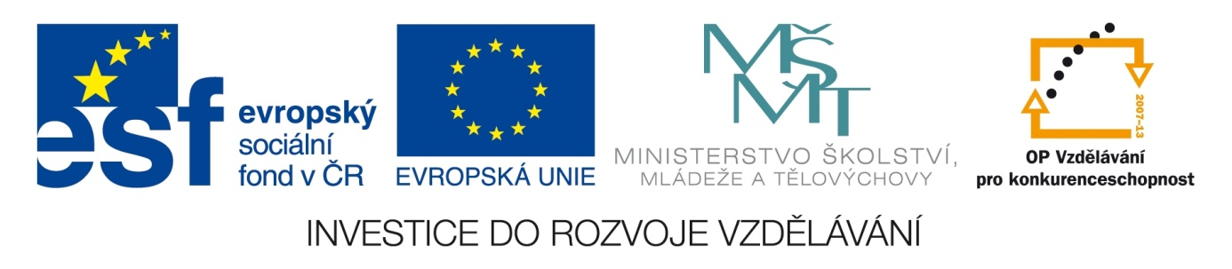

ŠKOLA: Městská střední odborná škola, Klobouky u Brna
nám. Míru 6, příspěvková organizace
ČÍSLO PROJEKTU: CZ.1.07/1.5.00/34.1020
NÁZEV PROJEKTU: Peníze do škol
ČÍSLO ŠABLONY: II/2 Inovace a zkvalitnění výuky cizích jazyků
na středních školách
AUTOR: Mgr. Veronika Krůzová
REALIZACE: Pracovní listy k maturitním otázkám
TÉMATICKÁ OBLAST: Všeobecná témata
NÁZEV DUMu: At the restaurant
POŘADOVÉ ČÍSLO DUMu: 04
KÓD DUMu: VY_22_INOVACE_3_1_04_KRU
DATUM TVORBY: 2012/2013
ANOTACE: Pracovní list je určen pro použití v předmětu anglický jazyk. Je zaměřen na procvičení slovní zásoby týkající se návštěvy v restauraci. Studenti spojují obrázky s názvy předmětů a tvoří příkladový rozhovor „v restauraci“. Tento pracovní list je studentům kopírován pro samostatnou práci, která je následně kontrolována v rámci třídy za pomoci vyučujícího.

4. At the restaurant
A) Match the pictures with the words

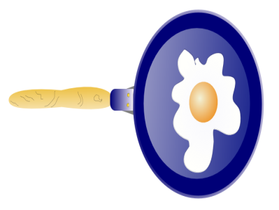 | saucepan
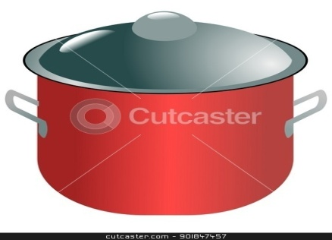 | napkin
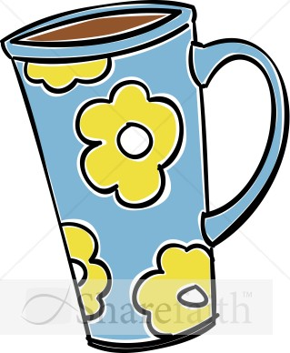 | ladle
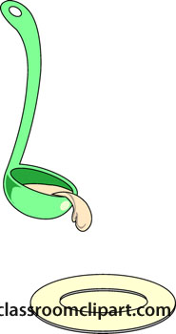 | plate
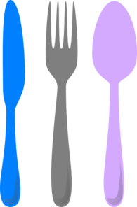 | frying pan
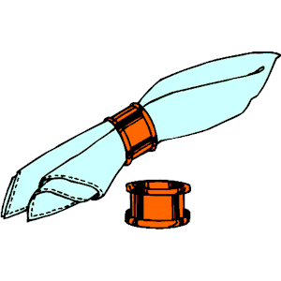 | glass
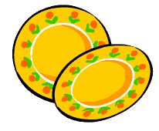 | cutlery (knife, fork, spoon)
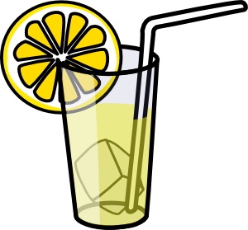 | mug

B) Put the dialogues in the correct order

1.
A: Can I help you?
A: Here is the menu.
A: Of course. So that´s cafe latte instead of the black coffee?
A: Ok. Would you also like to eat?
B: I´ll have a cup of black coffee and a glass of water, please.
B: Thank you. Moreover, I have just decided, I would like to change the order. I´d prefer cafe latte, please.
B: Yes, I would.
B: Yes, that´s right.

2.
A: Have you already chosen the meal?
A: Ok, would you like anything else?
A: Would you also like to have some sauce? I´d recommend tartar sauce with the potatoes.
B: I´ll have the roast pork with the roast potatoes.
B: Ok, thank you very much for the recommendation, I´ll have the sauce as well.
B: That´s all, thank you very much.

3.
A: Here you are.
A: Of course you can. Would you also like anything to drink?
A: Was everything all right?
B: Thank you.
B: Yes, I´ll have some orange juice.
B: Yes, thank you very much. However, I´d like to have some dessert. Can I have some honey cake?

4.
A: Ok, how would you like to pay?
A: Ok, that´s £20.25, please.
A: Thank you very much, bye.
B: Bye.
B: Here you are. Keep the change.
B: I have forgotten my credit card in the car so I´ll pay with money.
B: Waiter, I´d like to pay.

Zdroje:
1. Frying pan padella. Cksinfo [online]. [cit. 2012-10-03]. Dostupné z: <http://www.cksinfo.com/food/eggs/index.html>

2. Kovalenko, O. Modern saucepan. Cutcaster [online]. 2012 [cit. 2012-10-03]. Dostupné z:
<http://cutcaster.com/vector/901847457-modern-saucepan/>

3. Tall coffee mug. Sharefaith [online]. [cit. 2012-10-03]. Dostupné z: <http://www.sharefaith.com/image/tall-coffee-mug-clipart.html>

4. Laddle spoon. Classroomclipart [online]. 2012 [cit. 2012-10-03]. Dostupné z: <http://classroomclipart.com/clipart-view/Clipart/Kitchen/ladle-K0107_jpg.htm>

5. Cutlery. Clker [online]. 2011 [cit. 2012-10-03]. Dostupné z: <http://www.clker.com/clipart-cutlery.html>

6. Napkin. Cliparts101 [online]. 2012 [cit. 2012-10-15]. Dostupné z: <http://cliparts101.com/free_clipart/53334/Napkin>

7. Water in food. H2ouniversity [online]. [cit. 2012-10-15]. Dostupné z: <http://www.h2ouniversity.org/html/K2_sci_water_food.html>

8. Lamonade glass. Clker [online]. 2008 [cit. 2012-10-15]. Dostupné z: <http://www.clker.com/clipart-16678.html>

1.
A: Can I help you?
B: I´ll have a cup of black coffee and a glass of water, please.
A: Ok. Would you also like to eat?
B: Yes, I would.
A: Here is the menu.
B: Thank you. Moreover, I have just decided, I would like to change the order. I´d prefer cafe latte, please.
A: Of course. So that´s cafe latte instead of the black coffee?
B: Yes, that´s right.

2.
A: Have you already chosen the meal?
B: I´ll have the roast pork with the roast potatoes.
A: Would you also like to have some sauce? I´d recommend tartar sauce with the potatoes.
B: Ok, thank you very much for the recommendation, I´ll have the sauce as well.
A: Ok, would you like anything else?
B: That´s all, thank you very much.

3.
A: Was everything all right?
B: Yes, thank you very much. However, I´d like to have some dessert. Can I have some honey cake?
A: Of course you can. Would you also like anything to drink?
B: Yes, I´ll have some orange juice.
A: Here you are.
B: Thank you.
4.
B: Waiter, I´d like to pay.
A: Ok, how would you like to pay?
B: I have forgotten my credit card in the car so I´ll pay with money.
A: Ok, that´s £20.25, please.
B: Here you are. Keep the change.
A: Thank you very much, bye.
B: Bye.

