

ŠKOLA: Městská střední odborná škola, Klobouky u Brna
nám. Míru 6, příspěvková organizace
ČÍSLO PROJEKTU: CZ.1.07/1.5.00/34.1020
NÁZEV PROJEKTU: Peníze do škol
ČÍSLO ŠABLONY: II/2 Inovace a zkvalitnění výuky cizích jazyků
na středních školách
AUTOR: Mgr. Veronika Krůzová
REALIZACE: Pracovní listy k maturitním otázkám
TÉMATICKÁ OBLAST: Všeobecná témata
NÁZEV DUMu: Health
POŘADOVÉ ČÍSLO DUMu: 16
KÓD DUMu: VY_22_INOVACE_3_1_16_KRU
DATUM TVORBY: 2012/2013
ANOTACE: Pracovní list je určen pro použití v předmětu anglický jazyk. Je zaměřen na procvičení slovní zásoby týkající se zdraví. Studenti hovoří o způsobech jak pečovat o své zdraví a být fit. Tento pracovní list je studentům kopírován pro samostatnou práci, která je následně kontrolována v rámci třídy za pomoci vyučujícího.

16. Health
A) What do people do to keep fit?

1. Eat a lot of fruit and vegetables
2. Stay awake late at night
3. Drink a lot of alcohol
4. Smoke a few cigarettes a day
5. Eat a lot of fat
6. Do a lot of sports
7. Focus on positive thinking
8. Eat food with little fat
9. Eat a lot of salt
10. Drink a lot of water

B) Match the two halves of these sentences

1. | You should go running...
2. | If you don´t eat a lot of fat food...
3. | Eating a lot of fat...
4. | You clean your inner body...
5. | People are able to keep thinking at school...
6. | Problems seem much easier to solve...
7. | The better friends you have...
8. | Don´t try to find the reason...

a. | ...you won´t be tired.
b. | ...when they eat fruit and vegetables.
c. | ...when you try to stay positive.
d. | ...is bad for your complexion.
e. | ...the better you feel.
f. | ...at least twice a week.
g. | ...why some people don´t like you.
h. | ...when you drink a lot of water.

1. | 2. | 3. | 4. | 5. | 6. | 7. | 8.

C) Match the pictures with the descriptions

 | Everybody should do this every day. It is usually easier when there are a lot of good friends around you.
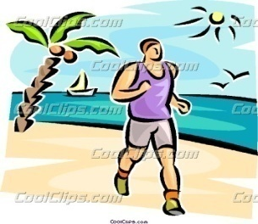 | It is said that it isn´t easy to do this activity, however, people who do it say, that you feel independent. Moreover, it makes your muscles stronger.
 | This activity is perfect for your body and soul as well. You stay in the fresh air and the result of the work is usually very tasty.
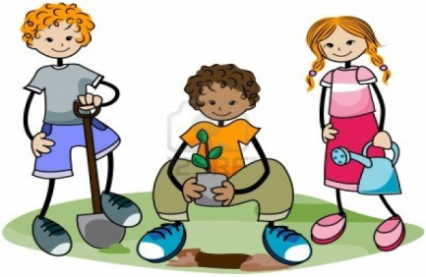 | It isn´t possible to do this in our country and I really envy the people who live at the seaside. If I lived there, I would do the activity every morning at the sunrise.
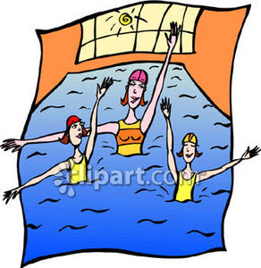 | I´m happy technology is so perfect these days that I can do this activity anywhere. I always get in a much better mood.
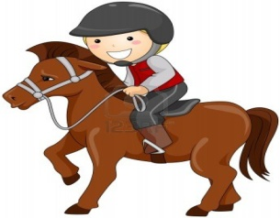 | I love this activity because I always experience a lot of fun with my friends. I´m sure I wouldn´t keep doing it without my friends.

Zdroje:
1. Leishman, R. A woman dancing and listening to music. Clipartof [online]. [cit. 2012-09-07]. Dostupné z: <http://www.clipartof.com/portfolio/toonaday/illustration/cartoon-woman-dancing-and-listening-to-music-1044631.html>

2. Man running on the beach. Coolclips [online]. [cit. 2012-09-07]. Dostupné z: <http://dir.coolclips.com/Sports/Physical_Fitness_and_Exercise/Jogging/man_running_on_the_beach_vc063094.html>

3. Leishman, R. Laughing. Illustrationsof [online]. [cit. 2012-09-07]. Dostupné z: <http://www.illustrationsof.com/441875-royalty-free-laughing-clipart-illustration>

4. Medina, L. Gardening kids with clipping path. 123rf [online]. [cit. 2012-09-07]. Dostupné z: <http://www.123rf.com/photo_4687692_gardening-kids-with-clipping-path.html>

5. Women water aerobics. Picturesof [online]. [cit. 2012-09-07]. Dostupné z: <http://www.picturesof.net/pages/080709-181516-887029.html>

6. Medina, L. Boy horseback riding. 123rf [online]. [cit. 2012-09-07]. Dostupné z: <http://www.123rf.com/photo_7394213_boy-horseback-riding.html>

