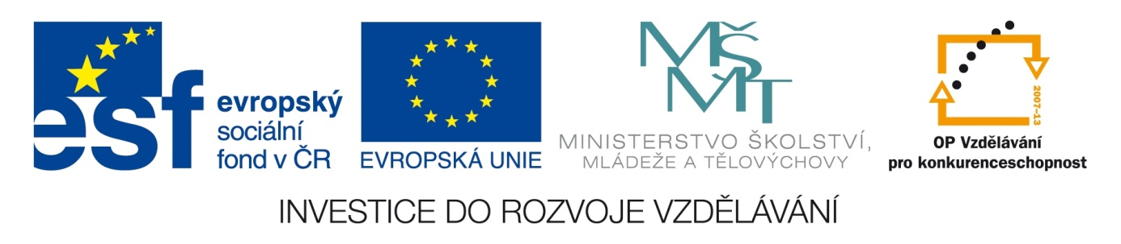

ŠKOLA: Městská střední odborná škola, Klobouky u Brna
nám. Míru 6, příspěvková organizace
ČÍSLO PROJEKTU: CZ.1.07/1.5.00/34.1020
NÁZEV PROJEKTU: Peníze do škol
ČÍSLO ŠABLONY: II/2 Inovace a zkvalitnění výuky cizích jazyků
na středních školách
AUTOR: Mgr. Veronika Krůzová
REALIZACE: Pracovní listy k maturitním otázkám
TÉMATICKÁ OBLAST: Všeobecná témata
NÁZEV DUMu: In the shop
POŘADOVÉ ČÍSLO DUMu: 21
KÓD DUMu: VY_22_INOVACE_3_1_21_KRU
DATUM TVORBY: 2012/2013
ANOTACE: Pracovní list je určen pro použití v předmětu anglický jazyk. Je zaměřen na procvičení slovní zásoby týkající se obchodu. Studenti anglicky označují výrazy spojené s provozem v obchodech a tvoří vzorový rozhovor „v obchodě“. Tento pracovní list je studentům kopírován pro samostatnou práci, která je následně kontrolována v rámci třídy za pomoci vyučujícího.

21. In the shop
A) Match the pictures with the correct words

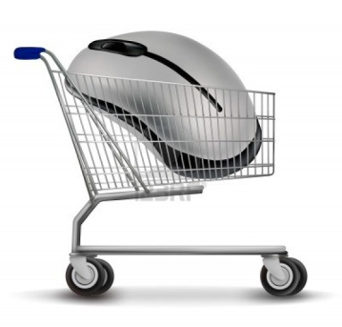 | hanger
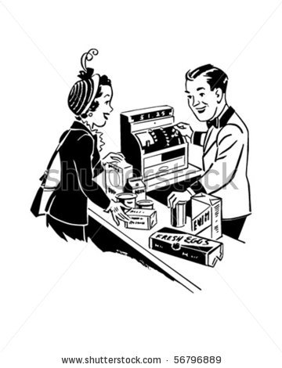 | shelves
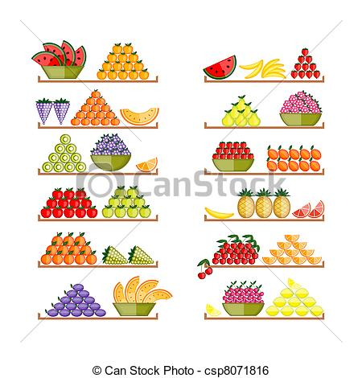 | shop assistant
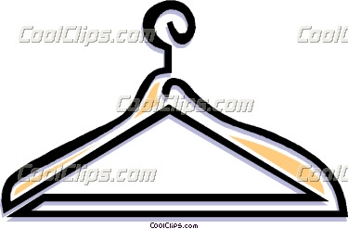 | checkout
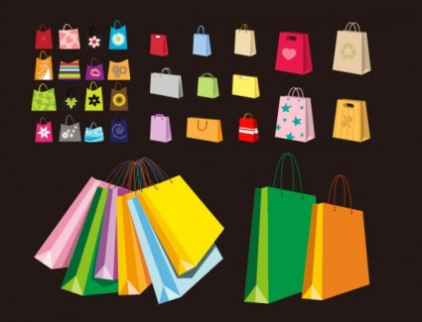 | fitting room
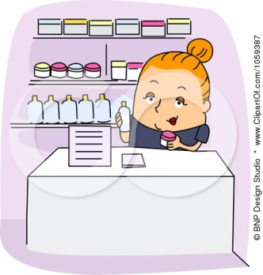 | trolley
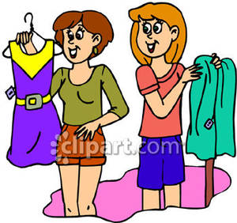 | discount
 | paper bag

B) Put the dialogue in the correct order

A: And we also have them in all the sizes. It´s just up to you, what colour you choose.
A: Bye.
A: Definitely! You are really beautiful in the dress! Will you have it?
A: Good morning
A: Here you are.
A: It doesn´t matter, I´ll give you No. 38.
A: Let me have a look at the correct size. What size are you?
A: May I help you?
A: Of course you can. It´s 96 pounds.
A: Of course, the changing rooms are over there.
A: OK, there is a large collection of dresses for this summer. Have a look here.
A: The cashier is over there, I´ll take your dress there.
B: 36
B: Hello
B: Here you are. Bye.
B: I will
B: I would like to buy some summer dress and some baggy trousers
B: OK, I think I´m quite old in black and I´m too pale in white. Pink is for younger girls and I don´t like blue. Well, the brown dress with white spots is really nice and elegant!
B: Thank you for your help. I think it fits much better! What do you think?
B: Thank you. It doesn´t fit me very well, I think it´s too small. I may have put on my weight.
B: Thank you. May I pay by credit card?
B: Thank you. May I try it on?
B: Wow, I think there is everything I can only imagine! Dresses with flowers, stripes, plain dresses, chequered, polka dot dresses!

Zdroje:
1. Galantseva, N. Shopping cart with mouse. 123rf [online]. [cit. 2012-11-06]. Dostupné z: <http://www.123rf.com/photo_10881152_shopping-cart-with-mouse-vector.html>

2. At the checkout. Shutterstock [online]. [cit. 2012-11-06]. Dostupné z: <http://www.shutterstock.com/pic-56796889/stock-vector-at-the-checkout-shopping-retro-clip-art.html>

3. Shelves with fruits. Canstockphoto [online]. 2011 [cit. 2012-11-06]. Dostupné z: <http://www.canstockphoto.com/shelves-with-fruits-for-your-design-8071816.html>

4. Clothes hanger. Coolclips [online]. 2011 [cit. 2012-11-06]. Dostupné z: <http://dir.coolclips.com/Household/Clothing_Apparel_Textiles/Clothes_Hangers/clothes_hanger_hous1030.html>

5. A variety of colourful clip art bag bags. All-free-download [online]. [cit. 2012-11-06]. Dostupné z: <http://all-free-download.com/free-vector/vector-clip-art/a_variety_of_colorful_clip_art_bag_bags_155183.html>

6. a dermatologist's assistant holding products. Clipartof [online]. [cit. 2012-11-06]. Dostupné z: <http://www.clipartof.com/portfolio/bnpdesignstudio/illustration/dermatologists-assistant-holding-products-1059387.html>

7. Women trying on dresses. Picturesof [online]. [cit. 2012-11-06]. Dostupné z: <http://www.picturesof.net/pages/081106-231724-730048.html>

8. Thoman, C. Discount. Illustrationsof [online]. [cit. 2012-11-06]. Dostupné z: <http://www.illustrationsof.com/1080629-royalty-free-discount-clipart-illustration>

A: Good morning
B: Hello
A: May I help you?
B: I would like to buy some summer dress and some baggy trousers
A: OK, there is a large collection of dresses for this summer. Have a look here.
B: Wow, I think there is everything I can only imagine! Dresses with flowers, stripes, plain dresses, chequered, polka dot dresses!
A: And we also have them in all the sizes. It´s just up to you, what colour you choose.
B: OK, I think I´m quite old in black and I´m too pale in white. Pink is for younger girls and I don´t like blue. Well, the brown dress with white spots is really nice and elegant!
A: Let me have a look at the correct size. What size are you?
B: 36
A: Here you are.
B: Thank you. May I try it on?
A: Of course, the changing rooms are over there.
B: Thank you. It doesn´t fit me very well, I think it´s too small. I may have put on my weight.
A: It doesn´t matter, I´ll give you No. 38.
B: Thank you for your help. I think it fits much better! What do you think?
A: Definitely! You are really beautiful in the dress! Will you have it?
B: I will
A: The cashier is over there, I´ll take your dress there.
B: Thank you. May I pay by credit card?
A: Of course you can. It´s 96 pounds.
B: Here you are. Bye.
A: Bye.

