Autor: | Mgr. Vít Klimeš
Název materiálu: | VY_32_INOVACE_4_ANGLICKY_JAZYK_REALIE_04  Londýn – pracovní list
Téma sady: | ANJ - Reálie
Obor, ročník: | Ekonomické lyceum, Obchodní akademie, Veřejnosprávní činnost, Sociální činnost, 4. ročník
Datum vytvoření: | leden 2014
Anotace: | Londýn - pracovní list, základní fakta, historie, důležitá místa, zajímavosti
Metodický obsah: | Ověření osvojení si učiva

Dílo smí být dále šířeno pod licencí CC BY-SA.
Materiály jsou určeny pro bezplatné používání pro potřeby výuky a vzdělávání na všech typech škol a školských zařízení. Jakékoliv další využití podléhá autorskému zákonu.
Všechna neocitovaná autorská díla jsou dílem autora.
Všechny neocitované kliparty a další grafické objekty jsou součástí prostředků výukového sw Smart Notebook a MS Office.

Cílem tohoto pracovního listu je procvičení vědomostí a ověření si osvojení informací prezentovaných v powerpointové prezentaci „Spojené království Velké Británie a Severního Irska“. Žáci v pracovním listu převážně doplňují vynechaný text tak, aby informace v něm byly fakticky i gramaticky správné. Pracovní list metodicky navazuje na prezentaci.

In all exercises fill in the gaps so that all the sentences are grammatically correct and true.
London
- London is the ______________ of the UK.
- It is also the capital of __________.
- It is in the __________–east of the UK.
[Mark London on the correct line on the map below]
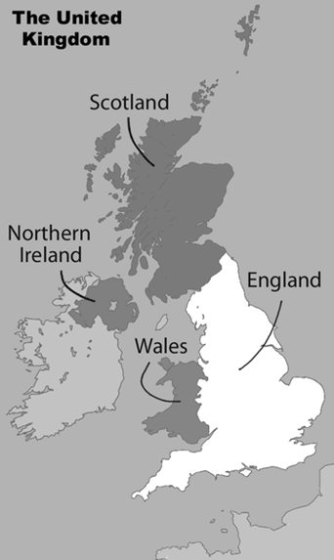
Obr. 1 a Map of the UK [1]

London – Basic Facts
- The population of London is about ___ million.
- It is the largest city in __________.
- London is divided into 33 __________.
- It is a ______________and multi-ethnic city.
- London lies on the River __________.
London – Basic Facts - history
- It was founded by the __________in 43AD after they invaded Britain.
- It was called ______________at that time.
- After the Norman Conquest, which began in 1066, William the Conqueror was crowned at Westminster Abbey and started the construction of the ________________.
- At that time it was called ______________.
- London became the real capital during ______________reign (1327 -1377).

London – Basic Facts - history
- The ______________in 1665 killed nearly 100,000 people.
- The ________of London in 1666 burned to the ground almost 80% of the city.
- It suffered a lot of bombardment during ______________.
London – Famous Places
[Fill in the gaps and match sentences to the pictures]
- ________________is a large gothic church in the centre of London.
- It is the ____________and burial place for British monarchs.
- The Palace of Westminster known as the _________________ is the place where the House of Commons and the House of Lords meet.
- ____________ Palace is the London residence and workplace of the British monarch.
- The _________________ is a royal historic castle on the River Thames.
- The __________Jewels are kept there.
- __________Bridge on the River Thames is one of the symbols of London.
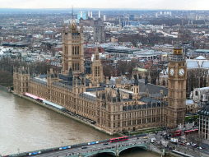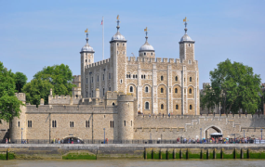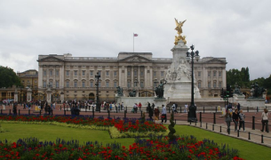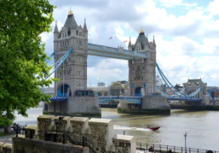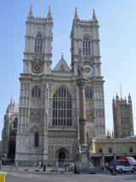
Obr. 5 a sight [5]
Obr. 3 a sight [3]
Obr. 6 a sight [6]
Obr. 4 a sight [4]
Obr. 2 a sight [2]

London – Other Places to Visit
[Fill in the gaps and match sentences to the pictures]
- Trafalgar __________is a tourist sight in central London.
- There is __________Column in honour of ____________________.
- __________ Circus is one of London's busiest squares.
- It is famous for illuminated __________ and for the statue of __________.
- The __________ Eye is a famous tourist attraction located in the centre of London on the bank of the River __________.
- The London Underground, known as the __________, is the _______ underground railway in the world.
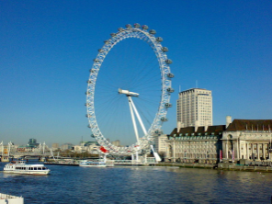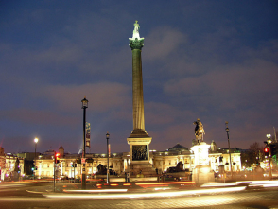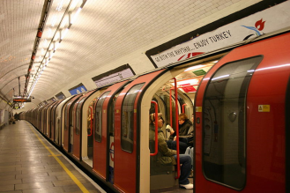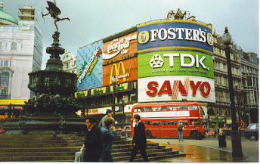
Obr. 10 a sight [10]
Obr. 9 a sight [9]
Obr. 8 a sight [8]
Obr. 7 a sight [7]

KEY TO EXERCISES (ŘEŠENÍ)
London
- London is the capital city of the UK.
- It is also the capital of England.
- It is in the south–east of the UK.
[Mark London on the correct line on the map below]
London
Obr. 1 a Map of the UK [1]

London – Basic Facts
- The population of London is about 8 million.
- It is the largest city in Europe.
- London is divided into 33 boroughs.
- It is a multicultural and multi-ethnic city.
- London lies on the River Thames.
London – Basic Facts - history
- It was founded by the Romans in 43AD after they invaded Britain.
- It was called Londinium at that time.
- After the Norman Conquest, which began in 1066, William the Conqueror was crowned at Westminster Abbey and started the construction of the Tower of London.
- At that time it was called Lunduntown.
- London became the real capital during Edward III’s reign (1327 -1377).

London – Basic Facts - history
- The Great Plague in 1665 killed nearly 100,000 people.
- The Great Fire of London in 1666 burned to the ground almost 80% of the city.
- It suffered a lot of bombardment during World War II.
London – Famous Places
[Fill in the gaps and match sentences to the pictures]
- Westminster Abbey is a large gothic church in the centre of London.

- It is the coronation and burial place for British monarchs.
- The Palace of Westminster known as the Houses of Parliament is the place where the House of Commons and the House of Lords meet.

- Buckingham Palace is the London residence and workplace of the British monarch.

- The Tower of London is a royal historic castle on the River Thames.
- The Crown Jewels are kept there.

- Tower Bridge on the River Thames is one of the symbols of London.
Obr. 5 a sight [5]
Obr. 3 a sight [3]
Obr. 6 a sight [6]
Obr. 4 a sight [4]
Obr. 2 a sight [2]

London – Other Places to Visit
[Fill in the gaps and match sentences to the pictures]
- Trafalgar Square is a tourist sight in central London.
- There is Nelson's Column in honour of Admiral Lord Nelson.

- Piccadilly Circus is one of London's busiest squares.

- It is famous for illuminated advertising and for the statue of Eros.
- The London Eye is a famous tourist attraction located in the centre of London on the bank of the River Thames.

- The London Underground, known as the Tube, is the oldest underground railway in the world.

Obr. 10 a sight [10]
Obr. 9 a sight [9]
Obr. 8 a sight [8]
Obr. 7 a sight [7]

References – Pictures (Zdroje obrázků):

- EQUESTENEBRARUM. Wikimedia [online]. 2008 [cit. 2013-11-15]. Dostupné z: http://commons.wikimedia.org/wiki/File:Topographic_Map_of_the_UK_-_English.png
- DANIKAUF. Wikimedia [online]. 2005 [cit. 2014-01-03]. Dostupné z: http://commons.wikimedia.org/wiki/File:Westminster_palace.jpg

- COLLOWÂN, Bob. Wikipedia [online]. 2013 [cit. 2014-01-03]. Dostupné z: http://cs.wikipedia.org/wiki/Soubor:Tower_of_London_viewed_from_the_River_Thames.jpg
- SNOWMANRADIO. Wikimedia [online]. 2008 [cit. 2014-01-03]. Dostupné z: http://commons.wikimedia.org/wiki/File:Buckingham_Palace_-London-18Aug2008-4c.jpg

- DUDVA. Wikimedia [online]. 2013 [cit. 2014-01-03]. Dostupné z: http://commons.wikimedia.org/wiki/File:The_Tower_Bridge_in_London.jpg

- PEEL, Mike. Wikimedia [online]. 2010 [cit. 2014-01-03]. Dostupné z: http://commons.wikimedia.org/wiki/File:Westminster_Abbey,_2006.jpg
- KALAHA. Wikimedia [online]. 2008 [cit. 2014-01-03]. Dostupné z: http://commons.wikimedia.org/wiki/File:London_Eye_from_Westminster_Bridge.jpg
- VIBIN. Wikimedia [online]. 2012 [cit. 2014-01-03]. Dostupné z: http://commons.wikimedia.org/wiki/File:Trafalgar_Square_at_night_2.jpg
- JCORNELIUS. Wikimedia [online]. 2005 [cit. 2014-01-03]. Dostupné z: http://commons.wikimedia.org/wiki/File:London_Underground_Tube_Stock_1992.jpg
- SMITH, Colin. Geograph [online]. 2013 [cit. 2014-01-03]. Dostupné z: http://www.geograph.org.uk/photo/265001

References and Copyright (Zdroje a autorská práva):

- Victorianweb [online]. 2010 [cit. 2014-01-03]. Dostupné z: http://www.victorianweb.org/history/hist4.html
- Wikipedia [online]. 2013 [cit. 2014-01-03]. Dostupné z: http://en.wikipedia.org/wiki/Westminster_Abbey
- Wikipedia [online]. 2014 [cit. 2014-01-03]. Dostupné z: http://en.wikipedia.org/wiki/Palace_of_Westminster
- EL-HMOUDOVÁ, Dagmar. <i>Angličtina maturitní témata</i>. Třebíč: Petra Velanová, 2006. ISBN 978-80-86873-04-6

