Autor: | Mgr. Vít Klimeš
Název materiálu: | VY_32_INOVACE_4_ANGLICKY_JAZYK_REALIE_14  Kanada – pracovní list
Téma sady: | ANJ - Reálie
Obor, ročník: | Ekonomické lyceum, Obchodní akademie, Veřejnosprávní činnost/Sociální činnost, 4. ročník
Datum vytvoření: | říjen 2013
Anotace: | Kanada, základní fakta, geografie, fauna, významná města, vláda a politický systém
Metodický obsah: | Ověření osvojení si učiva

Dílo smí být dále šířeno pod licencí CC BY-SA.
Materiály jsou určeny pro bezplatné používání pro potřeby výuky a vzdělávání na všech typech škol a školských zařízení. Jakékoliv další využití podléhá autorskému zákonu.
Všechna neocitovaná autorská díla jsou dílem autora.
Všechny neocitované kliparty a další grafické objekty jsou součástí prostředků výukového sw Smart Notebook a MS Office.

Cílem tohoto pracovního listu je procvičení vědomostí a ověření si osvojení informací prezentovaných v powerpointové prezentaci „New Zealand“. Žáci v pracovním listu převážně doplňují vynechaný text tak, aby informace v něm byly fakticky i gramaticky správné. Pracovní list metodicky navazuje na prezentaci.
In all exercises fill in the gaps so that all the sentences are grammatically correct and true.

Canada – Basic Facts
- Canada is located in the northern part of _____________.
- It _____________ the USA to the south as well as in the
north - west (Alaska).
- The _____________ of Canada is 34.7 million.
- Both _____________ and _____________ are official languages in Canada.
Canada – Politics
- Canada is a part of the British _________________.
- It is a constitutional _____________.
- The ____________________ is the monarch of the United Kingdom.
- Her/His representative is the _____________________.
- The head of the government is the ____________________.
Canada – Cities
- The capital city of Canada is _____________.
- _____________ is Canada’s largest city.
- _____________ is the second largest city in Canada.
- _____________ is located in the province of British Columbia.
[Write names for the four cities on the map bellow]
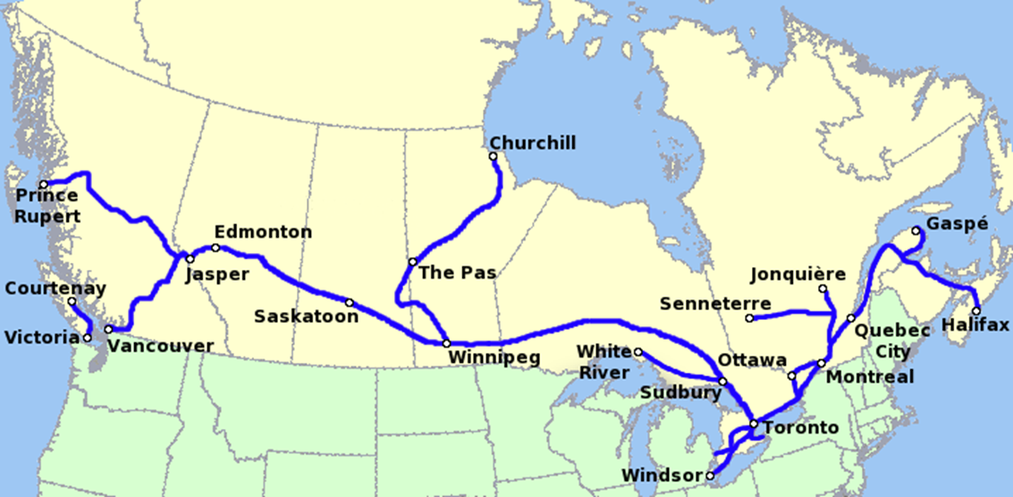
Obr. 1 a Map of Canada [1]

Canada – Geography
- Canada consists of 10 _____________ and 3 territories.
- It is the _____________ largest country in the world.
- Canada's coastline is the _____________ in the world.
- The Canadian Rockies are one of the most _____________ sights ______ tourists in Canada.
- _____________, with its 5,959 metres above sea level, is Canada’s highest peak.
The people of Canada
- The _____________, the _____________ and the _____________ people are considered to be the native people of Canada.
Canada – Wildlife
[Fill in the gaps and match sentences to the pictures]
- Both _____________ and _____________ bears are plentiful in Canada.
- _____________ and _____________ are both even-toed hoofed animals living in Canada.
- _____________ and _____________ are well-known predators of Canada.
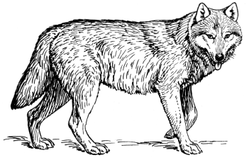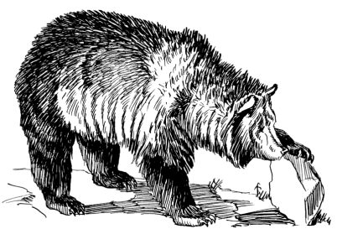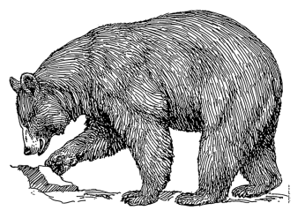
Obr. 2 an animal [2]
Obr. 4 an animal [4]
Obr. 3 an animal [3]
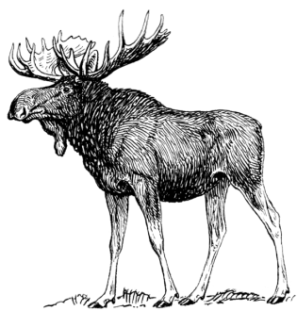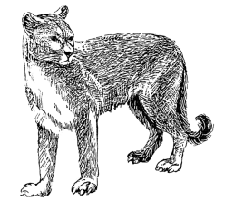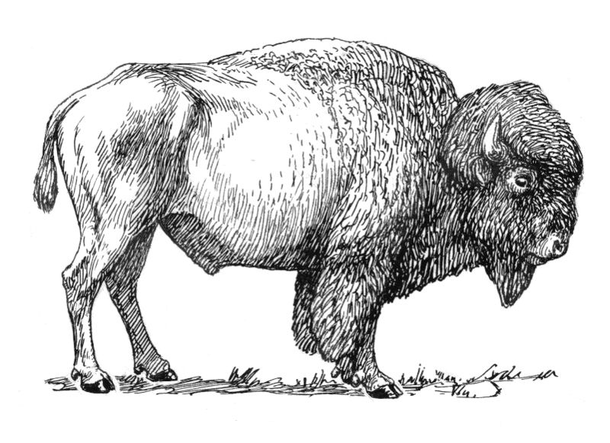
Obr. 7 an animal [7]
Obr. 6 an animal [6]
Obr. 5 an animal [5]

Popular sports and famous people
- _________________, a famous Canadian singer, has been included in the American Rock and Roll Hall of Fame.
- _________________ is a Canadian singer and songwriter.
- _________________is the most popular sport in Canada.
KEY TO EXERCISES (ŘEŠENÍ)

Canada – Basic Facts
- Canada is located in the northern part of North America.
- It borders the USA to the south as well as in the
north - west (Alaska).
- The population of Canada is 34.7 million.
- Both English and French are official languages in Canada.
Canada – Politics
- Canada is a part of the British Commonwealth.
- It is a constitutional monarchy.
- The head of state is the monarch of the United Kingdom.
- Her/His representative is the Governor General.
- The head of the government is the Prime Minister.
Canada – Cities
- The capital city of Canada is Ottawa.
- Toronto is Canada’s largest city.
- Montreal is the second largest city in Canada.
- Vancouver is located in the province of British Columbia.
[Write names for the four cities on the map bellow]
Toronto
Montreal
Ottawa
Vancouver
Obr. 1 a Map of Canada [1]

Canada – Geography
- Canada consists of 10 provinces and 3 territories.
- It is the second largest country in the world.
- Canada's coastline is the longest in the world.
- The Canadian Rockies are one of the most popular sights with tourists in Canada.
- Mount Logan, with its 5,959 metres above sea level, is Canada’s highest peak.
The people of Canada
- The Inuit, the Métis and the First Nations people are considered to be the native people of Canada.
Canada – Wildlife
[Fill in the gaps and match sentences to the pictures]
- Both grizzly and black bears are plentiful in Canada.

- Bison and moose are both even-toed hoofed animals living in Canada.

- Cougars and wolves are well-known predators of Canada.

Obr. 2 an animal [2]
Obr. 4 an animal [4]
Obr. 3 an animal [3]
Obr. 7 an animal [7]
Obr. 6 an animal [6]
Obr. 5 an animal [5]

Popular sports and famous people
- Leonard Cohen, a famous Canadian singer, has been included in the American Rock and Roll Hall of Fame.
- Avril Lavigne is a Canadian singer and songwriter.
- Ice hockey is the most popular sport in Canada.

References – Pictures (Zdroje obrázků):

- Wikipedia [online]. 2008 [cit. 2013-10-01]. Dostupné z: http://en.wikipedia.org/wiki/File:ViaRailNetworkMap.png
- Wikimedia [online]. 2009 [cit. 2013-10-19]. Dostupné z: http://commons.wikimedia.org/wiki/File:Wolf_(PSF).png
- Wikimedia [online]. 2008 [cit. 2013-10-19]. Dostupné z: http://commons.wikimedia.org/wiki/File:Grizzly_bear_(PSF).png
- Wikimedia [online]. 2008 [cit. 2013-10-19]. Dostupné z: http://commons.wikimedia.org/wiki/File:Black_bear_(PSF).png
- Wikimedia [online]. 2009 [cit. 2013-10-19]. Dostupné z: http://commons.wikimedia.org/wiki/File:Moose_(PSF).png
- Wikimedia [online]. 2008 [cit. 2013-10-19]. Dostupné z: http://commons.wikimedia.org/wiki/File:Cougar_(PSF).png
- Wikimedia [online]. 2007 [cit. 2013-10-19]. Dostupné z: http://commons.wikimedia.org/wiki/File:Bison_(PSF).jpg

References and Copyright (Zdroje a autorská práva):

- Bbc [online]. 2013 [cit. 2013-10-19]. Dostupné z: http://www.bbc.co.uk/news/world-us-canada-16841114
- Wikipedia [online]. 2013 [cit. 2013-10-19]. Dostupné z: http://en.wikipedia.org/wiki/Canada
- Wikipedia [online]. 2013 [cit. 2013-10-19]. Dostupné z: http://en.wikipedia.org/wiki/Leonard_Cohen

