Autor: | Mgr. Vít Klimeš
Název materiálu: | VY_32_INOVACE_4_ANGLICKY_JAZYK_REALIE_16  Austrálie – pracovní list
Téma sady: | ANJ - Reálie
Obor, ročník: | Ekonomické lyceum, Obchodní akademie, Veřejnosprávní činnost, Sociální činnost, 4. ročník
Datum vytvoření: | listopad 2013
Anotace: | Austrálie, základní fakta, geografie, fauna, významná města, vláda a politický systém
Metodický obsah: | Ověření osvojení si učiva

Dílo smí být dále šířeno pod licencí CC BY-SA.
Materiály jsou určeny pro bezplatné používání pro potřeby výuky a vzdělávání na všech typech škol a školských zařízení. Jakékoliv další využití podléhá autorskému zákonu.
Všechna neocitovaná autorská díla jsou dílem autora.
Všechny neocitované kliparty a další grafické objekty jsou součástí prostředků výukového sw Smart Notebook a MS Office.

Cílem tohoto pracovního listu je procvičení vědomostí a ověření si osvojení informací prezentovaných v powerpointové prezentaci „Austrálie“. Žáci v pracovním listu převážně doplňují vynechaný text tak, aby informace v něm byly fakticky i gramaticky správné. Pracovní list metodicky navazuje na prezentaci.
In all exercises fill in the gaps so that all the sentences are grammatically correct and true.

Australia – Basic Facts
- Australia lies_____________ the Pacific and Indian oceans.
- It is located 2.000 km from _____________.
- The _____________ of Australia is nearly 23 million.
- English is the major _____________ in Australia.
Australia – Politics
- Australia is a part of the _____________ Commonwealth.
- It is a _____________ monarchy.
- The _____________ is the monarch of the United Kingdom.
- Her _____________ is the Governor General.
- The head of the _____________ is the Prime Minister.
Australia – Cities
- The capital city of Australia is _____________.
- _____________ is Australia’s largest city.
- _____________ is the second largest city in Australia.
- _____________ is the third largest city in Australia.
[Write names for the four cities on the map bellow]
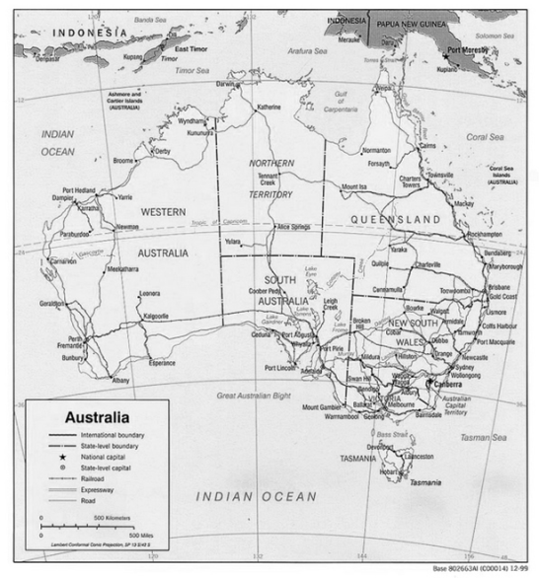
Obr. 1 a Map of Australia [1]
Australia – Geography
- Australia _____________ 6 states and 2 main territories.
- Although Australia is a country, it is also the smallest _____________ in the world.
- The __________________________ is the largest coral reef in the world.
- ________________________ is the highest peak on the Australian mainland.
- _____________ cover a significant part of Australia.
- There are also _____________ in the north-east of Australia.
The people of Australia
- The native people of Australia are called _____________.
- The first Europeans started significantly settling Australia at the end of _____ century.
Australia – Wildlife
[Fill in the gaps and match sentences to the pictures]
- _____________ are very typical animals of Australia.
- The _____________ is another typical marsupial living in Australia.
- The _____________ is a marsupial predator living on the island of Tasmania.
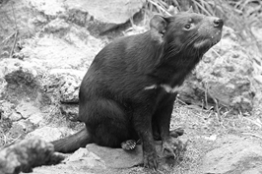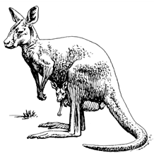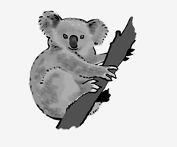
Obr. 4 an animal [4]
Obr. 3 an animal [3]
Obr. 2 an animal [2]

Popular sports and famous people
- _____________ is a famous Australian actress.
- The singer _____________ comes from Australia.
- __________________and __________________are the most popular sports.

KEY TO EXERCISES (ŘEŠENÍ)

Australia – Basic Facts
between
- Australia lies_____________ the Pacific and Indian oceans.
New Zealand
- It is located 2.000 km from _____________.
population
- The _____________ of Australia is nearly 23 million.
language
- English is the major _____________ in Australia.
Australia – Politics
British
- Australia is a part of the _____________ Commonwealth.
constitutional
- It is a _____________ monarchy.
British
- The _____________ is the monarch of the United Kingdom.
representative
- Her _____________ is the Governor General.
government
- The head of the _____________ is the Prime Minister.
Australia – Cities
Canberra
- The capital city of Australia is _____________.
Sydney
- _____________ is Australia’s largest city.
Melbourne
- _____________ is the second largest city in Australia.
Brisbane
- _____________ is the third largest city in Australia.
[Write names for the four cities on the map bellow]
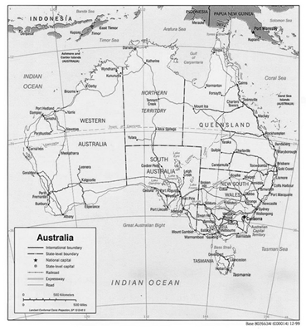
Melbourne
Canberra
Obr. 1 a Map of Australia [1]
Sydney
Brisbane

Obr. 1 a Map of Australia [1]
Australia – Geography
consists of
- Australia _____________ 6 states and 2 main territories.
continent
- Although Australia is a country, it is also the smallest _____________ in the world.
Great Barrier Reef
- The __________________________ is the largest coral reef in the world.
Mount Kosciuszko
- ________________________ is the highest peak on the Australian mainland.
Deserts
- _____________ cover a significant part of Australia.
rainforests
- There are also _____________ in the north-east of Australia.
The people of Australia
Aborigines
- The native people of Australia are called _____________.
18th
- The first Europeans started significantly settling Australia at the end of _____ century.
Australia – Wildlife
[Fill in the gaps and match sentences to the pictures]
Kangaroos
- _____________ are very typical animals of Australia.

koala
- The _____________ is another typical marsupial living in Australia.
Tasmanian devil
- The _____________ is a marsupial predator living on the island of Tasmania.

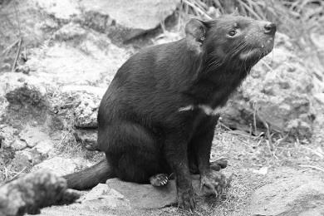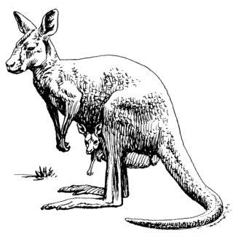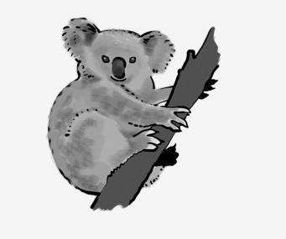
Obr. 4 an animal [4]
Obr. 3 an animal [3]
Obr. 2 an animal [2]

Popular sports and famous people
Nicole Kidman
- _____________ is a famous Australian actress.
Kylie Minogue
- The singer _____________ comes from Australia.
Australian Football
Rugby League
- __________________and __________________are the most popular sports.

References – Pictures (Zdroje obrázků):

- WILHELM, Sarah L. Flickr [online]. 2011 [cit. 2013-11-02]. Dostupné z: http://www.flickr.com/photos/slwilhelm/5881033122/sizes/z/in/photostream/
- LEHMANN, Mike. Wikipedia [online]. 2007 [cit. 2013-11-07]. Dostupné z: http://en.wikipedia.org/wiki/File:TasmanianDevil_1888.jpg
- FORESMAN, Pearson Scott. Wikimedia [online]. 2008 [cit. 2013-11-07]. Dostupné z: http://commons.wikimedia.org/wiki/File:Kangaroo_(PSF).png
- GILLBANK, Jan. Wikimedia [online]. 2013 [cit. 2013-11-07]. Dostupné z: http://commons.wikimedia.org/wiki/File:Koala_illustration.jpg

References and Copyright (Zdroje a autorská práva):

- BBC [online]. 2013 [cit. 2013-11-02]. Dostupné z: http://www.bbc.co.uk/news/world-asia-15674831
- Wikipedia [online]. 2013 [cit. 2013-11-02]. Dostupné z: http://en.wikipedia.org/wiki/Australia

