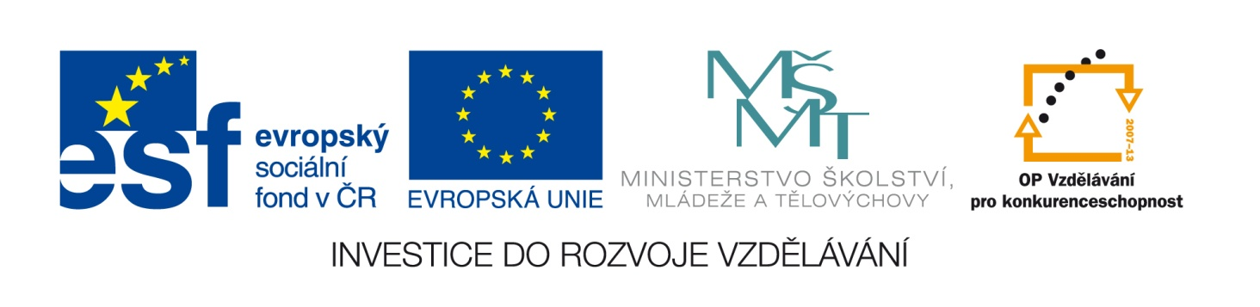

Škola | Základní škola T.G.Masaryka Komárov, okres Beroun
Jméno autora | Pavla Kredbová
Datum vytvoření | 10.2. 2014
Vzdělávací obor | Anglický jazyk
Tématická oblast | Anglický jazyk 7. ročník
Téma | Past continuous
DIGITÁLNÍ UČEBNÍ MATERIÁL: VY_32_INOVACE_01_Aj7_74

Anotace:
Tento materiál slouží k procvičení znalostí o minulém čase průběhovém
Materiál začíná teoretickou částí, kde je zopakována tvorba kladné a záporné věty a otázky a krátkých odpovědí.
Cvičení 1 – děti doplňují do vět správný tvar slovesa být v minulém čase
Cvičení 2 – děti převádí kladné věty na záporné.
Cvičení 3 – děti dávají slova do správného pořadí tak, aby vznikla smysluplná věta
Cvičení 4 – děti odpovídají na otázky a to buď kladně nebo záporně
Cvičení 5 – děti popisují, co dělaly osoby na obrázku včera odpoledne

Tento materiál může být použit k procvičování, doporučuji pustit ho na interaktivní tabuli a správné řešení dopisovat do textu, tak děti vidí správnou formu a procvičují si psaní v cizím jazyce
Materiál může být použit také jako test.

Past continuous
Záporná věta:
I wasn‘t playing
You weren‘t playing
He wasn‘t playing
She wasn‘t playing
It wasn‘t playing

We weren‘t playing
You weren‘t playing
They weren‘t playing

Kladná věta:
I was playing
You were playing
He was playing
She was playing
It was playing

We were playing
You were playing
They were playing

Krátké odpovědi:
Yes, I was. No, I wasn’t.
Yes, I was. No, I wasn‘t.
Yes, he was. No, he wasn’t.
Yes, she was. No, she wasn‘t.
Yes, it was. No, it wasn‘t

Yes, we were. No, we weren’t.
Yes, we were. No, you weren‘t.
Yes, they were. No, they weren‘t
Otázka:
Was I playing?
Were you playing?
Was he playing?
Was she playing?
Was it playing?

Were we playing?
Were you playing?
Were they playing?

Doplň do vět správné tvary slovesa BÝT v minulosti (was/were):
Alison _____ eating. They ______ playing music.
We ______ listening to the band. John ______ writing a letter.
I ______ drinking water. You ______ singing a song.

Převeď dané věty do záporu:
She was playing football. ____________________________________________
They were brushing their hair. __________________________________________
You were making a cake. _______________________________________________
I was taking photos. __________________________________________________
It was eating meat. __________________________________________________

Dej slova do správného pořadí:
at/watching/we/five/were/o’clock/TV ____________________________________
was/Sarah/last/working/year/Japan/in ___________________________________
you/walking/were/from/home/?/work ____________________________________
weren’t/bus/they/waiting/the/stop/at ____________________________________
afternoon/shining/the/yesterday/was/sun _________________________________

Odpověz na otázky, buď kladně nebo záporně,podle toho jestli je za větou + nebo –
Was he riding a horse? + ___________________________________________
Were my parents travelling last year? - ________________________________
Was Madonna singing at the concert? + _________________________________
Were you studying for the test? + ____________________________________
Was it snowing last winter? - ________________________________________

Odpověz podle obrázků na následující otázku:
WHAT WERE THEY DOING YESTERDAY AFTERNOON?
______________ ___________________
______________ ___________________

____________________ ________________________
____________________ ________________________

_____________________ ________________________
_____________________ ________________________

ŘEŠENÍ:
Doplň do vět správné tvary slovesa BÝT v minulosti (was/were):
Alison WAS eating. They WERE playing music.
We WERE listening to the band. John WAS writing a letter.
I WAS drinking water. You WERE singing a song.

Převeď dané věty do záporu:
She was playing football. SHE WASN’T PLAYING FOOTBALL.
They were brushing their hair. THEY WEREN’T BRUSHING THEIR HAIR.
You were making a cake. YOU WEREN’T MAKING A CAKE.
I was taking photos. I WASN’T TAKING PHOTOS.
It was eating meat. IT WASN’T EATING MEAT.

Dej slova do správného pořadí:
at/watching/we/five/were/o’clock/TV WE WERE WATCHING TV AT FIVE O’CLOCK.
was/Sarah/last/working/year/Japan/in SARAH WAS WORKING IN JAPAN LAST YEAR.
you/walking/were/from/home/?/work WERE YOU WALKING HOME FROM WORK?
weren’t/bus/they/waiting/the/stop/at THEY WEREN’T WAITING AT THE BUS STOP.
afternoon/shining/the/yesterday/was/sun THE SUN WAS SHINING YESTERDAY AGTERNOON.

Odpověz na otázky, buď kladně nebo záporně,podle toho jestli je za větou + nebo –
Was he riding a horse? + YES, HE WAS.
Were my parents travelling last year? – NO, THEY WEREN‘T
Was Madonna singing at the concert? + YES, SHE WAS.
Were you studying for the test? + YES, I WAS.
Was it snowing last winter? – NO, IT WASN’T.
Odpověz podle obrázků na následující otázku:
WHAT WERE THEY DOING YESTERDAY AFTERNOON?
HE WAS READING. SHE WAS EATING.

HE WAS WALKING. HE WAS WRITING.

SHE WAS DANCING. HE WAS SWIMMING.

Zdroje:
Obrázky:
Čtení: http://officeimg.vo.msecnd.net/en-us/images/MH900232988.jpg
Jezení: http://officeimg.vo.msecnd.net/en-us/images/MH900232980.jpg
Chůze: http://officeimg.vo.msecnd.net/en-us/images/MH900232157.jpg
Psaní: http://officeimg.vo.msecnd.net/en-us/images/MH900232133.jpg
Tanec: http://officeimg.vo.msecnd.net/en-us/images/MH900232134.jpg
Plavání: http://officeimg.vo.msecnd.net/en-us/images/MH900232144.jpg

