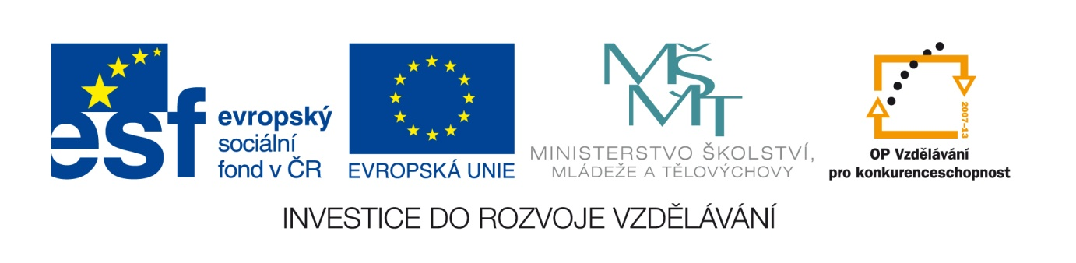

Datum: 2.5.2013

Projekt: Kvalitní výuka

Číslo DUM: VY_22_INOVACE_13

Jméno autora: Irena Moučková

Název práce: -ed/-ing adjectives

Předmět: anglický jazyk

Ročník: 1

Časová dotace: 10 minut

Vzdělávací cíl: Tento materiál je určen k ověření znalostí z oblasti používání
přídavných jmen.

Pomůcky: test, psací potřeby

Poznámka: Studenti vypracovávají test samostatně.

Inovace: Zapojení audiovizuální techniky do výuky

- Imagine you were in these situations. How did you feel?
Choose from these adjectives – exhausted,worried,excited,bored,frightened,confused,
annoyed, surprised

- The film wasn´t very interesting . I was …………………………………………………………………………….
- My mum is going to hospital. I´m …………………………………………………………………………………….
- An unidentified flying object landed the Earth. I was ……………………………………………………..
- The work was really hard. I was ………………………………………………………………………………………..
- I didn´t understand the instructions. I was really …………………………………………………………….
- I watched a horror movie. I felt really ……………………………………………………………………………..
- I missed the bus. I was ……………………………………………………………………………………………………
- I´m going on holiday to Australia. I´m ……………………………………………………………………………..

- Complete the sentences. Use one of the adjectives.
Use one of these adjectives.
Surprise-
Dissapoint-(2*)
Excit- +-ed
Relax- + -ing
Confus-
Worry-
Embarras-

- I lost in a strange town. I was really ………………………………………………………………………………..
- I applied for a job, but I didn´t get it. I was ……………………………………………………………………..
- She is on a two-week holiday. How ………………………………………………………………………………..
- I saw him playing football. He told me he wasn´t interested in sport. I was very ……………
- We have no money for electricity. Our financial situation is ………………………………………….
- When we went to the restaurant, we found out that we had left money at home.
It was ………………………………………………………..
- Yesterday I didn´t pass the exam. I was really ………………………………………………………………..
- I was lying on the beach. It was really ……………………………………………………………………………

Solution:

- Imagine you were in these situations. How did you feel?
Choose from these adjectives – exhausted,worried,excited,bored,frightened,confused,
annoyed, surprised

- The film wasn´t very interesting . I was bored.
- My mum is going to hospital. I´m worried.
- An unidentified flying object landed the Earth. I was surprised.
- The work was really hard. I was exhausted.
- I didn´t understand the instructions. I was really confused.
- I watched a horror movie. I felt really frightened.
- I missed the bus. I was annoyed.
- I´m going on holiday to Australia. I´m excited.

- Complete the sentences. Use one of the adjectives.
Use one of these adjectives.
Surprise-
Disappoint-(2*)
Excit- +-ed
Relax- + -ing
Confus-
Worry-
Embarras-

- I lost in a strange town. I was really confused.
- I applied for a job, but I didn´t get it. I was disappointed.
- She is on a two-week holiday. How exciting.
- I saw him playing football. He told me he wasn´t interested in sport. I was very surprised.
- We have no money for electricity. Our financial situation is worrying.
- When we went to the restaurant, we found out that we had left money at home. It was embarrasing.
- Yesterday I didn´t pass the exam. I was really disappointed.
- I was lying on the beach. It was really relaxing.

Assessment:
1 item = 1 point
16 – 14 points = mark 1
13 – 11 points = mark 2
10 – 8 points = mark 3
7 – 5 points = mark 4
4 – 0 points = mark 5

Použité zdroje:
SOARZ, Liz and John: New Headway, Pre – intermediate, Oxford University Press, Oxford, 2007, ISBN 978-0-19-471585-0.
FALLA Tim,DAVIES Paul A: Maturita Solutions, Oxford University Press, Oxford, 2007,ISBN 978-0-190455169-4.
MURPHY, Raymond: English Grammar in Use, Cambridge University Press, 1994, ISBN 0-521-43680-X.

