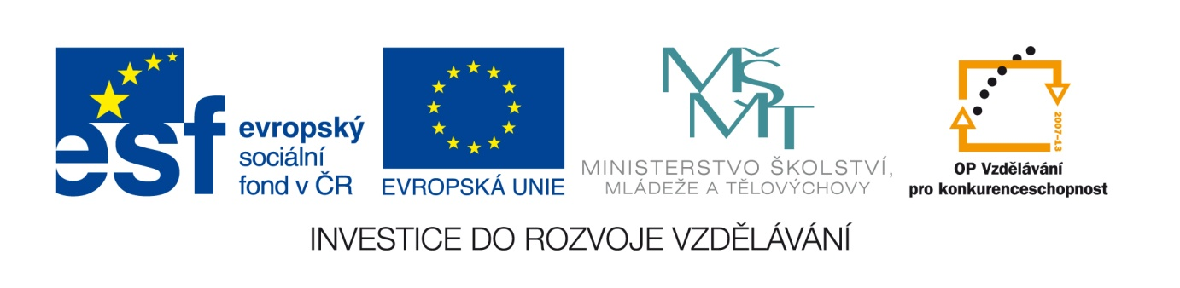
Datum: 2.5.2013

Projekt: Kvalitní výuka

Číslo DUM: VY_22_INOVACE_14

Jméno autora: Irena Moučková

Název práce: How are you feeling? - practice

předmět: anglický jazyk

Ročník: 1

Časová dotace: 10 minut

Vzdělávací cíl: Procvičování slovní zásoby týkající se pocitů a způsobu
prožívání různých situací.

Pomůcky: Pracovní list, psací potřeby

Poznámka: Studenti vypracovávají pracovní list samostatně, pak konfrontují své odpovědi navzájem a se správným řešením.

Inovace: zapojení audiovizuální techniky do výuky

PRACTICE HOW ARE YOU FEELING?
Look at the picture. How are the people feeling? Choose an adjective from the box.
Angry, ill, excited,nervous, worried,fed up
……………………………………………………………………..
…………………………………………………………………….
…………………………………………………………………….
……………………………………………………………………..
…………………………………………………………………..
……………………………………………………………………….

Choose a reply(1-5) to the situations (a-e).
- Good luck. Just do your best.
- Lucky you. Have a good time.
- Cheer up! You have got me. I´m always here for you.
- That´s good. I´m so pleased to her that.
- I´m sorry to hear that! Why don´t you go home to bed.I´m sure you will be all right soon.

- I´m feeling a lot better.
.......................................................................................................................................
- I´m a bit worried. I have got an exam today.
…………………………………………………………………………………………………………………………………….
- I don´t feel very well. I think I´m getting a cold.
…………………………………………………………………………………………………………………………………….
- I´m on holiday to Greece.
……………………………………………………………………………………………………………………………………
- I feel sad. I had an argument with my boyfriend.
……………………………………………………………………………………………………………………………………

SOLUTION: PRACTICE HOW ARE YOU FEELING?
Look at the picture. How are the people feeling? Choose an adjective from the box.
Angry, ill, excited,nervous, worried,fed up
EXCITED
ILL
WORRIED
ANGRY
NERVOUS
FED UP

Choose a reply(1-5) to the situations (a-e).
- Good luck. Just do your best.
- Lucky you. Have a good time.
- Cheer up! You have got me. I´m always here for you.
- That´s good. I´m so pleased to hear that.
- I´m sorry to hear that! Why don´t you go home to bed.I´m sure you will be all right soon.

- I´m feeling a lot better.
That´s good. I´m pleased to hear that.
- I´m a bit worried. I have got an exam today.
Good luck. Just do your best.
- I don´t feel very well. I think I´m getting a cold.
I´m sorry to her that! Why don´t you go home to bed. I´m sure you will be all right soon.
- I´m on holiday to Greece.
Lucky you. Have a good time.
- I feel sad. I had an argument with my boyfriend.
Cheer up! You have got me. I´m always her efor you.

Použité zdroje:
SOARZ, Liz and John: New Headway, Pre – intermediate, Oxford University Press, Oxford, 2007, ISBN 978-0-19-471585-0.
www.fotosearch.cz
http://www.fotosearch.cz/UNQ004/u27233251/
http://www.fotosearch.cz/fotografii-snimku/ill.html
http://www.fotosearch.cz/UNQ518/u17994896/
http://www.fotosearch.cz/ULY172/u12240995/
http://www.fotosearch./ULY161/u25017618/
http://www.fotosearch.czcz/IMR481/ie311-083/

