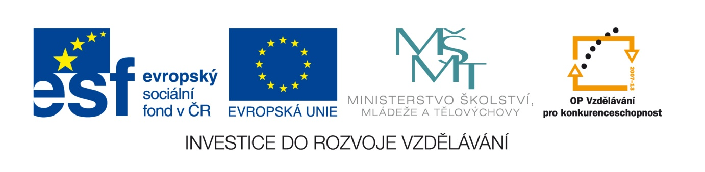

Datum: 1.6.2013

Projekt: Kvalitní výuka

Číslo DUM: VY_22_INOVACE_16

Jméno autora: Irena Moučková

Název práce: Comparatives, superlatives

předmět: anglický jazyk

Ročník: 1

Časová dotace: 10 minut

Vzdělávací cíl: Tento materiál slouží k ověření znalostí stupňování přídavných
jmen. Zároveň si rozšiřují slovní zásobu.

Pomůcky: pracovní listy, psací potřeby

Poznámka: Studenti vypracovávají pracovní listy samostatně.

Inovace: zapojení audiovizuální techniky do výuky

TEST – COMPARATIVES, SUPERLATIVES

- Write the missing forms of these adjectives.

Scary ……………………… ……………………….
Generous ……………………... ………………………..
…………………… worse ……………………….
…………………… ……………………… the ugliest
Mean ……………………… ………………………
…………………… ……………………… the best
Rude ……………………… ………………………
Thin ……………………… .................................

- Write true sentences using the comparative form of the adjectives in brackets.

- April/January (short)
…………………………………………………………………………………………..

- Fiats/Ferraris (expensive)
…………………………………………………………………………………………..

- Silver/gold (heavy)
………………………………………………………………………………………
- Fruit/ junk food (healthy)
………………………………………………………………………………………

- Complete the sentences with an opposite adjective in its comparative or superlative form.

- Russia is the smallest country in the word.
No, it isn´t.It is ……………………………………………………………………..
- The Atlantic Ocean is larger than the Pacific Ocean.
No, it isn´t. The Atlantic Ocean is ………………………………………............
- Mount Everest is the lowest mountain in the word.
No, it isn´t. Mount Everest is …………………………………………………….
- Earth is further to the sun than Mars.
No, it isn´t. Earth is ………………………………………………………………

- Everything is more cheap in my country.
………………………………………………………………………………………
- She is as tall than her mother.
………………………………………………………………………………………
- Rome was hotter that I expected.
………………………………………………………………………………………
- What does New York like? It is really exciting.
TEST – COMPARATIVES, SUPERLATIVES

- Write the missing forms of these adjectives.

Scary scarier the scariest
Generous more generous the most generous
Bad worse the worst
Ugly uglier the ugliest
Mean meaner the meanest
Good better the best
Rude ruder the rudest
Thin thinner the thinnest

- Write true sentences using the comparative form of the adjectives in brackets.

- April/January (short)
April is shorter than January.

- Fiats/Ferraris (expensive)
Ferraris are more expensive than Fiats.

- Silver/gold (heavy)
Gold is haevier than silver.
- Fruit/ junk food (healthy)
Fruit is healthier than junk food.

- Complete the sentences with an opposite adjective in its comparative or superlative form.

- Russia is the smallest country in the word.
No, it isn´t.It is the larger country in the word.
- The Atlantic Ocean is larger than the Pacific Ocean.
No, it isn´t. The Atlantic Ocean is smaller than the Pacific Ocean.
- Mount Everest is the lowest mountain in the world.
No, it isn´t. Mount Everest is the highest mountain in the world.
- Earth is further to the sun than Mars.
No, it isn´t. Earth is nearer to the sun than Mars.

- Everything is more cheap in my country.
Everything is cheaper in my country.
- She is as tall than her mother.
She is as tall as her mother.
- Rome was hotter that I expected.
Rome was hober than I expected.
- What does New York like? It is really exciting.
What is New York like? I tis really exciting.
Assessment:

1 item = 1 point

20 – 18 points = mark 1
17 - 15 points = mark 2
14 - 11 points = mark 3
10 - 7 points = mark 4
6 - 0 points = mark 5

..

Použité zdroje:
SOARZ, Liz and John: New Headway, Pre – intermediate, Oxford University Press, Oxford, 2007, ISBN 978-0-19-471585-0.
FALLA Tim,DAVIES Paul A: Maturita Solutions, Oxford University Press, Oxford, 2007,ISBN 978-0-190455169-4.
MURPHY, Raymond: English Grammar in Use, Cambridge University Press, 1994, ISBN 0-521-43680-X.

