Dotkněte se inovací CZ.1.07/1.3.00/51.0024

Anglický jazyk - Historie Británie: Rod Tudorovců
2 British history
Students get some information about British history
Basic Information

The Tudors were the British Royal Dynasty from 1485 to 1603. There were six monarchs in this dynasty.
The first King Henry VII. Tudor was very famous because he won War of Two Roses: 1455 – 1485. He got married to Elisabeth of York. He had several children, the first son Arthur, the Prince of Wales. He got married to Catherine of Aragon, but he died when he was fifteen years old. Henry VII. Tudor was a king from 1485 to 1509.

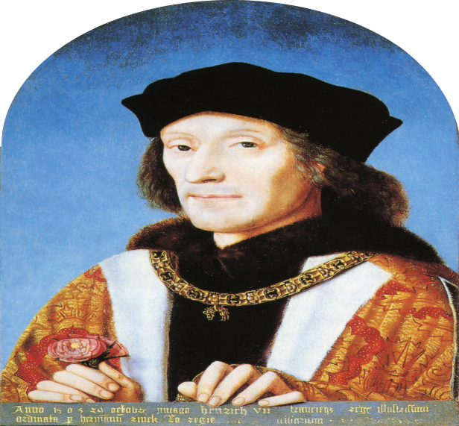 Picture No. 1 – Henry VII. (The First Tudor)

Henry VII. Tudor had several children, but the most famous king was Henry VIII. He was the second monarch of the House of Tudor. He was born in 1491 and he died in 1547. He was very famous because he had six wives. He was a king from 1509 to 1547.

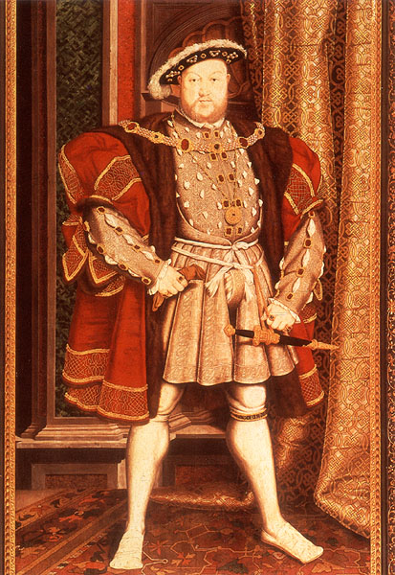Picture No. 2 – Henry VIII. (The Second Tudor)

His first wife was Catherine of Aragon. They had six children, but only a daughter Mary survived. Henry VIII. Tudor wanted to have a son and he wanted to get married to Anne Boleyn that´s why he founded Anglican Church in 1533.
His second wife was Anne Boleyn .They had a daughter Elisabeth I. Anne Boleyn was executed in 1536. She had a daughter- Elisabeth I. later Queen of England.
His third wife was Jane Seymour. They had a son Edward VI., but Jane Seymour died 9 days after birth of Edward VI. Historian say that he loved only Jane from all his wives.
His fourth wife was German Anne of Cleves. They didn´t have any children and they got divorced after six months.
His fifth wife was Catherine Howard, she was very young, when she got married to Henry VIII. She was executed by Henry VIII. Tudor after two years of their marriage.
His sixth wife was Catherine Parr. She was a widow twice, when she got married to Henry VIII.
After Henry´s VIII. Tudor death, his only son Edward VI. /1547 – 1553/ became an English king. He died, when he was sixteen years old.

After Edward´s death Jane Grey became a Queen of England, but only 9 days. She was the shortest British queen in history. Mary a daughter of Catherine of Aragon executed her in the Tower of London.

Queen Mary became a fifth British Queen from Tudor´s Dynasty. She sometimes called Bloody Mary because she killed about 300 people. She imprisoned her step- sister Elisabeth I. in the Tower of London.

When the Queen Mary died, her step- sister Elisabeth I. became an English Queen. She was a queen from 1558 to 1603. She was the last Tudor because she wasn´t married and she didn´t have any children. Elisabeth I. was very clever, she was a daughter of executed Anne Boleyn and Henry VIII.

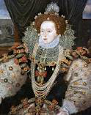 Picture No. 3 – Elisabeth I. ( last Tudor Queen)

1 Students answer these questions:

σ Task 1:
Can you name all monarchs from the Tudor ´s Dynasty?

σ Task 2:

Can you write something about Henry VIII?

σ Task 3:

How many children did Henry VIII. Tudor have?

σ Task 4:

Who was the last Tudor?

σ Task 5:

Who founded Anglican Church?
Použitá literatura a zdroje:

Elton, G. R. (1998), Velká kniha evropských panovníků, Praha: Regia

Maurois, A. (1993), Dějiny Anglie, Praha: Nakladatelství Lidové noviny

Morgan, O. Kenneth (1997) Dějiny Británie

Weirová A. (1999), Šest žen Jindřicha VIII., Praha: Melantrich

Vypracovala: Bc. Martina Sulovari

Elton, G. R. (1998), Velká kniha evropských panovníků, Praha: Regia, str. 337
Jindřich VII. (1457-1509), anglický král (1485-1509), první panovník z rodu Tudorovců, manželka byla Alžběta z Yorku
Arthur, Prince z Walesu ( 1486-1502), první syn Jindřicha VII. a Alžběty z Yorku
Maurois, A. (1993), Dějiny Anglie, Praha: Nakladatelství Lidové noviny, str. 173
Jindřich VIII. (1509- 1547), byl znám svými šesti manželkami a dvě z nich nechal popravit Anne Boleyn a Catherine of Howard, založil anglikánskou církev a stal se hlavou této církve a odtrhl se od Říma a tudíž od papeže
Morgan, O. Kenneth (1997) Dějiny Británie, str. 216
Weirová A. (1999), Šest žen Jindřicha VIII., Praha: Melantrich, str. 6
Ibid. str.8
Maurois, A. (1993), Dějiny Anglie, Praha: Nakladatelství Lidové noviny, str. 175
Maurois, A. (1993), Dějiny Anglie, Praha: Nakladatelství Lidové noviny, str. 178
Elton, G. R. (1998), Velká kniha evropských panovníků, Praha: Regia, str. 340

