2) Fill in don’t or doesn’t
- I _____ go to school on Sunday.
- He _____ like carrots.
- They _______ play tennis.
- She ______ have a dog.
- We _________ watch TV in the morning.

3) Correct the mistakes
- She don’t like ice cream. → __________
- They doesn’t go to school. → __________
- He don’t play football. → __________

4) Make negative sentences
Use the prompts and make sentences.
- (I / like / milk) → ____________________
- (She / play / piano) → ____________________
- (We / have / cats) → ____________________
- (He / read / books) → ____________________

1. Doplň správné sloveso (be / have got / can)
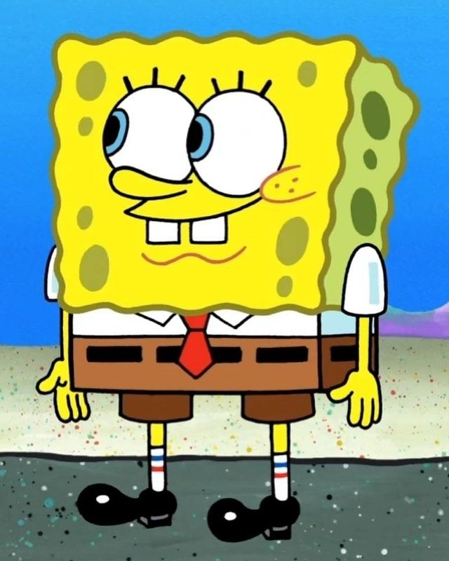
a) SpongeBob ________ cook.
b) He ______ make Krabby Patties.
c) He _________ two big teeth.
d) Patrick _______ clever.
e) Squidward ________ play the clarinet.
f) They ________ best friends.
g) Mr. Krabs ________ very rich.
h) SpongeBob _________ lazy.

Doplň can/ can’t
Example: Plankton can talk, but he can’t fly.
- SpongeBob → cook / fly

- Patrick → sleep a lot / play the clarinet

- Squidward → play the clarinet / sing well
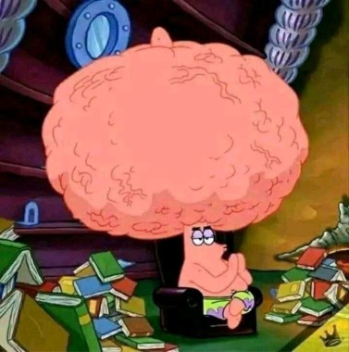
- Sandy → do karate / live under the sea

3. Napiš věty s have got
a) SpongeBob __________ (two big teeth).
b) Patrick __________ (a shell).
c) Squidward __________ (a clarinet).
d) Mr. Krabs __________ (a lot of money).
e) SpongeBob __________ (a pet snail, Gary).
f) Patrick __________ (a car).

4. Doplň přivlastňovací zájmena
a) SpongeBob loves _______ job.
b) Patrick is ______ best friend.
c) Squidward plays _______ clarinet every day.
d) We like _____ teacher, Mrs. Puff.
e) Mr. Krabs loves ______ money.
f) Gary is SpongeBob’s pet. SpongeBob loves _______ snail.
g) Pearl is Mr. Krabs’s daughter. ______ father is very strict.
h) This is SpongeBob and Patrick. ________ house is in Bikini Bottom.

