Possessive case
VY_22_INOVACE_03-39

Ročník: | 6.
Vzdělávací oblast: | Jazyk a jazyková komunikace
Vzdělávací obor: | Anglický jazyk
Tematický okruh: | Gramatika
Téma: | Possessive case – Přivlastňovací pád
Jméno autora: | Mgr. Pavlína Vlková
Vytvořeno dne: | 27. srpna 2011
Metodický popis,  (anotace): | Materiál může sloužit jako pracovní list pro individuální výuku nebo je možné jej promítnout celé skupině a pracovat společně. Procvičuje přivlastňovací pád v několika cvičeních.

POSSESSIVE CASE (přivlastňovací pád)

- Match the sentences to the pictures.
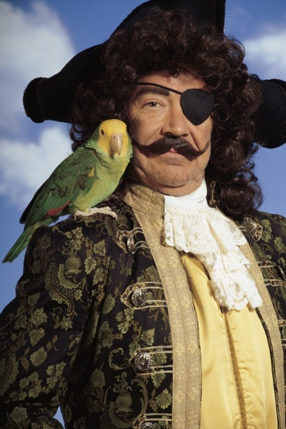
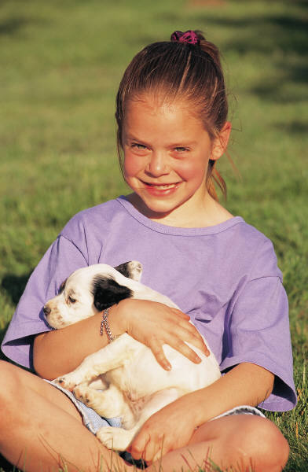
This is Sally.
This is a parrot.
This is a pirate.
This is a dog.
This is his parrot.
This is her dog.
This is Sally's dog.
This is the pirate's parrot.

2. Write the sentences with the possessive case.(A noun is singular, add 's.)

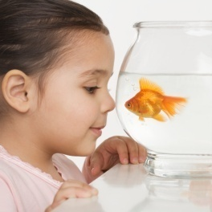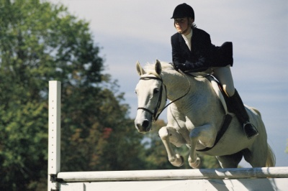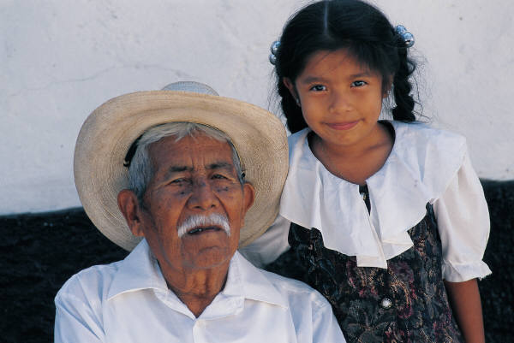
44
3
2
44
1
1. (Anna/fish) – This is Anna's fish.
2. (Jamie/horse) -
3. (Salma/grandfather) -
4. (Bill/dogs) -

3. Match the sentences to the pictures.

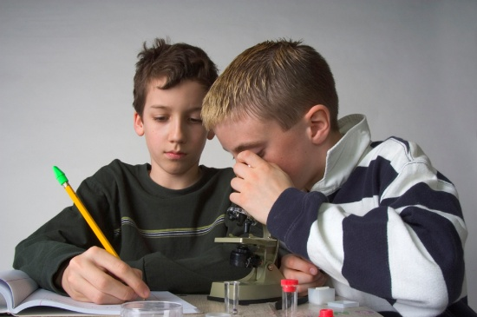

These are the girls.
These are the boys.
This is a grandfather.
This is a microscope.
This is their microscope.
This is their grandfather.
This is girls'grandfather.
This is boys'microscope.
4. Write the sentences with the possessive case. (A noun is plural and ends in -s, add ' .)
44
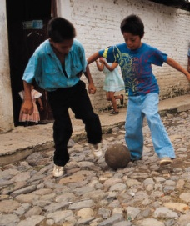
2
3
1
1. (Students/teacher) – This is the students' teacher.
2. (Girls/computer) -
3. (Boys/ball) -
4. (Parents/house) -

5. Write 3 sentences about your friends, use possessive case.

example: This is Laura's schoolbag.
These are Ben's pens.

6. Put the apostrophe (') in the correct place.

- These are Bill's toys.
- Where isfathers car?
- Is this grandmothers room?
- My brothers names are John and Adam.
- What is your sisters name?
- They are Steves cousins.

Použité obrázky – www.office.microsoft.com [online]. c2011 [cit. 2011-08-27].

POSSESSIVE CASE

Pokyny

Materiál může sloužit jako pracovní list pro individuální výuku nebo je možné jej promítnout celé skupině a pracovat společně. Procvičuje přivlastňovací způsob v několika cvičeních.

Řešení

- Match the sentences to the pictures.
This is Sally.
This is a parrot.
This is a pirate.
This is a dog.
This is his parrot.
This is her dog.
This is Sally's dog.
This is the pirate's parrot.
2. Write the sentences with the possessive case.(A noun is singular, add 's.)
1. (Anna/fish) – This is Anna's fish.
2. (Jamie/horse) - This is Jamie's horse.
3. (Salma/grandfather) - This is Salma's grandfather.
4. (Bill/dogs) - These are Bill's dogs.
3. Match the sentences to the pictures.

These are the girls.
These are the boys.
This is a grandfather.
This is a microscope.
This is their microscope.
This is their grandfather.
This is girls' grandfather.
This is boys' microscope.

4. Write the sentences with the possessive case. (A noun is plural and ends in -s, add ' .)
1. (Students/teacher) – This is the students' teacher.
2. (Girls/computer) - This is the girls' computer.
3. (Boys/ball) - This is the boys' ball.
4. (Parents/house) - This is the parents' house.

5. Write 3 sentences about your friends, use possessive case.
- vlastní odpovědi žáků, kontrolujeme správně použitý přivlastňovací způsob
6. Put the apostrophe (') in the correct place.

- These are Bill's toys.
- Where is father's car?
- Is this grandmother's room?
- My brothers'names are John and Adam.
- What is your sister's name?
- They are Steve's cousins.

